Local Address & Emergency Contacts
It is important to keep your local address and emergency contact information updated and accurate. UWL requires students to review their local address and phone number once a semester while they are enrolled. A short form will pop up in WINGS at the start of the fall and spring semesters as a reminder.

Directions
- Read the directions at the top of the form.
- Scroll to the Local Address section and enter in your local address.
  - If you are staying in a residence hall, please put in your home address for your local address. Your residence hall information will be entered by the Residence Life Office.
  - If you have an apartment in La Crosse, please put in that address. When filling out address fields, you can put your apartment number at the end of your street address.
  - You do not need to put in a County.
  - If you are enrolled entirely in online courses, enter in the address where you are physically located while enrolled.
  - If you are physically located outside of the United States, please fill in the below as much as you can and then contact the Records and Registration office at records@uwlax.edu or 1.608.785.8951 for assistance updating your local address to the correct country.

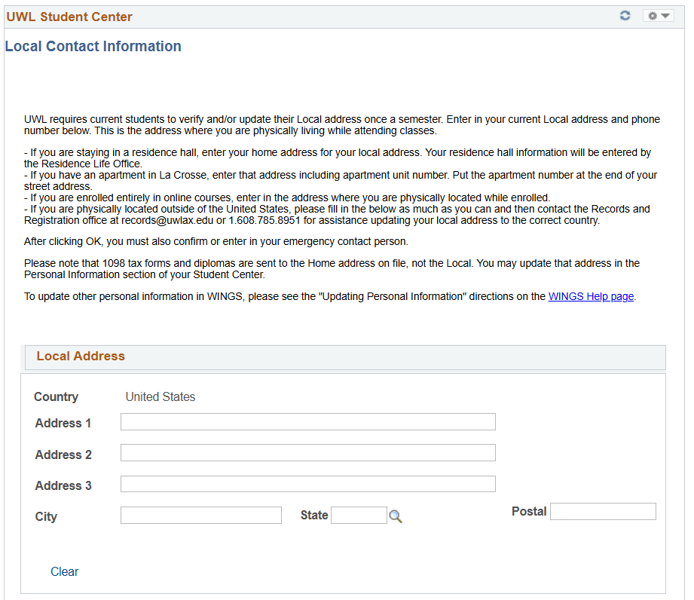

- Enter in your Local Phone number in digits only and indicate phone type. This should be your cell phone or other local number where you can be contacted directly. Please note that phone numbers and addresses are not published in the online directory.

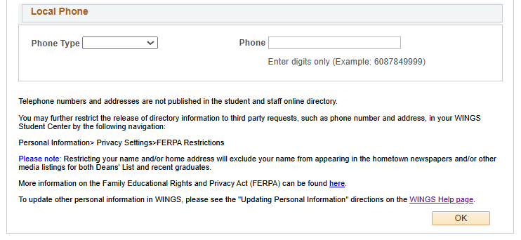

- Click the OK button. The next page is the Emergency Contact page. If no current emergency contact information is found, click the Add an Emergency Contact button and enter information for your emergency contact, including Name, Relationship, Address, and Phone. Click Save when done. If there is a contact listed and you would like to change it, click the pencil icon to edit. Make sure at least one contact is marked as Primary and then save.

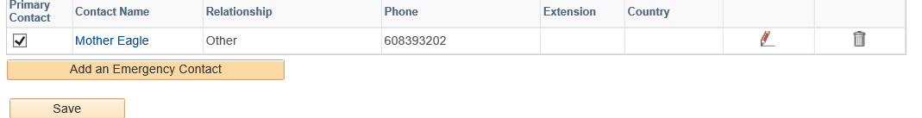

To update other personal information in WINGS, please see the Updating Personal Information directions on the WINGS help page.

Privacy restrictions
- You may further restrict the release of directory information to third party requests, such as phone number and address, in your WINGS Student Center. Use the left-hand menu to navigate to Self Service, Campus Personal Information, FERPA Restrictions. Detailed directions on how to add or update the privacy settings on your directory information is in Privacy Settings/FERPA Restrictions on the WINGS help page.
- Please note that restricting your name and/or home address will exclude your name from appearing in the hometown newspapers and/or other published listings of both Deans' List awards and recent graduates.
- The definition of directory information and the Family Educational Rights and Privacy Act is on UWL's FERPA website.

