Update Your Personal Information

Overview
- Scroll down to the Personal Information section of your Student Center.
- Review the links on the left and click on the information you would like to update. If you don't see the item in the links, open the Other Profile Information drop-down menu and select an item. Click the double arrow Go button.

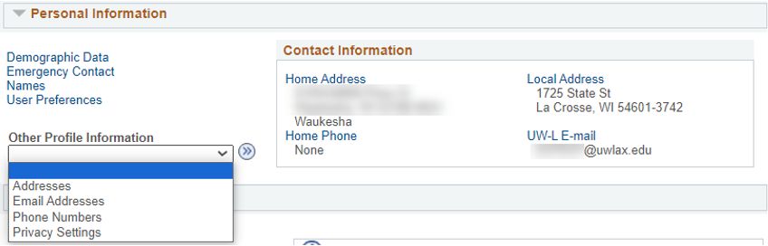

- Update your information as needed. A brief description of how to update addresses and names follows.

Addresses
UWL uses the Home and Local addresses for various purposes. The Home address is your address when you are not at school, and later, where you move to after graduation. Diplomas are mailed to Home addresses. The Local address in your address when you are at school, whether a residence hall or nearby apartment. The Local address is used when verifying voter ID.

- Select Addresses from the Other Profile Information drop down menu. Click the double arrow Go button.

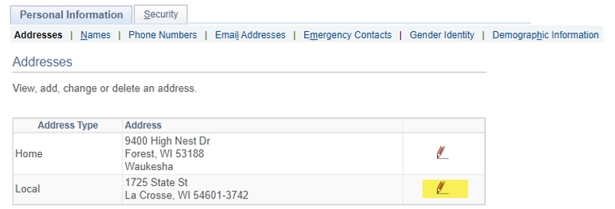

- Select the edit icon next to the address type you want to edit. Or click Add a new address to add another address type.
- Enter the updated address. You may select another country by clicking the Change Country link on the top right. This may change the formatting of how the address should be entered.
- Click the Ok button to move to the next step.
- On the next screen, make sure only the address type you are updating is checked under Address Types. The Date changes will take effect can be left as today's date.

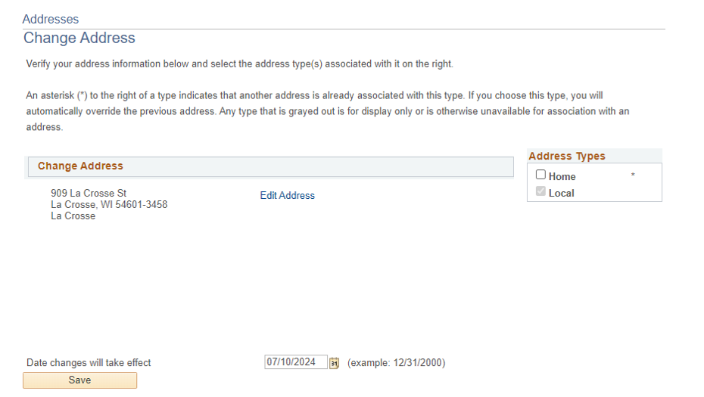

- Click save and wait for the system to finish saving.

Name
Students must provide documentation of a legal name change (or to fix a typo) to the Records and Registration office (117 Graff Main Hall) to update their legal name. However, you may add two alternative names without documentation:

- A Name in Use, sometimes called a preferred name, is the name you would like to be identified by on campus instead of your legal name. You can only request a name in use for your first name. Please note there are some situations where the use of your legal name will be necessary.

  - New applicants to UWL automatically receive a name in use if they entered a name different from their legal name in the Preferred Name/Name in Use Field on the application.
  - To request or change a name in use after starting at UWL, submit a Name in Use form. The full Name in Use policy and additional information can be found on the Name in Use website.

- A Degree name may be added to print on your diploma upon graduation. For instance, if you want your middle initial on your diploma instead of your whole middle name or visa versa, create a degree name. If you don't provide a degree name, your legal name as it is listed in WINGS will be used. To add a degree name:
  - Select Names from the link in the Personal Information section of your Student Center.

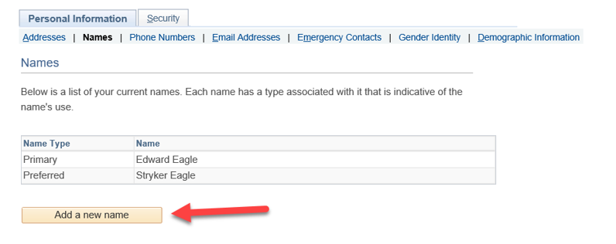

  - If a preferred name is listed, that is considered your name in use.
  - Click the Add a new name button.
  - Select Degree for Name Type. Enter the desired name as you want it listed on your diploma. The Date changes will take effect can be left as today's date.
  - Click save and wait for the system to finish saving.

Other personal information you may update through WINGS:
- Phone numbers
- Personal email address
  - Please update your personal email address if it changes, becomes deactivated, or you originally used someone else's email when applying to UWL.
  - Your personal email will be used for communication after you have graduated, such as sending you a link to your digital diploma and information from the Alumni & Friends Foundation.
- Emergency contacts
- Gender identity
- Privacy settings on how your directory information is used – details are in the Privacy Settings/FERPA Restrictions directions.

Personal information you need assistance changing:
- Legal name
- Legal sex
- Social security number
- UWL campus email address – this change can be initiated by submitting a Name in Use form.

Contact the Records and Registration Office at records@uwlax.edu or stop in at 117 Graff Main Hall if you need assistance.

