Validating Your Schedule
in Schedule Planner
(a.k.a. checking the prerequisites)

Use the validation feature to check whether you meet all the course prerequisites before you register instead of during the enrollment process. This option gives you more time to make changes to your shopping cart and to obtain any needed overrides before your registration appointment begins.

Directions:
- Develop and save a schedule with one or more courses following the steps in Search for Classes/Creating a Schedule using Schedule Planner.
- Click on the View link next to a potential schedule that you like.
  - If you already have courses in your shopping cart, go directly to the shopping cart by clicking Shopping Cart in the top bar. (If you are on a mobile device, this might be at the bottom.)

- Click Validate.

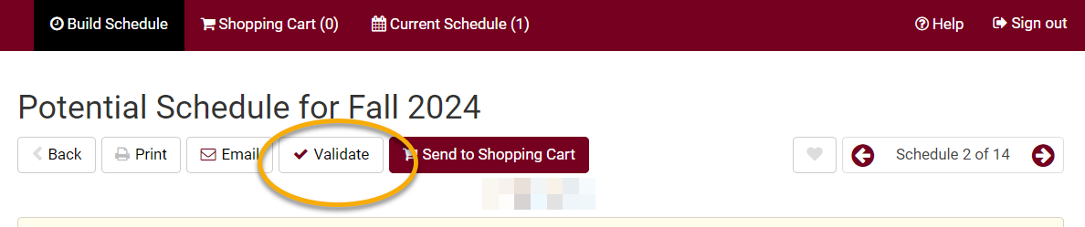

- Review your results and read the messages. Some common messages:

  - A green checkmark means you will be able to register into the course.

  - Hold on record means there is a hold that must be removed before you can register. The most common holds are 1) an advising hold which can be removed after talking with your advisor and 2) a cashiers hold for an outstanding bill which must be paid before you can register. You can see what the hold is by going to your WINGS Student Center and viewing the Holds section on the right.

  - If you receive an Enrollment requisites are not met error, review your Course History to figure out which course or requirement you might be missing. Speak with the department/instructor offering the course if you have questions about the prerequisites.

  - Consent Required means you will need permission from the instructor to get into the class.

  - If you receive a message that starts with "This course has been taken previously," check your Course History to verify if you received a "D" or "F" in that class.

    - For undergraduates, only UWL classes that have been graded with a "D" or an "F" can be repeated at UWL, unless you are allowed to earn credit multiple times in the class. You can repeat a UWL course with any grade at another school. If you received a "C" or higher in a UWL course and register to repeat it, you will be dropped from the class before the start of the term if you do not drop yourself first.
    - If you have transfer credit for the course, you can repeat the course at UWL, but the transfer credit will need to be removed from your record as you usually cannot earn credit twice for a class. Contact Records and Registration at records@uwlax.edu if you would like to repeat a transfer course at UWL.

- The message “The Requirement Designation Option was set to "YES" by the enrollment process” means that the course is a general education or writing emphasis course. If there is a green check mark with it, there is no problem.

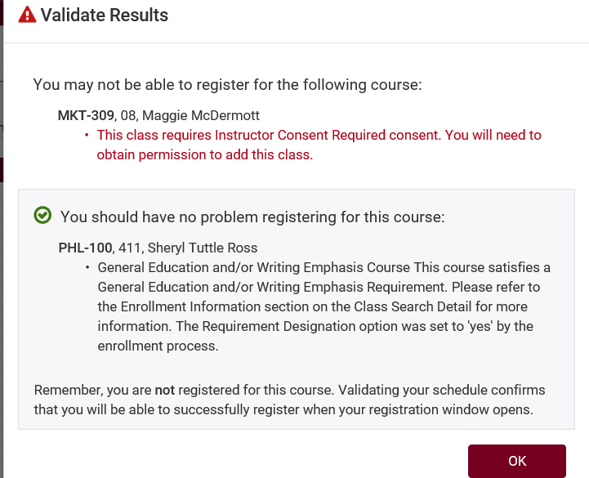

- Change or keep courses, as needed.

- If you add or change courses, be sure to validate again to catch any new errors.

Remember:
- Validate twice! – once when you first build your schedule and again the day before or day of your registration after putting your courses in the shopping cart. Things may have changed between these two dates, plus some issues are not visible until the courses are officially in the shopping cart.
- If the class is closed, check for a waitlist. If there is no waitlist, you may contact the instructor to ask for an override, but please note that the instructor may not approve an override. Many classes do not have the capacity to add additional students.
- If you have questions about registration, contact your advisor or the Records and Registration Office in 117 Graff Main Hall or at records@uwlax.edu, 608.785.8951.

