Find Your Position on the Wait List

- In the Academics section of your WINGS Student Center, select Class Schedule from the drop-down menu. Click the double arrow button.

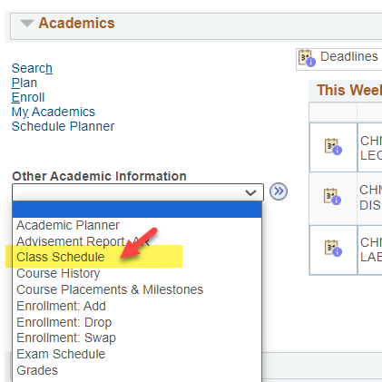

- In the List view, switch the filter options to Show Waitlisted Classes and click Filter.

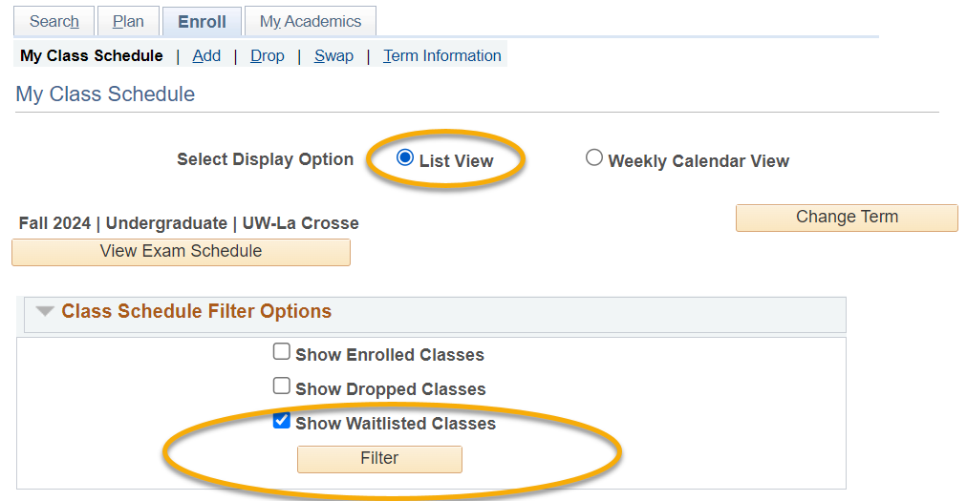

- The Waitlist Position field shows your current position.

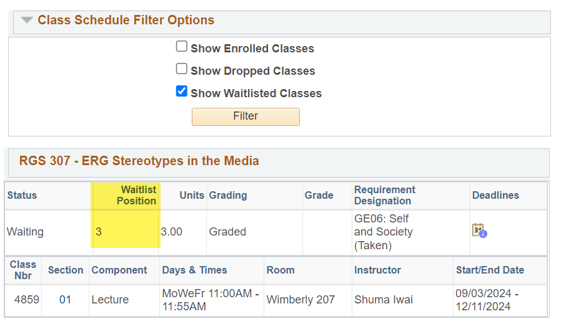

Note: Your wait list position is not listed in Schedule Planner, only in WINGS.

