Register onto a Waitlist in Schedule Planner
  - - Without a Swap -

How to see if class has a waitlist:
- Go to the Add Course section and search for course.
  - If you know all sections are full, you will need to change the Course Status filter to Open & Full to find the course in the search.
- In your Course list, click on Sections.
- There will be a column called Waitlist Seats Open indicating the number of waitlisted seats available. If the course has no waitlist seats left or doesn't have a waitlist at all, it will say 0.
- Click on the blue circle with an 'i' (Section Details) next to the subject to see more information on that section. If there is a waitlist with students on it, there will be a Waitlist Enrollment line. You can also see the Waitlist Seats Open number in the Section Details.
- If there is no Waitlist Enrollment in the details and the Waitlist Seats Open column is at 0, the section does not have a waitlist.

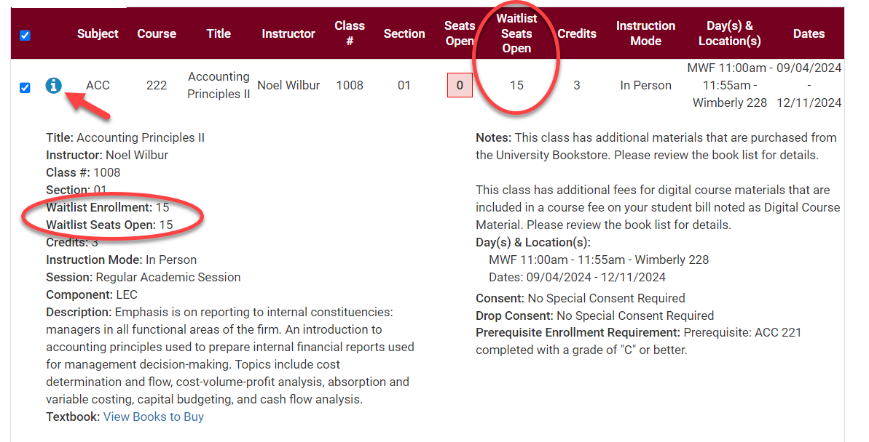

How to register onto a wait list:
- Open Schedule Planner and set your Course Status filter to Open and Full to get all courses. Schedule Planner does not show closed classes in the search results when the filter is set to Open Classes only.

- Find the class you want following the Search for Classes in Schedule Planner directions and add to your Course lists on Build Schedule page.

- Click Generate Schedules and review until you find the right one. Click View.

- Once you have selected the potential schedule, click Send to Shopping Cart.

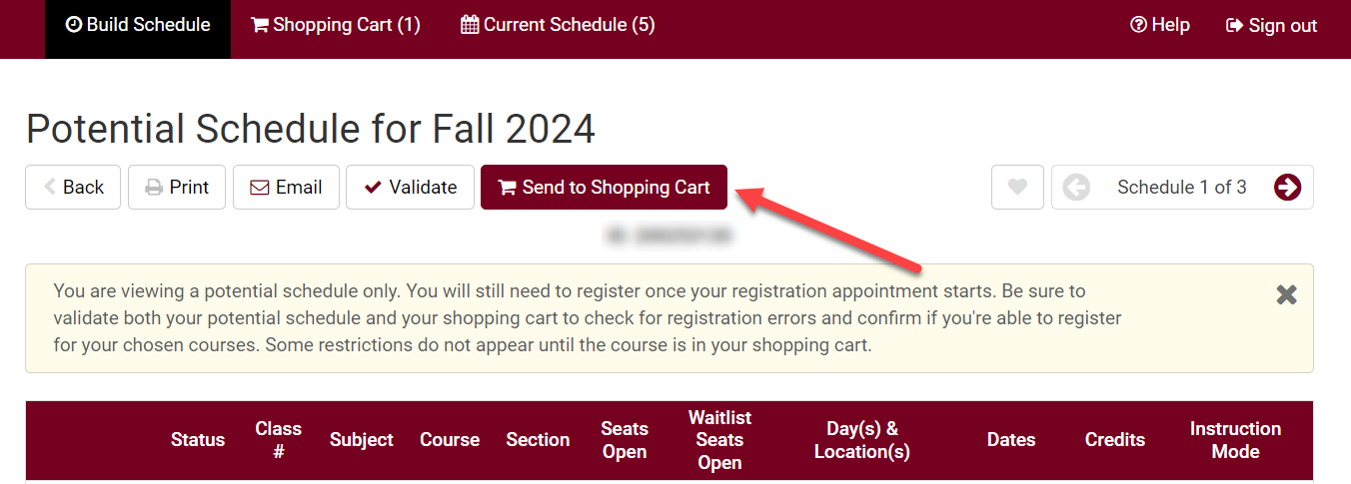

- As you add to the shopping cart, each section with an available waitlisted seat will show up with a "Waitlist?" option.

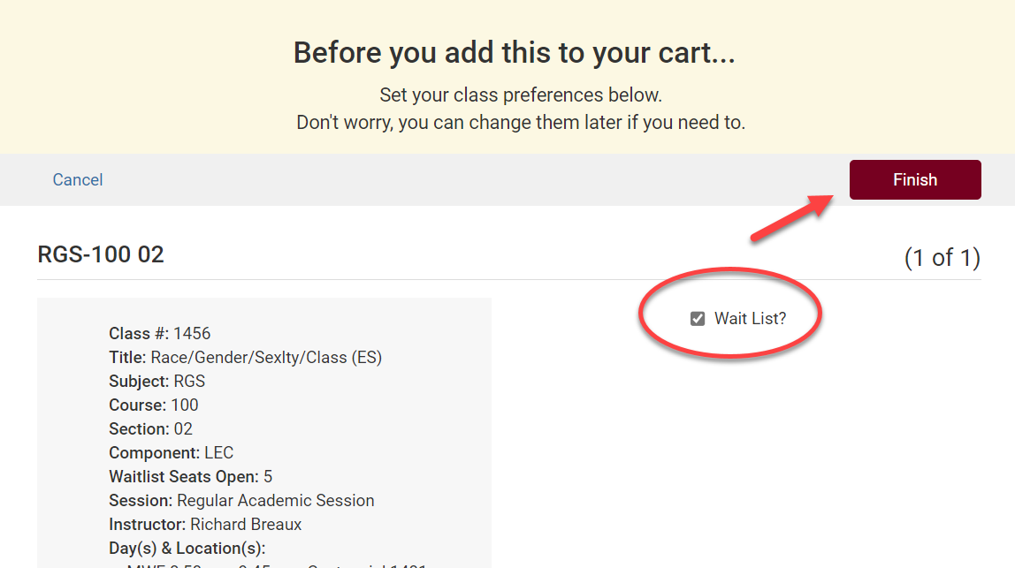

- Checkmark the Waitlist? box and click Finish.

Tip: Use the SWAP feature in your WINGS Student Center to get on a waitlist if you want the system to drop you from a different class if a seat opens up in this one. See Swapping onto a Waitlist in Schedule Planner.
- Click Register and proceed through the registration steps.

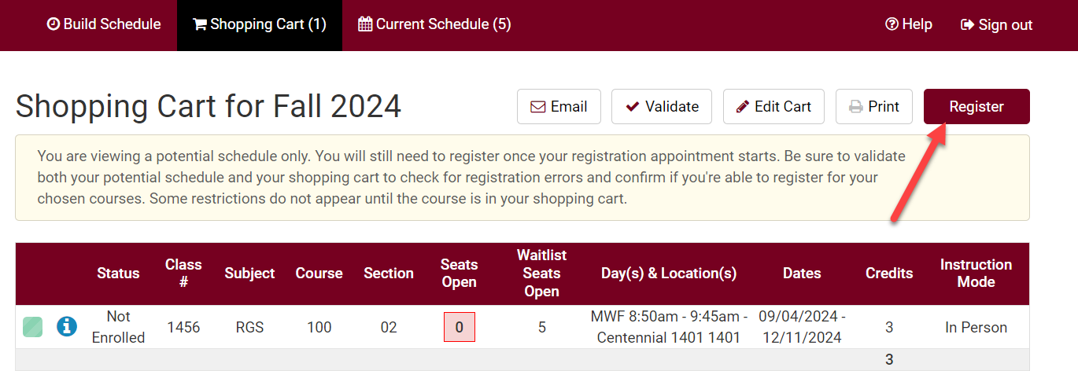

- Review your results.
  - If successful, you will receive a message with a position number (1 being highest).

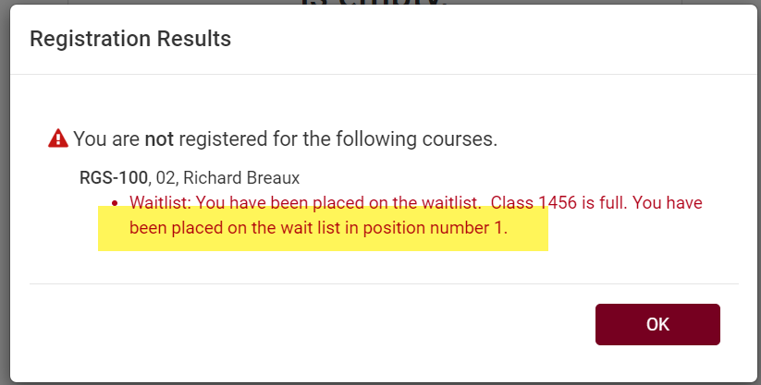

  - If you forgot to check the waitlist box, you may get a message saying the course is closed with directions on how to get on the wait list.
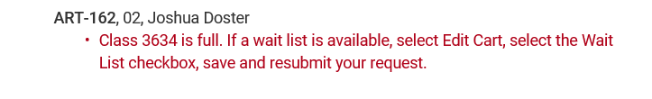
  - If you get a "class is full" message at registration, return to your Shopping Cart and click Edit Cart to see if the section has waitlist as an option. If the section has a waitlist with seats available, the Waitlist? box will appear for you to check. Click that box and then Save.
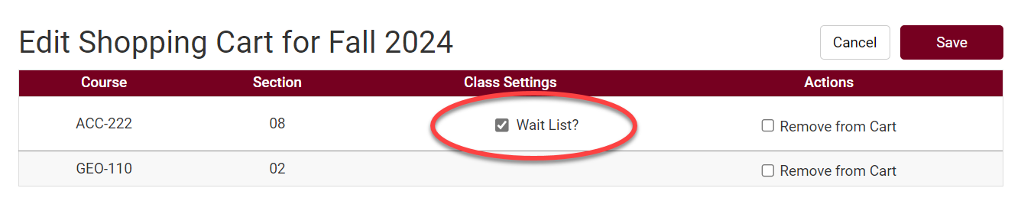
  - Then click the Register button again.

- The waitlisted class will display in your class schedule, under the Current Schedule tab, with a status of Waitlisted.

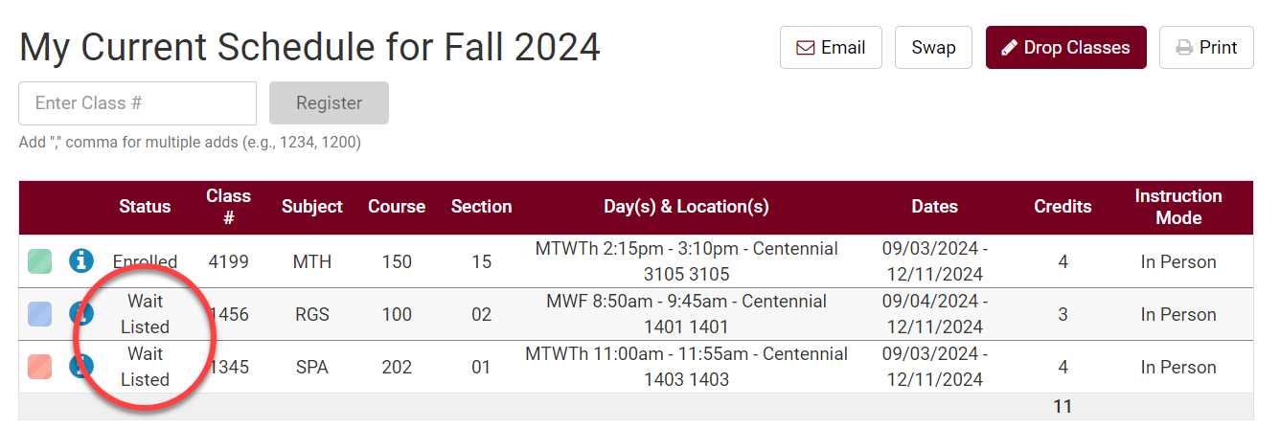

See the Swapping onto a Waitlist in Schedule Planner section for directions on how to swap with a waitlist. See the Waitlist FAQs for more information about how waitlists work.

