Register onto a Waitlist
in WINGS
  - - Without a swap -

To register onto a waitlist through WINGS:

- Find the class you want following the Search for Classes in WINGS directions. If the class is closed and has a waitlist, the status of the class will have the yellow triangle waitlist indicator.

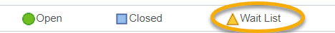

You can determine the waitlist capacity by clicking on the class link for the section in your search results.

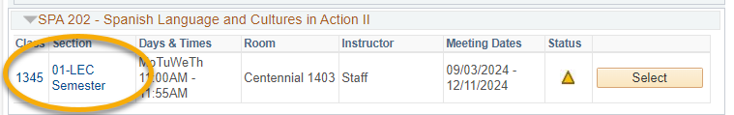

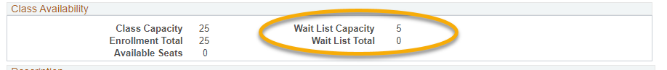

- Click Select next to your desired section on the right to add it to your shopping cart.

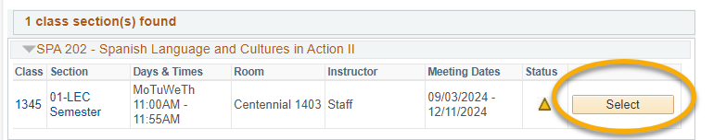

- On the Select classes to add screen, check the box for Waitlist if class is full and click Next.

Important: If the class is already in your shopping cart but you didn't check the waitlist box when it was added, you will have to drop it out of the cart and add it back in so that you can check the waitlist box.

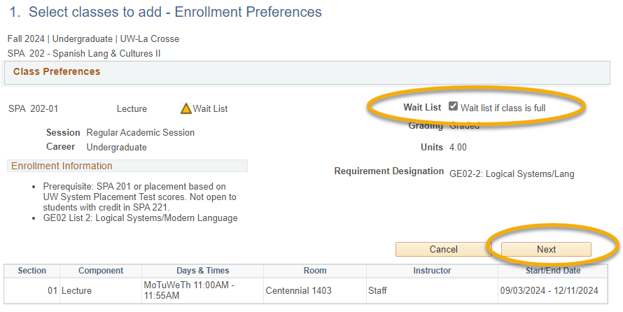

- Continue through the rest of the enrollment steps.
  - Click Proceed to Step 2 of 3.
  - Click Finish Enrolling. If you haven't agreed to the terms and conditions yet, you will need to click Agree and then continue to finish enrolling.

- View Results
  - You must meet all class prerequisites to get on the waitlist. If the waitlist is full, you will get a red X and an error message explaining. Check back later to see if the wait list has seats that opened up.
  - If successfully put on the waitlist, you will get a green check mark and a position number (#1 for the first person, # 2 for the second, etc…).

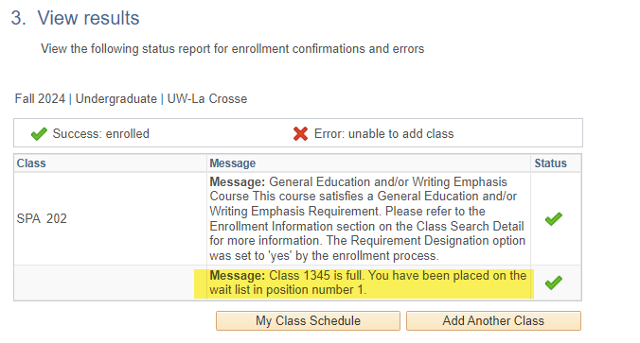

The waitlisted class will display in the Weekly Calendar view of your class schedule. It will be noted with a status of Waiting.

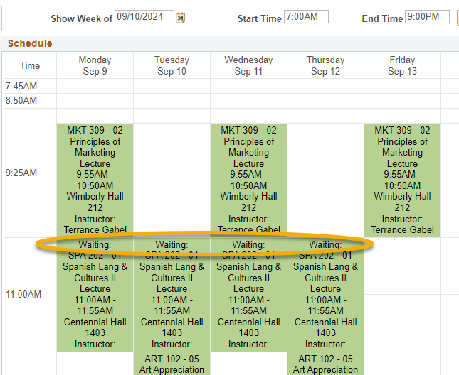

To see it on the list view, go to your class schedule and check the filters at the top to include the Show Waitlisted Classes.

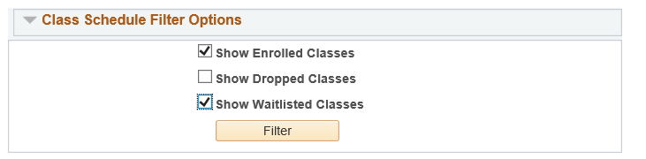

Important: you can't swap courses after the tenth day of the semester on a full semester course (shorter classes have shorter deadlines). After that time, you will need instructor, department and Deans office permission to add or swap courses, and you may receive a 'W' for the course you drop.

See the Swapping onto a Waitlist in Schedule Planner section for directions on how to swap with a waitlist. See the Waitlist FAQs for more information about how waitlists work.

