What If Advisement Report Guide

Considering switching or adding a major, minor, or certificate? The What-If Report creates a tentative academic Advisement Report using your in-progress and completed courses. The What If also allows future courses to be added so you can see how they will affect the requirements.

- In the Academics area of your Student Center, select What-If Report from the Other Academic drop down and click the arrow.

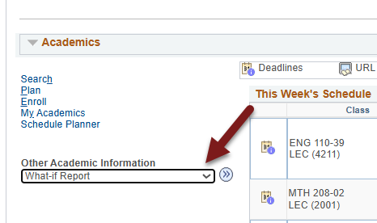

- Click on Create New Report.

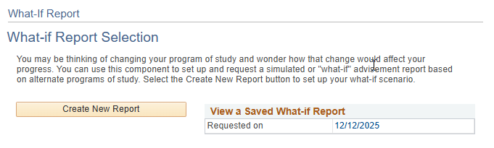
If there is a saved report, you can view it by clicking the date. It will include the classes you registered in or completed since the report was first run, using the criteria you entered originally. Only one report can be saved at a time, and it will always be the last report run. To change what majors/minors are included on the report, create a new report.

- On the Create a What-if Scenario page, the Program Scenario section defaults to your current college/school and your first three majors/minors (if you have that many).

The below sample student is currently a Chemistry major in the College of Science and Health. This student was admitted in the Fall of 2025, so the report uses the degree requirements approved for that year.

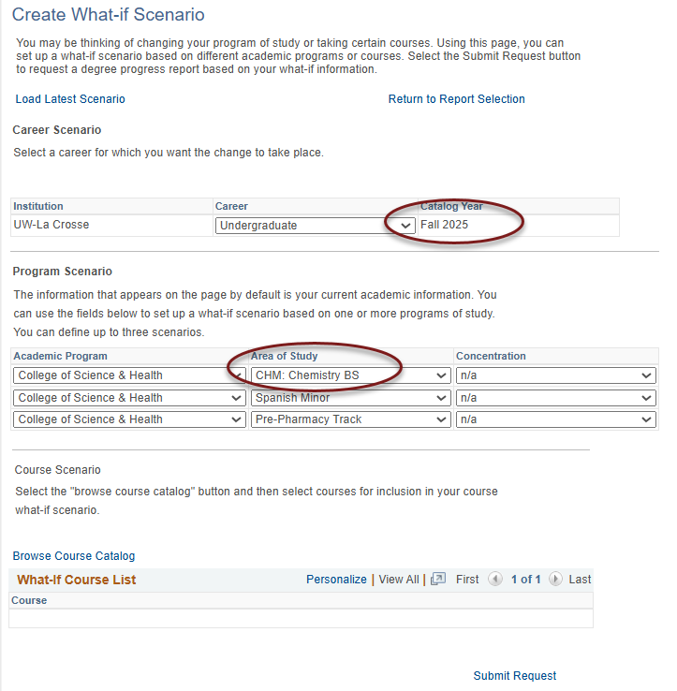

- Next, select up to three plans under Area of Study. Our sample student wants to see how a second major in Biology would change the Advisement Report, keeping the Spanish minor.
  - The Academic Program is the UWL college or school your primary major is in. The Academic Program will remain the College of Science and Health for all three lines because the primary major of Chemistry is in the College of Science and Health.
  - Your primary major always goes in the first row.
  - 2nd majors, minors, pre-professional programs should go in the next two rows.
  - The options under Area of Study are restricted to those available for that college/school. For example, no CBA majors will show up if the College of Science and Health is selected.
  - The Concentration options will always say n/a because the different emphases and concentrations are options under the Area of Study.
  - The majors/minors/programs available are based on the catalog year. Newer majors/minors may not be available if they were created after you first started at UWL. If you are aware of a new major but can't find it, contact your advisor or your college dean's office for assistance.

Changing majors/minors only:

- If you don't need to add any future courses, click Submit Request.

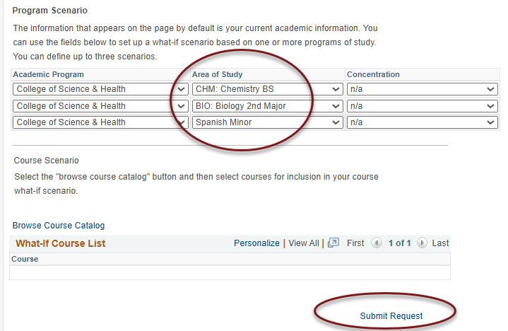

- A what-if advisement report will be generated using the majors/minors you selected. Once you have reviewed the AR, click Cancel at the bottom to return to your Student Center and start over.

Adding in future courses you might take:

- To see whether a certain course will satisfy a requirement in the AR on the What-If Scenario page, before submitted the request, scroll to the Course Scenario section and find the course using the Browse Course Catalog link.

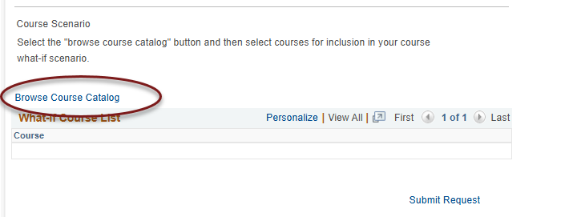

- Select the subject prefix using the alphabetical links at the top.
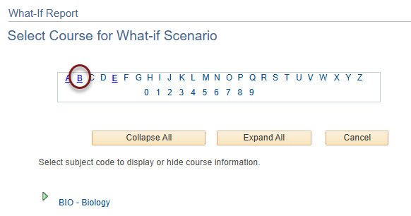

- Then click on the green arrow next to the subject to see the list of courses for that subject.

- Select the course's title to see the Course Details or click Select to add the course. Please note the typically offered information is an estimate, and courses are not guaranteed to be offered in those terms.
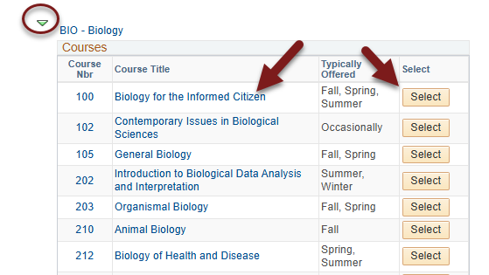

- On the Course Detail screen, use the View Class Sections to see if it will be scheduled in the next semester and learn more about the course. Note: you can't add individual sections of the course to the report.

- Click Return to Select Course for What-If Scenario to go back and select the course to add to the report.

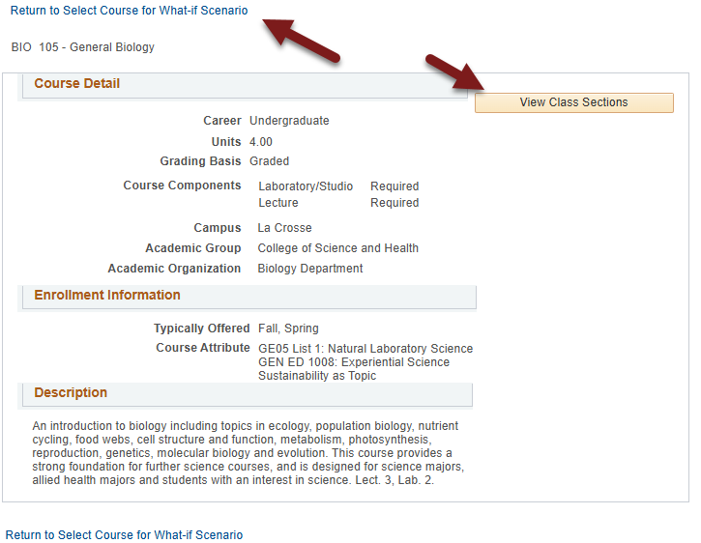

- Once selected, the course will appear on the What-If Scenario page in the Course Scenario section.

- Choose the term in which you plan to take the course. Entering the correct term helps keep track of when you plan on taking the course. However, you can run the report with the defaulted term. Important: The terms listed do not indicate when the course will actually be offered.

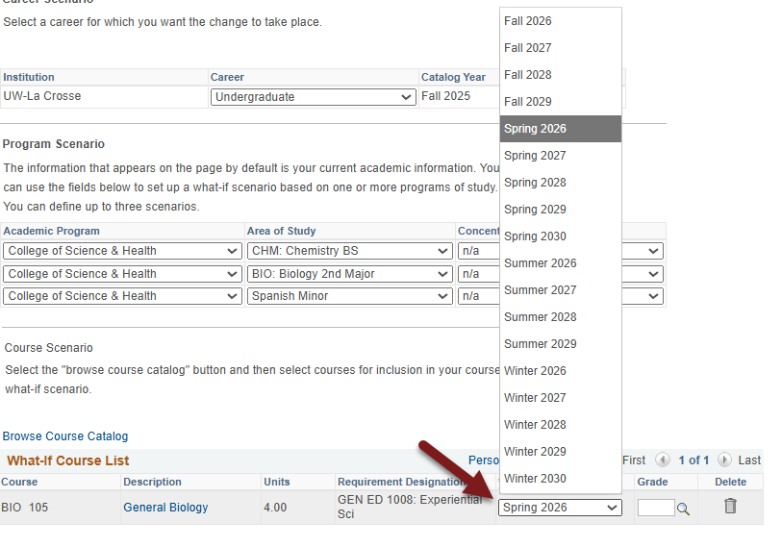

- If getting a certain grade in a class is necessary to satisfy a requirement, enter in a grade. Example: CBA students must earn a "C" or better several core courses to complete the college core.

- If needed, use the trash can icon to remove the course.

- When ready, click Submit Request. Like with the My Planner AR, if the course satisfies a requirement, that section will now appear closed. Use the green arrow to open sections if needed and see the course. A question mark is in the Status column to indicate it might be taken.

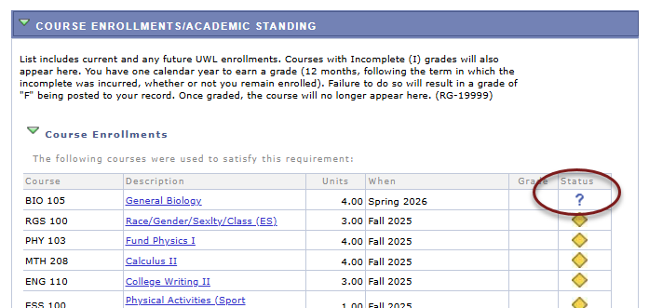

If the course doesn't meet any requirement, it will fall into the Courses Not Allocated section, which is normally a collapsed section.

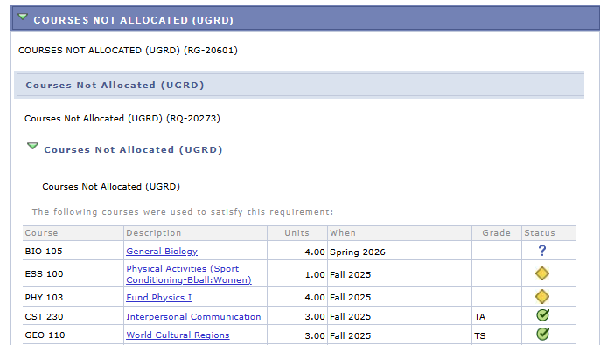

All courses in the AR fall into the Course Enrollments/Academic Standing section at the top and the first 120 credits in the University Requirements for Graduation section.

