Guide to Your

WINGS Student Center

&

Registration

  - Updated Spring 2026

Table of Contents
Update Your Personal Information 4
Request a Name in Use 8
Local Address & Emergency Contacts 9
Privacy Settings/FERPA Restrictions 12
Setting up a FERPA Secure PIN 17
Pay Your Student Bill Online 22
Guest Access to Pay Bills 23
Accept/Decline Your Financial Aid 27
View Your Advisement Report 29
Using My Planner 37
View Course Placements (and other milestones) 48
Viewing Your Term Grades & GPA 51
View Your Transcript 54
View Transfer Credit Report 57
What If Advisement Report Guide 59
Your Course History 67
Where to Find Your Current College (Program) & Major/Minor 68
How to Submit Your Intent to Graduate 69
Finding Your Registration Appointment 74
Search for Classes/Create a Schedule in Schedule Planner 76
Search for Classes/Using the Shopping Cart in Your WINGS Student Center 86
Validating Your Schedule in Schedule Planner (a.k.a. checking the prerequisites) 94
Register for a Class using Schedule Planner 97
Register for a Class using WINGS 104
Drop a Class in Schedule Planner 109
Drop a Class in WINGS 112
Swap a Class Using Schedule Planner 116
Swap a Class in WINGS 122
Class Schedule Calendar View 127
Final Exam Schedules 131
Academic Deadlines for Your Classes 133
Register onto a Waitlist in Schedule Planner 136
Swapping onto a Waitlist in Schedule Planner 140
Register onto a Waitlist in WINGS 147
Swapping onto a Waitlist in WINGS 151
Waitlist FAQs 155
Find Your Position on the Wait List 160
View Your Holds and To Do List 162
Obtain an Enrollment Verification 166
View Textbooks for Classes 168
WI Voter ID Verification 171



Update Your Personal Information

Overview
- Scroll down to the Personal Information section of your Student Center.
- Review the links on the left and click on the information you would like to update. If you don't see the item in the links, open the Other Profile Information drop-down menu and select an item. Click the double arrow Go button.

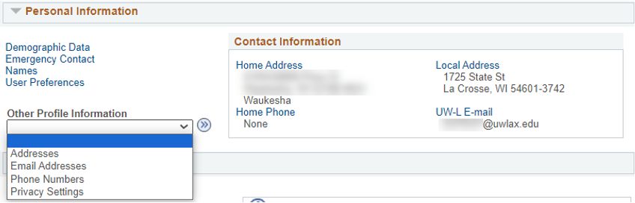

- Update your information as needed. A brief description of how to update addresses and names follows.

Addresses
UWL uses the Home and Local addresses for various purposes. The Home address is your address when you are not at school, and later, where you move to after graduation. Diplomas are mailed to Home addresses. The Local address in your address when you are at school, whether a residence hall or nearby apartment. The Local address is used when verifying voter ID.

- Select Addresses from the Other Profile Information drop down menu. Click the double arrow Go button.

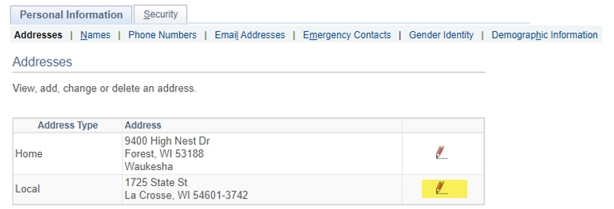

- Select the edit icon next to the address type you want to edit. Or click Add a new address to add another address type.
- Enter the updated address. You may select another country by clicking the Change Country link on the top right. This may change the formatting of how the address should be entered.
- Click the Ok button to move to the next step.
- On the next screen, make sure only the address type you are updating is checked under Address Types. The Date changes will take effect can be left as today's date.

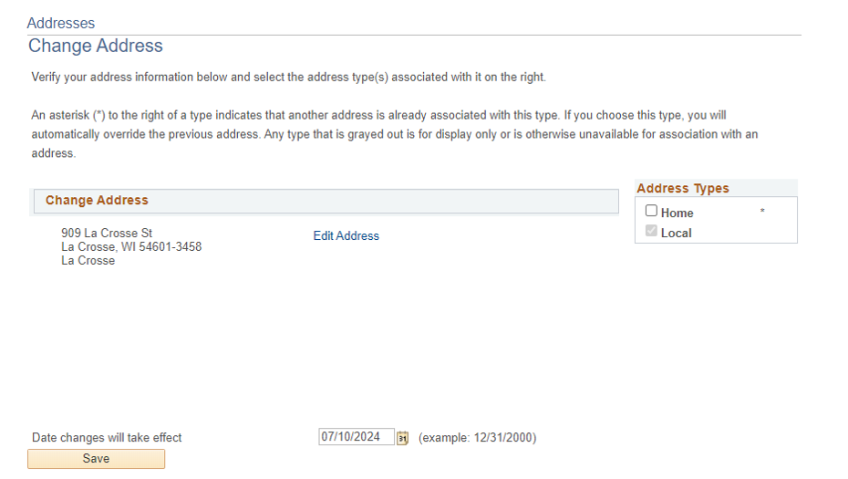

- Click save and wait for the system to finish saving.

Name
Students must provide documentation of a legal name change (or to fix a typo) to the Records and Registration office (117 Graff Main Hall) to update their legal name. However, you may add two alternative names without documentation:

- A Name in Use, sometimes called a preferred name, is the name you would like to be identified by on campus instead of your legal name. You can only request a name in use for your first name. Please note there are some situations where the use of your legal name will be necessary.

  - New applicants to UWL automatically receive a name in use if they entered a name different from their legal name in the Preferred Name/Name in Use Field on the application.
  - To request or change a name in use after starting at UWL, submit a Name in Use form. The full Name in Use policy and additional information can be found on the Name in Use website.

- A Degree name may be added to print on your diploma upon graduation. For instance, if you want your middle initial on your diploma instead of your whole middle name or visa versa, create a degree name. If you don't provide a degree name, your legal name as it is listed in WINGS will be used. To add a degree name:
  - Select Names from the link in the Personal Information section of your Student Center.

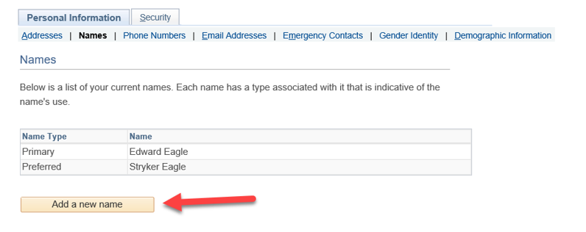

  - If a preferred name is listed, that is considered your name in use.
  - Click the Add a new name button.
  - Select Degree for Name Type. Enter the desired name as you want it listed on your diploma. The Date changes will take effect can be left as today's date.
  - Click save and wait for the system to finish saving.

Other personal information you may update through WINGS:
- Phone numbers
- Personal email address
  - Please update your personal email address if it changes, becomes deactivated, or you originally used someone else's email when applying to UWL.
  - Your personal email will be used for communication after you have graduated, such as sending you a link to your digital diploma and information from the Alumni & Friends Foundation.
- Emergency contacts
- Gender identity
- Privacy settings on how your directory information is used – details are in the Privacy Settings/FERPA Restrictions directions.

Personal information you need assistance changing:
- Legal name
- Legal sex
- Social security number
- UWL campus email address – this change can be initiated by submitting a Name in Use form.

Contact the Records and Registration Office at records@uwlax.edu or stop in at 117 Graff Main Hall if you need assistance.

Request a Name in Use

The University of Wisconsin-La Crosse recognizes that many students may use names other than their legal names to identify themselves. Any UWL student may choose to identify themselves within the university community with a Name in Use (first and/or middle name) that differs from their legal name. Students must legally change their surnames for a different surname to appear in UWL-related systems. (Legal name changes can be done by completing a Name Change Form in the Records & Registration Office and submitting the required supporting documentation.)
As long as the Name in Use is not for the purpose of misrepresentation, the Name in Use will appear instead of the person’s legal name in UWL related systems and documents except where the use of the legal name is required by university business or legal need.
In order to request that a name in use be used, students should go to the Records and Registration Office's Name in Use webpage and complete the Name In Use Form for students. No documentation other than the completed request form is needed.
The form and additional FAQs can be found on the Records and Registration website. A snippet from the form is shown below.
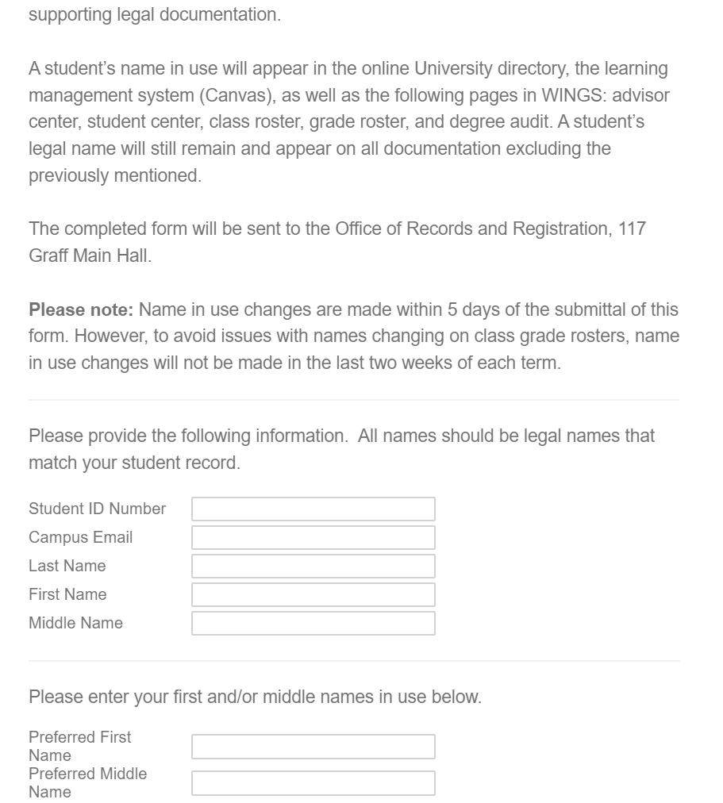
Please note that the "Name in Use" name type is labeled "Preferred" in WINGS.

Local Address & Emergency Contacts
It is important to keep your local address and emergency contact information updated and accurate. UWL requires students to review their local address and phone number once a semester while they are enrolled. A short form will pop up in WINGS at the start of the fall and spring semesters as a reminder.

Directions
- Read the directions at the top of the form.
- Scroll to the Local Address section and enter in your local address.
  - If you are staying in a residence hall, please put in your home address for your local address. Your residence hall information will be entered by the Residence Life Office.
  - If you have an apartment in La Crosse, please put in that address. When filling out address fields, you can put your apartment number at the end of your street address.
  - You do not need to put in a County.
  - If you are enrolled entirely in online courses, enter in the address where you are physically located while enrolled.

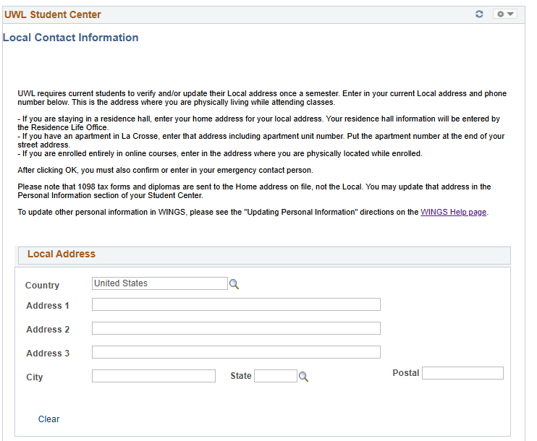

- Enter in your Local Phone number in digits only and indicate phone type. This should be your cell phone or other local number where you can be contacted directly. Please note that phone numbers and addresses are not published in the online directory.

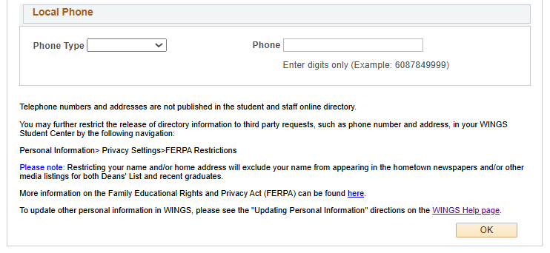

- Click the OK button. The next page is the Emergency Contact page. If no current emergency contact information is found, click the Add an Emergency Contact button and enter information for your emergency contact, including Name, Relationship, Address, and Phone. Click Save when done. If there is a contact listed and you would like to change it, click the pencil icon to edit. Make sure at least one contact is marked as Primary and then save.

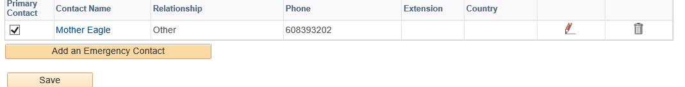

To update other personal information in WINGS, please see the Updating Personal Information directions on the WINGS help page.

Privacy restrictions
- You may further restrict the release of directory information to third party requests, such as phone number and address, in your WINGS Student Center. Use the left-hand menu to navigate to Self Service, Campus Personal Information, FERPA Restrictions. Detailed directions on how to add or update the privacy settings on your directory information is in Privacy Settings/FERPA Restrictions on the WINGS help page.
- Please note that restricting your name and/or home address will exclude your name from appearing in the hometown newspapers and/or other published listings of both Deans' List awards and recent graduates.
- The definition of directory information and the Family Educational Rights and Privacy Act is on UWL's FERPA website.

Privacy Settings/FERPA Restrictions
FERPA stands for Federal Education Rights and Privacy Act, and it governs the privacy of student educational records. The below shows how and which directory information can be restricted by the student in their WINGS Student Center.

Directions
- In the Personal Information section of your Student Center, select Privacy Settings from the drop-down menu. Click the double arrow Go button.

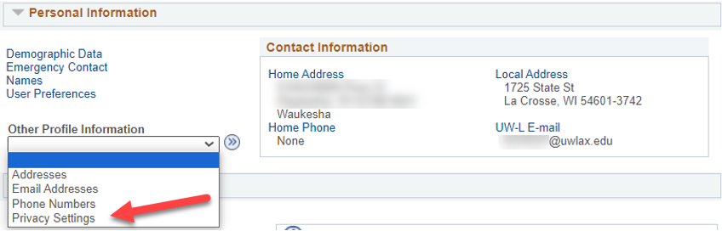

- If you already have some data restricted, that category will be listed. To restrict or unrestrict categories of data, click the Edit FERPA/Director Restrictions button.

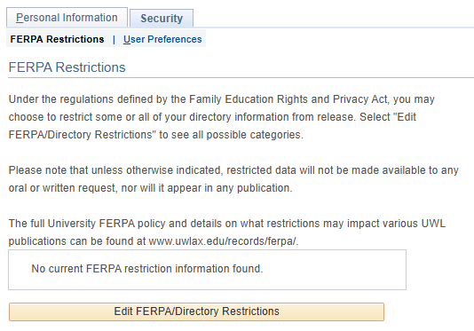

- On the next screen, you may restrict all, some, or none of the categories. To restrict all, click the Restrict All at the top of the page. To restrict some, go to each category and individually check what you want to restrict. Important: you may come back at any time and change the restrictions.

- A Release to Publication link will come up if a category is restricted; however, it cannot be used to release information temporarily or partially. If a category is restricted, it is restricted from all publications.

- Click save when done.

Considerations when restricting:

The online directory & Outlook
Your street addresses and phone numbers are not published in the online directory. Only your name in use, class level, primary major, and UWL campus email are currently published.

Restricting your primary name keeps all your information out of the online directory. However, it also means you can't be searched for in the Outlook directory or in Microsoft Teams. Also, blocking your name keeps it out of other publications, such as the Deans List, and prevents UWL from providing verifications for insurance and/or employment.

There is currently no way to block just your campus email from the online directory. You can block your name and email so they don't show together, but that means they will also not be searchable in Outlook. To make sure your name is searchable in Outlook, your name and campus and local address/email/phone must all be unrestricted. Keep in mind that street addresses and phone numbers are not actually published. You should be able to keep your home address, personal email, and home & cell phone restricted if you choose. However, please note restricting those may impact other publications.

Commencement
Both your primary/legal and degree names must be unrestricted for your name to be printed in the commencement program. The Degree Candidacy, Degree/Credential Earned, and Honors and Awards categories must also be unchecked. This must be done before April 1st for May Commencement, and November 1st for December Commencement to make it in time for printing. Commencement programs cannot be updated after they are printed.

In addition, if you'd prefer your Name in Use to be printed in the program, please add a Degree name.

Hometown newspapers, Deans Lists, & graduation announcements
Both your primary/legal name and home address must be unchecked for your information to be published in your hometown newspaper or to be published on UWL's website for the Deans List. The Honors and Awards category must also be unchecked for the Deans List publications. This should be done within two weeks after final grades are due to be included in these publications. Please note that most lists cannot be updated after being published.

Insurance, loan, and potential employer verifications
Your primary name and the related academic information categories must be unchecked for the information to be released to a third party. Academic information that is sometimes requested by these parties includes Attendance or Enrollment Dates, Enrollment Status, Programs of Study (a.k.a. your major), Degree Candidacy, Honors and Awards, and Degrees earned.

Having everything restricted
Any third party who calls, aside from exceptions within the law, will not be able to obtain any information about you, including whether you attended UWL.

No information will be included in publications such as online directories, newspapers, or the commencement program. No information will be released to potential employes, loan or insurance companies.

For current students, their names will not be searchable in Outlook or Teams, although their email will still be active, usable email addresses.

Having nothing restricted
Your campus email and major are published in the online directory and may be released upon request, along with any other directory information requested. Your photograph may be used in publications. Your name will be published in Deans' List and graduation lists, if applicable.

What will never be released without your consent
Your grades, academic standing, GPA, probations and/or ineligibilities, applications, tuition and billing, financial aid, non-academic disciplinary actions, and medical (HIPAA) information will never be released without your official authorization, except for specific exceptions required by law.

Authorizations to release restricted information
If you would like to keep categories restricted but also want UWL to release them for a specific situation, provide written authorization is required to release it. The written authorization or release should specify who the information can be released to, the date the release was signed, and what information exactly may be released. Written authorizations are treated as one-time authorizations This permission to release should be sent to the Records and Registration Office.

To make a release of information permanent, go into your WINGS Student Center and uncheck the category. If you are no longer a student at UWL, contact Records and Registration.

UWL's FERPA policy

FERPA restriction categories
- Addresses
  - Campus
  - Home
  - Local
  - Permanent
- Email Addresses
  - Campus
  - Personal
- Names
  - Degree
  - Former
  - Primary
- Phones
  - Campus
  - Cell
  - Home
  - Local
- Photograph
- Academic Information
  - Attendance Dates
  - Degree Candidacy
  - Degree/Credentials Earned and Date Awarded
  - Enrollment Dates
  - Enrollment Status – full time or part time
  - Honors and Awards – Deans List and graduation honors
  - Official UWL Sports/Activities participation information
  - Previous Institutions attended
  - Program(s) of Study – your major/minor or graduate program
  - Student Athlete Physical Factors

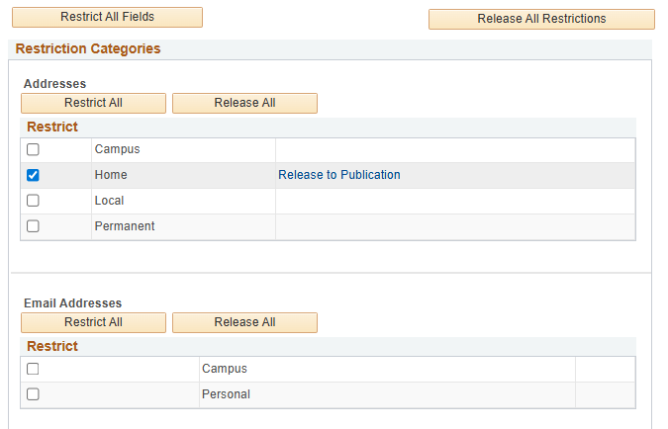
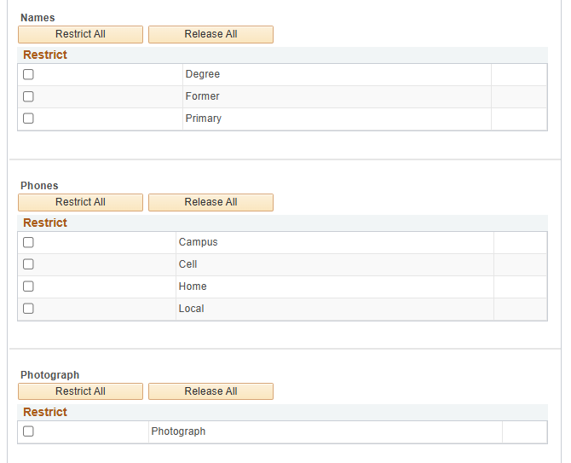
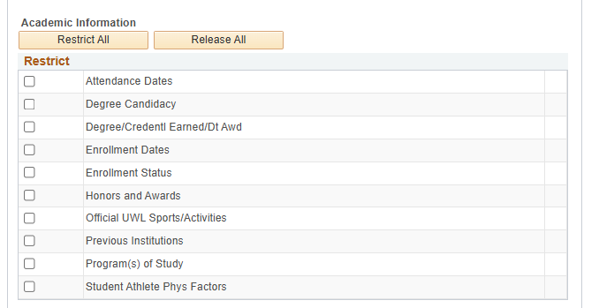

Setting up a FERPA Secure PIN
Your student records are confidential and protected under the Family Educational Rights and Privacy Act (FERPA). To comply with FERPA, students must verify their identity when contacting UWL offices and discussing personal and confidential information. Students visiting UWL offices may be required to provide a photo ID. Students contacting UWL offices remotely, such as through a phone call, will need to provide their student ID number and a six-digit FERPA Secure PIN number which is available in the student's WINGS account.

In addition, UWL staff cannot release your student records and financial account information to your parent, guardian, sponsor, or third-party designee without your prior formal consent. However, you may set a FERPA Secure PIN to allow UWL staff to release your personal information to a third-party designee, i.e., anyone who has your name and can provide the FERPA Secure PIN assigned to them. Please note that campus offices are not required to release your personal information to a person providing the PIN, but they may do so. This FERPA Secure PIN system protects your student records and complies with FERPA.

The FERPA Secure PIN does not grant the guest access to:
- View or discuss course grades
- View or discuss the student's current schedule of classes
- Sign documents or forms on behalf of the student

Tuition payments: Students may provide parents or guests a way to pay tuition through CashNet without accessing WINGS. The UWL Cashiers office has posted directions on how to create guest access to CashNet.

Important: Please be careful with whom you give a Secure PIN as you are choosing to release confidential information about your personal records.

Your Personal FERPA PIN

Creating your first PIN
- Login to your WINGS Student Center.
- Select UW-La Crosse from the left-hand menu.
- Select FERPA Secure Pin.
- Select Set/Update FERPA Secure PIN.
- The Terms and Conditions statement for the FERPA Secure Student PIN are:

I understand and agree that by providing my FERPA Secure Student PIN and student ID number to staff at UWL, I am verifying that I am the student assigned this FERPA Secure Student PIN and student ID number. Anytime I wish to change my FERPA Secure Student PIN, I can do so by logging into my WINGS account and manually changing my FERPA Secure Student PIN.

- Check the box next to I Accept These Terms if you agree to this statement. If you do not agree, stop here and do not create a PIN.
- A new section will appear with your name and Campus ID number. Click Set PIN.
- A 6-digit number will generate and appear next to the PIN label.

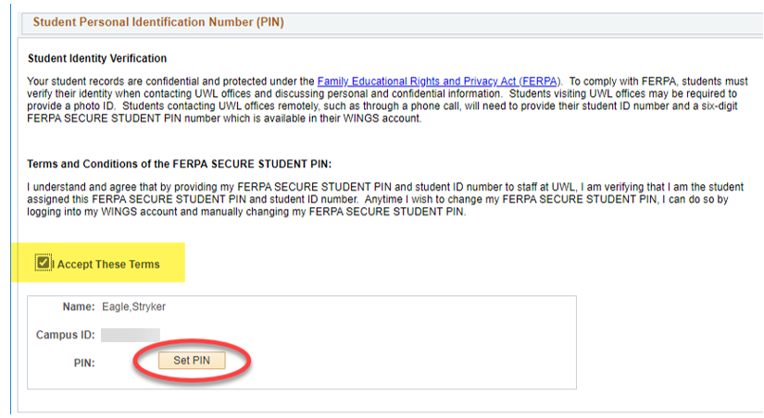

- Scroll down to the bottom of the page and click save.

Updating your PIN
If you feel your number is no longer secure (e.g. someone else may be using the number), you can generate a new PIN. Login into your WINGS Student Center and navigate to the Set/Update FERPA Secure PIN page. Click Set PIN again and then save. The old PIN will no longer be accepted by UWL offices.

Additional info
The FERPA Secure PIN can be changed at any time by current students. Students should not share their personal FERPA Secure PIN with anyone. This is used to authenticate the individual student's identity only.

Along with your campus ID and name, your FERPA Secure PIN will help identify you to staff members and allow them to release information to you. If you do not create a PIN for yourself, when you contact those offices, they will instead ask 1) for your campus ID and name; and 2) two or more other pieces of personally identifiable information such as classes you are or were enrolled in and other information from your record that will help identify you. If you come in person, they will ask to see a photo ID instead.

Former students
After you have graduated or left UWL, your FERPA Secure PIN is no longer available, and you must verify your identity using your campus ID and other pieces of information.

To create a PIN for another person to use, see the directions on FERPA PIN for Guest.

FERPA PIN for Guest/Parent

Creating a Guest PIN
- If you are already on the FERPA Secure PIN page in WINGS, scroll down to the Guest Personal Identification Number section. If you are not in WINGS yet,
  - Login to your WINGS Student Center.
  - Select UW-La Crosse from the left-hand menu.
  - Select FERPA Secure Pin.
  - Select Set/Update FERPA Secure PIN.
  - Scroll down to the Guest Personal Identification Number section
- The Terms and Conditions statement for a guest FERPA Secure PIN are:

I understand and agree that when my FERPA Secure PIN and name are provided to staff at UWL, it indicates the following:
- That I have granted permission for staff at UWL to share one or more of the following information with the holder of this FERPA Secure PIN:
  - Information about my tuition, fees and financial aid
  - Information found in my academic record, with the exception of current schedule of classes and all course grades.
- That this action will not permanently remove any FERPA block I may have for other purposes; however, it does indicate my desire for UWL staff to override the FERPA block and communicate with the holder of my FERPA Secure PIN each time contact is made.
- That anytime I wish to rescind this permission, I can do so by logging into my WINGS account and manually change my FERPA Secure PIN.
- That after changing my FERPA Secure PIN, I must provide my new FERPA Secure PIN to anyone with whom I wish to grant access to the information described above.

- Check the box next to I Accept These Terms if you agree to this statement. If you do not agree, stop here and do not create a PIN.
- A new section will appear with the option of creating PINs for up to three individuals. Enter your guest's name in the box next to Name.
- Click Set PIN. A 6-digit number will be generated and appear next to the PIN label.
- Check one or both boxes labeled Finances and/or Academic Records.

  - Finances: May discuss account charges and payments, financial aid disbursements, and enrollment status as it relates to your financial obligations to UWL.
  - Academic Records, with the exception of current schedule of classes and all course grades: May discuss application status, placement information, transcript status, test score status, enrollment, progress toward degree, academic standing, etc.
  - IMPORTANT: The FERPA Secure PIN does not grant access to:
    - Course grades and current schedule of classes
    - The holder party to sign documents or make decisions/changes on a student behalf

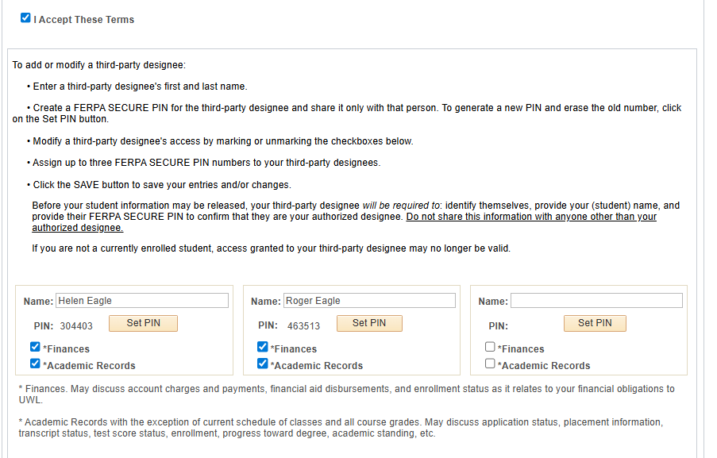

- If more than one person needs a PIN, repeat steps with the next Name field.
- Scroll down to the bottom of the page and click save.
- Contact your guest(s) and give them the FERPA Secure PIN generated. Before your student information may be released or discussed, your guest will be required to: identify themselves, provide your (student) name, and provide their FERPA Secure PIN to confirm they are your authorized designee. Do not sure the PIN with anyone other than your authorized designee.

Updating Guest PINs
You may change the FERPA Secure PIN any time while still a current student. Examples of reasons to change or remove the PIN are:
- You feel the PIN is no longer secure (e.g. someone else may be using the number)
- You no longer want the guest's to have access to discuss your records/account.

Generate a new PIN by coming back to the Set/Update FERPA Secure PIN, selecting Set PIN again next to the name that you would like to update, and click Save. The old PIN will no longer be accepted by UWL offices. To deny access, you may also remove the person's name. Always remember to click Save.

If you are no longer a student at UWL, access granted to your guest may no longer be valid.

Directory information restrictions vs FERPA secure PIN access
When a student gives a FERPA Secure PIN to a parent or other third party, that permission overrides any directory information restrictions that already exist. Directory information is information designated as public by the university, and it can be released by the institution for any purpose, at its discretion. For directions on how to restrict directory information, please see Privacy Settings/FERPA Restrictions on the WINGS Help page.

Please note that UWL offices are not required to release information to the third party providing the FERPA Secure PIN, but may do so.

Pay Your Student Bill Online
- Login to your WINGS Student Center. Scroll down to the Finances section.
- Click the Make a Deposit/Payment link.

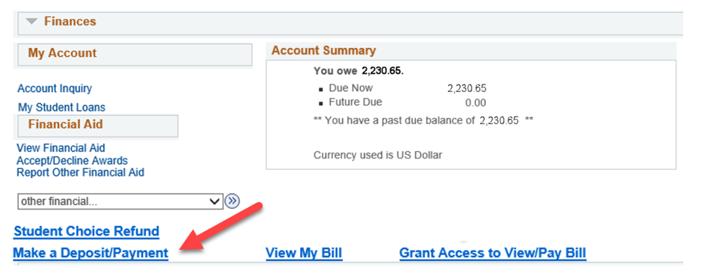

- A new window will pop up. Secure payments can be made through this page. (If a window or new tab does not pop up, you may have a pop-up blocker on. Check the settings on your internet browser and then try again.)

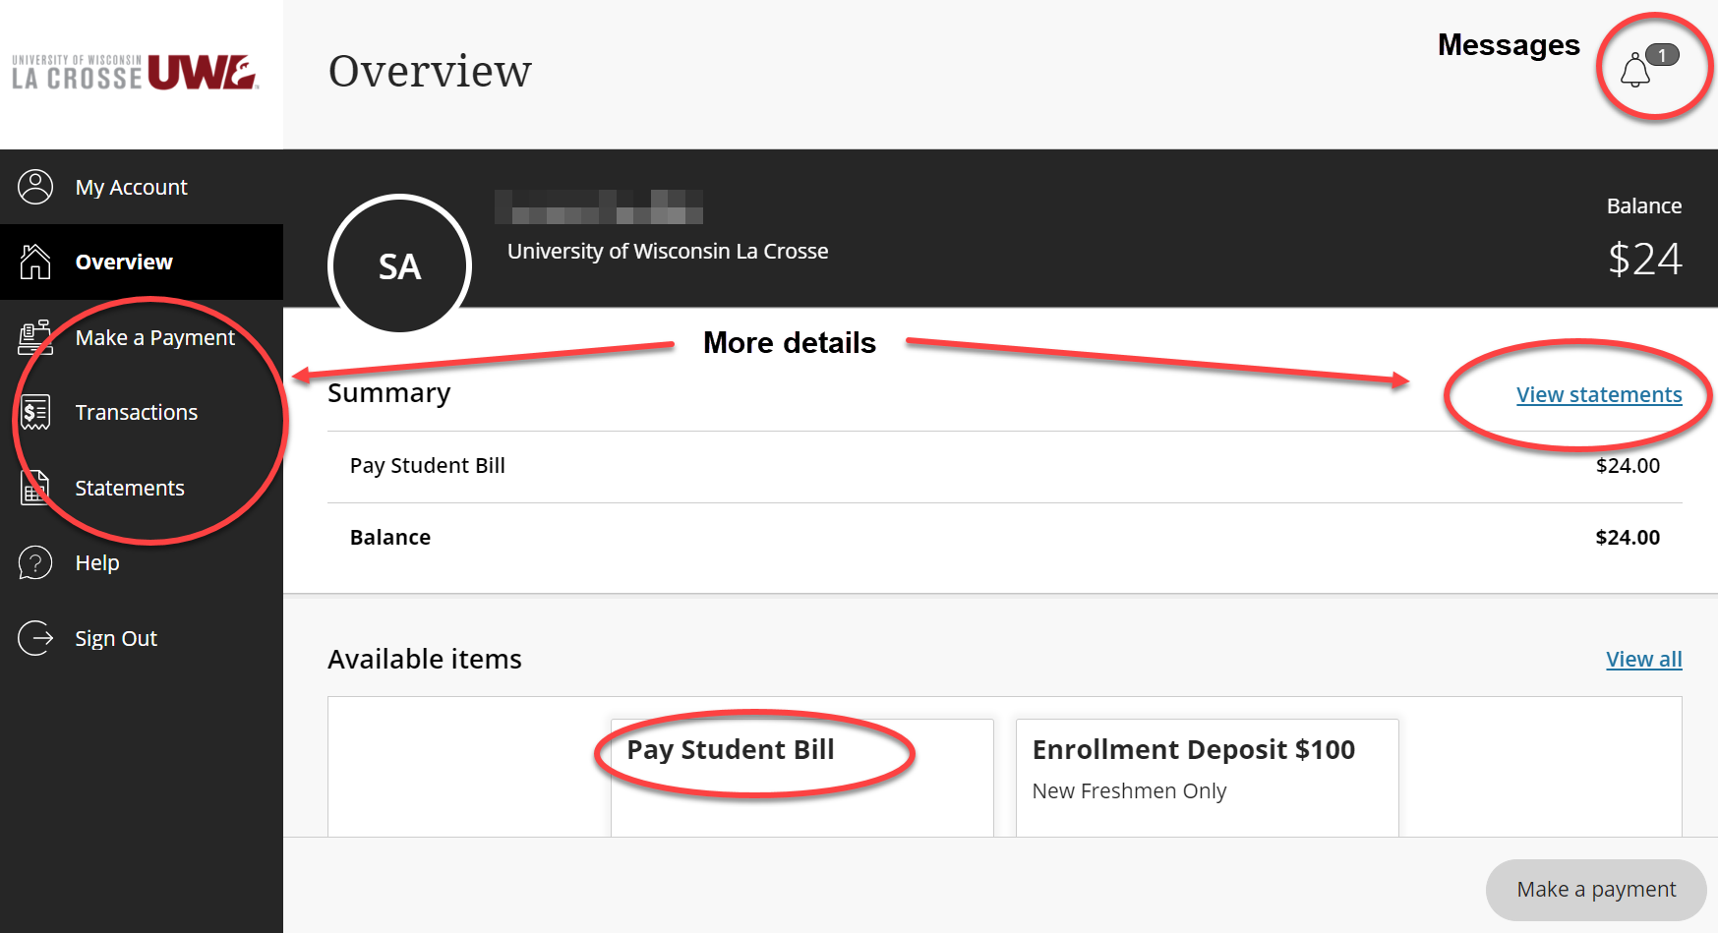

More information can be found at:
- Billing information
- Other payment options

Guest Access to Pay Bills
Bills can be paid electronically by a parent, guardian, or spouse if they are made an authorized payer in Cashnet. Follow the below steps:

Adding a Payer
- Login to your WINGS Student Center. Scroll down to the Finances section.
- Click the Grant Access to View/Pay Bill link.

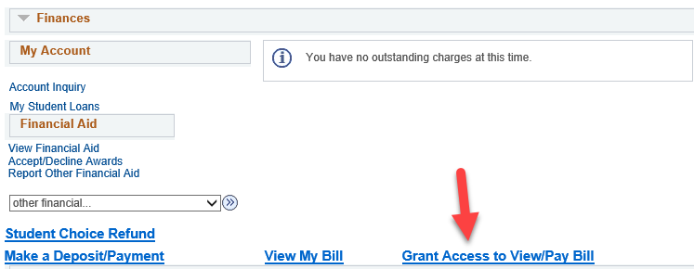

- A new window will pop up. Secure payments can be made through this page. (If a window or new tab does not pop up, you may have a pop-up blocker on. Check the settings on your internet browser and then try again.)
- Click My Account in top left.

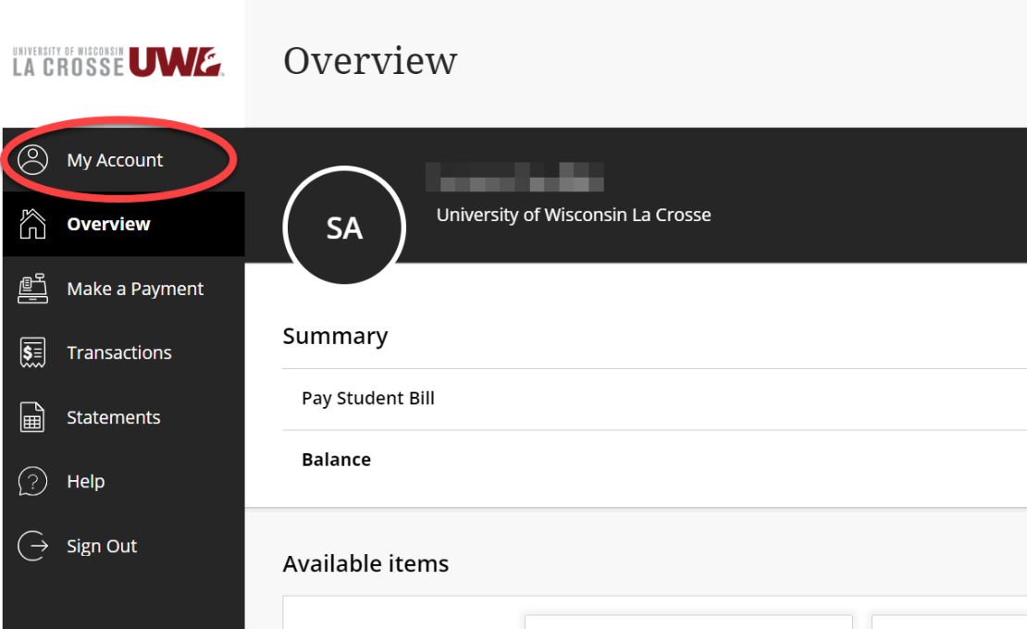

- On the next screen, scroll to the Payers section and select Send a payer invitation.

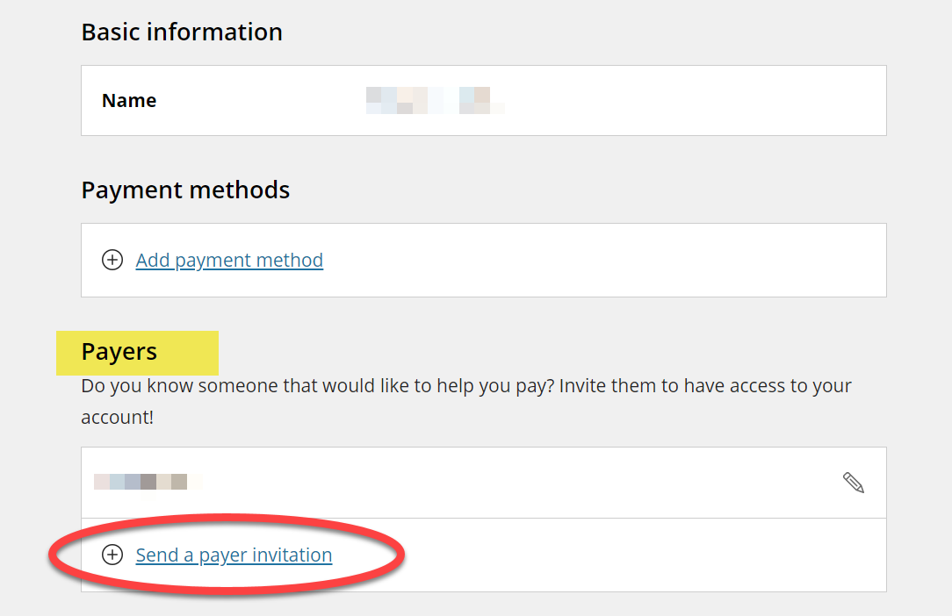

- Enter in their first name, last name, and email address. Re-enter their email address to confirm and add an optional message to be sent to the person you are adding. Check the box next to Allow access to statements, which confirms your authorization for the payer to have access to your account and/or make payments. Then select Send Invitation.

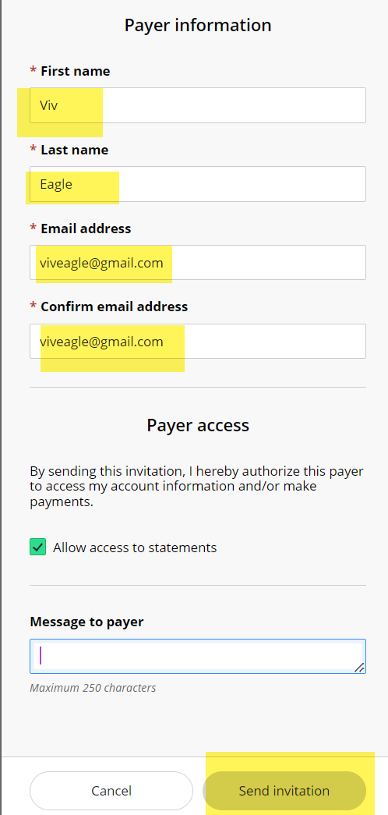

- The Payer will receive an email with their username and password with a link to log in to the system. Be sure to alert your authorized payer that you created a login for them and to look for the email with their password.

Please note this account grants access to your bill and to make payments in Cashnet. It does not give access to financial aid, grades, or other student information in WINGS. To give broader access to a guest or parent, create a guest FERPA PIN for them so they can discuss details with UWL staff. See Setting Up a FERPA Secure PIN directions, the section on setting a FERPA PIN for a guest/parent.

Reset Payer's Password
- If they need their password reset, you (the student) will need to reset the password by logging back in to Cashnet following the steps above and clicking My Account. Select the edit button next to the existing Payer whose password needs to be reset.

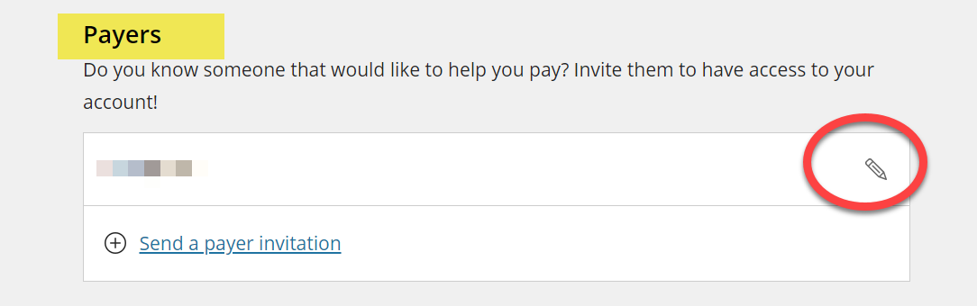

- Select Resend payer invitation. This also resets the password, and they will receive a new email with password. Save.

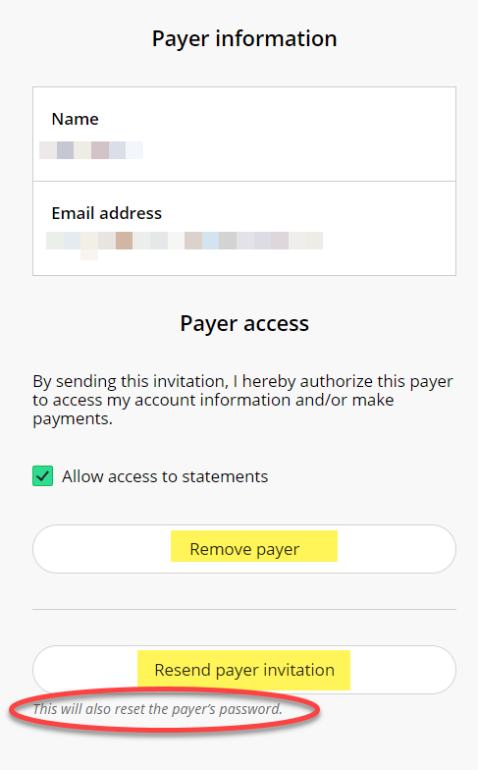

Remove Payer
- To remove a payer from being able to access your account or make payment on your behalf, log in to Cashnet using the Grant Access to View/Pay bill link in your WINGS Student Center. Select My Account in the left-hand menu.

- Select the edit button next to the existing payer whose password needs to be reset.

- Select Remove payer.

Please note this removes access only to your bill and making payments in Cashnet. If you gave a guest or parent access to discuss financial aid, grades, or other student information with UWL staff through a FERPA Secure PIN, that must be removed or updated separately. See Setting Up a FERPA Secure PIN directions.

Cashier's Office
More information about billing can be found on the Cashier's website.

The Cashier's Office is located in 121 Graff Main Hall.
Email:
cashiers@uwlax.edu
Phone: 608.785.8719

Accept/Decline Your Financial Aid
- Scroll down to the Finances area of your Student Center.
- Click the Accept/Decline Awards link in the Financial Aid list.

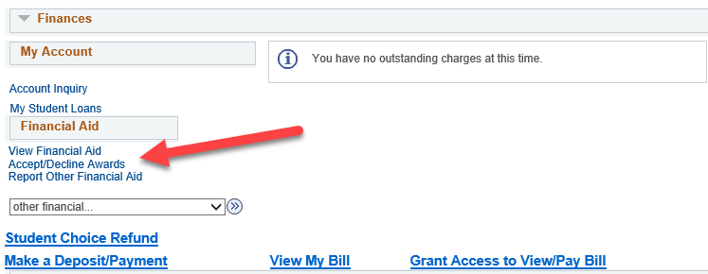

- You may encounter an Electronic User Consent agreement. By clicking OK and agreeing, you are giving UWL permission to conduct business with you electronically. You are also authorizing UWL to make a payment on your account with Title IV Federal Financial Aid funds for certain educationally related goods and services provided by the institution. Financial Aid will not pay late fees, finances charges, or athletic charges. If you choose to opt out of using Federal Aid for educationally related goods and services, you will need to contact the Cashier's Office. Students who are incarcerated in a state or federal correctional institution are not eligible for aid and are required be federal law to inform the Financial Aid Office of their incarceration. Please review your additional financial aid rights and responsibilities.

- Read through the agreement and either click ok to agree or cancel. If you have questions about the agreement, please email Financial Aid.

- If you click OK, next click on the appropriate Aid Year link.

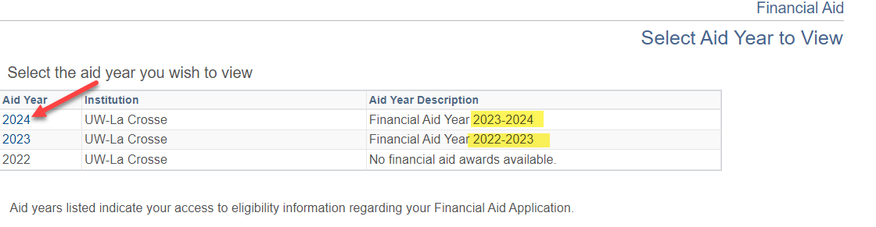

- Check either Accept or Decline next to each award and click Submit.

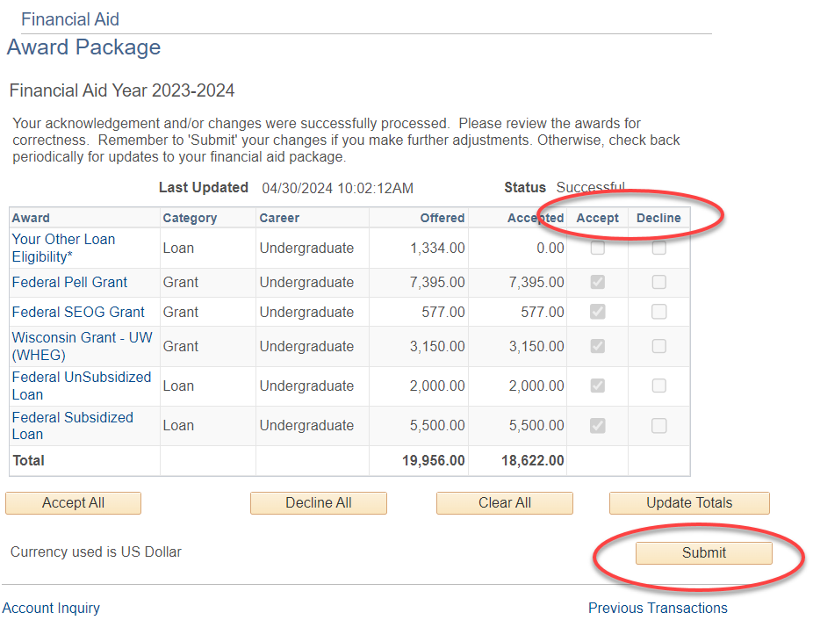

How to apply for financial aid
The first step in applying for financial aid is to complete the Free Application for Federal Student Aid (FAFSA). Be sure to include UWL’s school code (003919) on the FAFSA. Once UWL receives the FAFSA, the Financial Aid Office will send the student an e-mail as to whether they need additional documentation.

Where to find more information
A helpful guide to your financial aid offer can be found online, along with some tutorial videos and information about your cost of attendance.

The Financial Aid Office is located in 215 Graff Main Hall.
Email: finaid@uwlax.edu
Phone: 608.785.8604

View Your Advisement Report
The Advisement Report (AR) in WINGS provides you with access to your degree requirements, including general education, major, and college requirements. This report shows what requirements you have satisfied and what still need to be completed to earn your degree.

How to Access
- In the Academics area of your Student Center, select the My Academics link. Alternatively, you can also select Advisement Report-AR from the Other Academic Information drop down.

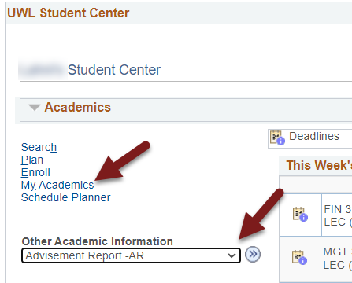

- The My Academics tab will be selected. Next to Academic Requirements, click View my advisement report.

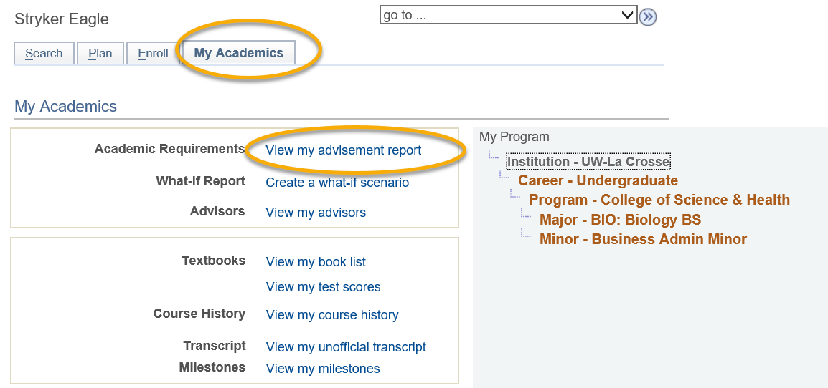

Navigating your Advisement Report (AR)

Collapsing/Expanding
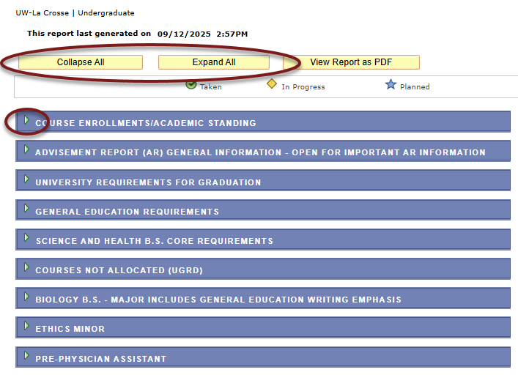
The AR is organized into collapsible sections. Sections contain collapsible sub-headings that categorize requirements. Requirements specify what a student needs to complete to satisfy degree requirements.

To individually expand or collapse a section, click the Expand Section arrow on the left of the section name. All arrows toggle between collapsing and expanding the section. If they point to the right, selecting them expands the section. If they are pointing down, selecting them collapses the section. You can also use the Collapse All and Expand All buttons at the top of the report.

The sections are organized by current course enrollment, university requirements, general education requirements, college/school core, courses not allocated, major, minors, certificates, honors, and pre-professional tracks.

Satisfied vs Not Satisfied
By default, expanded sections contain components with unsatisfied requirements while collapsed sections contain requirements that have been completed.

If a requirement starts with "Not Satisfied," you have not finished that requirement yet. If it starts with "Satisfied," you have completed that requirement.

However, it is possible for a section to be Not Satisfied but also collapsed, if you have closed it manually by clicking on the Collapse section arrow. Sometimes that is useful so you can focus on just one requirement at a time. To reset everything to the default, you will need to go out of the page and re-run the report.

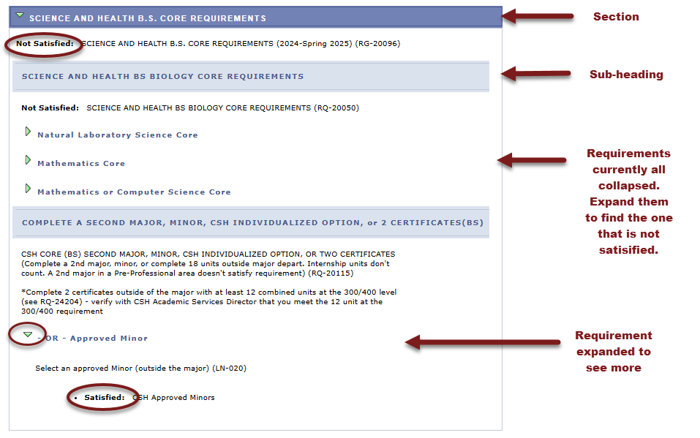

Sections

Course Enrollments/Academic Standing
This section contains currently enrolled courses, pre-registered courses for the next term, and your academic standing.

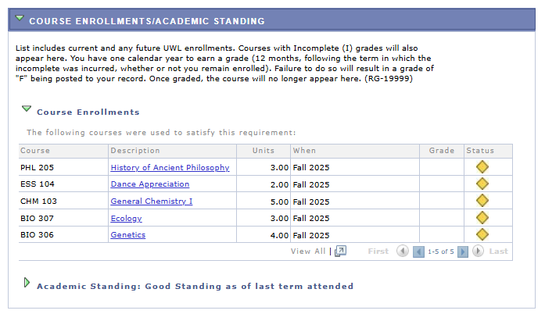

Advisement Report (AR) General Information
This section contains an explanation of the What- If AR, a note to second degree & non-degree students, and an explanation of the Courses Not Allocated section found farther down the AR. There may occasionally be other news pertaining to the AR listed in this section.

If you find errors on the AR, please report them to the your Dean's office.

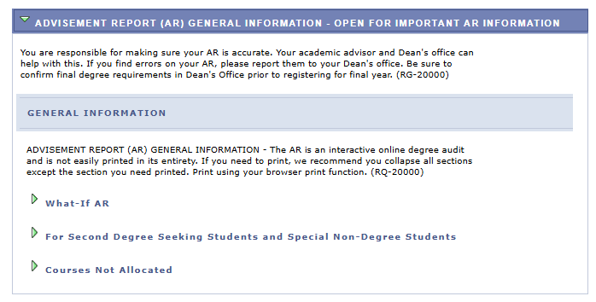

University Requirements for Graduation
The components in this section are required by the university for graduation. The green checkmark symbol denotes a completed or graded course (a.k.a. Taken). The yellow diamond symbol denotes an in-progress course.

Important: The blue star symbol denotes a planned course that has not been taken or enrolled in yet. This symbol only appears in the My Planner Advisement Report. The regular AR always shows the most up to date status of your requirements, so it is best to refer to that report each semester to ensure you are making progress as expected. The start of these directions shows how to get to the regular Advisement Report. Directions on the My Planner report are separate.

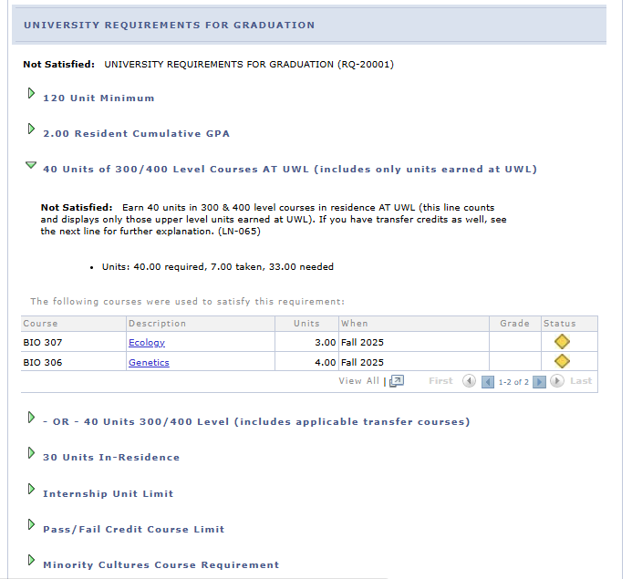

General Education Requirements
This section has several subsections that list the courses needed to satisfy each General Education category.

Use the navigation options at the bottom, right corner of class lists/course grid to view more of the available courses that are not displayed (by default the first 10 courses appear in a list). To view all on one page, click the View All link. To view more course details, click the course description/title link.

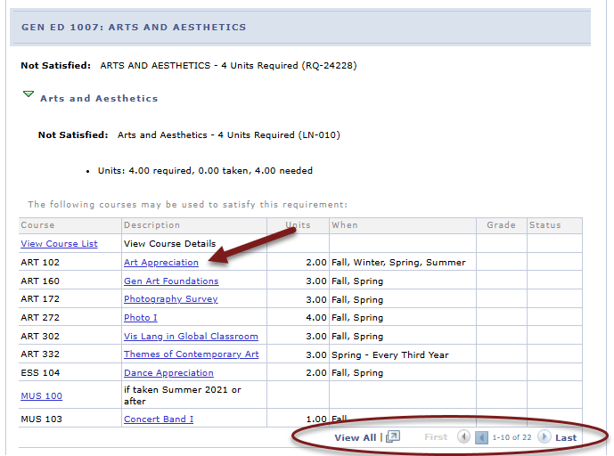

The course details include full course description, when the course is typically offered, course attributes, and any prerequisites.

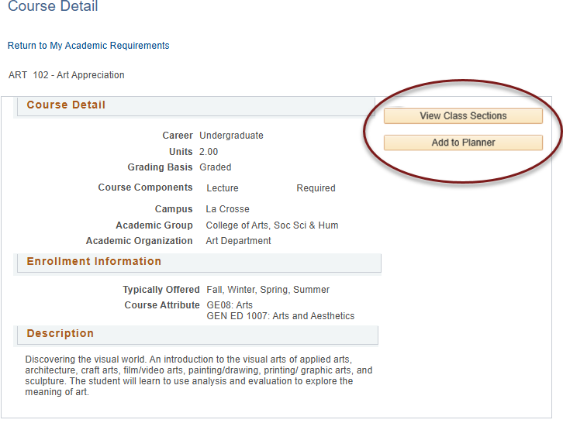
The course details also let you view the schedule to see if that course is being offered in the current or near future. Click View Class Sections to see if the course is scheduled. You can then decide whether to add the course to My Planner. The planner allows you to select courses based on your major/minor/degree requirements so you can plan your future academic schedule. You can plan one term, a year or your entire academic career using the planner. You can register using courses in My Planner later. See the My Planner directions for more planner details.

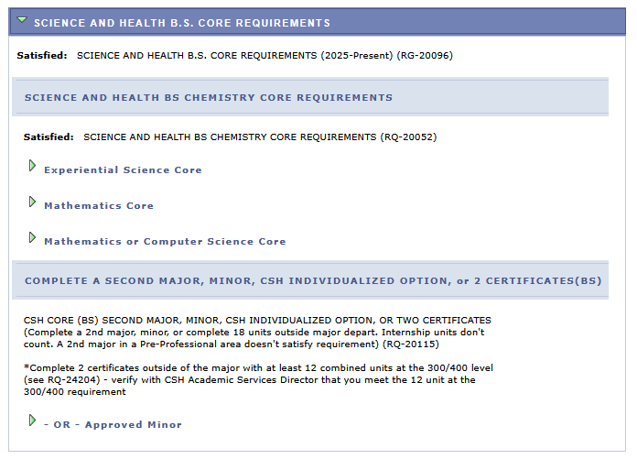
College or School Core Requirements

This section is related to your college or school's core requirements for graduation. Your college/school oversees your first major. In the example below, the student is a computer science major which is housed in the College of Science and Health.

Courses Not Allocated

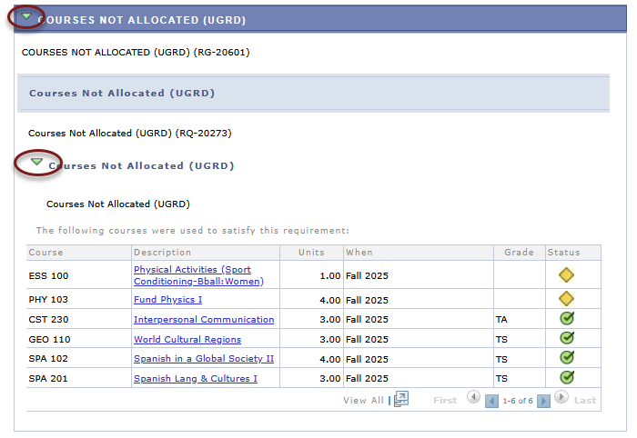
This section lists courses not used elsewhere in the Academic Requirement Report. For example, the grade may not have satisfied the minimum requirement, the student may have withdrawn or failed the course, or the course may have exceeded the number of hours needed for electives.

This section starts out collapsed. Click on the arrows to expand and see what courses are in this section.

Major and Minor Requirements
These sections include any major and/or minors you have declared. The following is a partial example of a computer science major. The major requirements are shown collapsed but are not satisfied. Click the arrows to expand the section details.

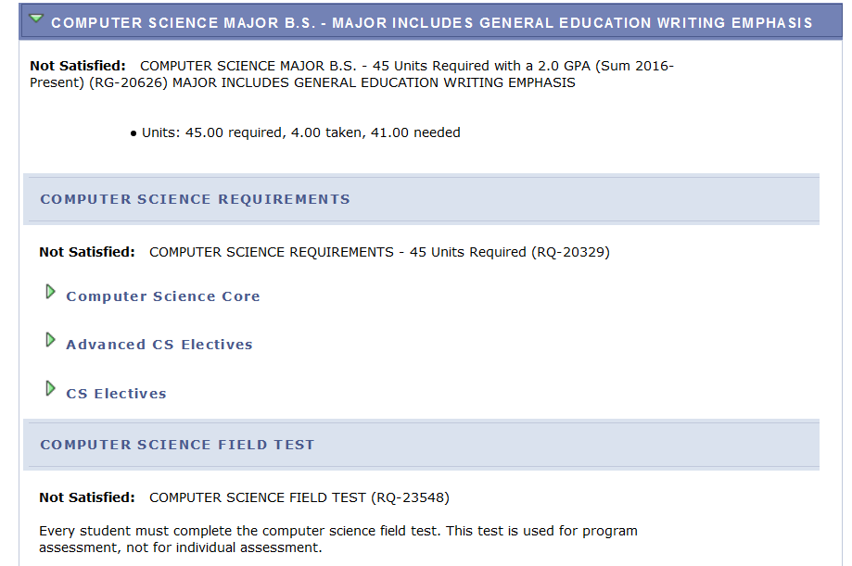

Pre-Professional Tracks/Other
Additional sections/requirements might appear, based on your college and situation, including pre-professional advising sections and individualized options taking the place of minors. As another example, students in CSH that have not yet declared a major will see a CSH 60 Units message.

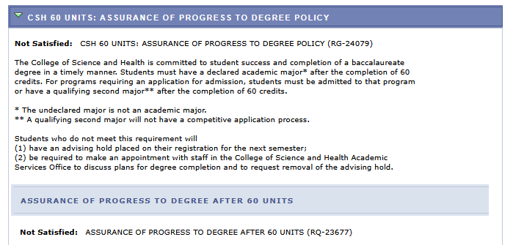

Using My Planner

My Planner allows students to map out what courses to take, term by term, using the requirements from the Advisement Report. It also connects to Schedule Planner so that students can add a planned course into their schedule during the appropriate term.

Important: the Advisement Report in My Planner closes requirement sections once a course has been added to your plan. However, the regular Advisement Report does not close that section until after you have actually registered into the course. It also shows the most up to date information about grades and credit totals. Thus, to avoid forgetting to register into the course and make sure you know what requirements are left, check your regular Advisement Report every semester as well. Directions on using the regular Advisement Report are separate.

Add Courses to My Planner

- To get to the Planner, click the Plan link in their Student Center. Or select Academic Planner from the dropdown.
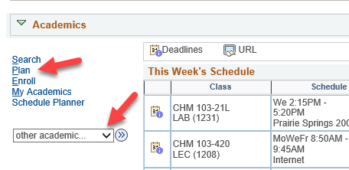

- Click the Plan By My Requirements. This is the My Planner Advisement Report, a copy of your regular Advisement Report where you can select courses from what requirements still need to be met.

Tip: Remember to remove courses from My Planner after enrolling or completing the class to avoid the course showing in the report twice, which can throw off credit totals.

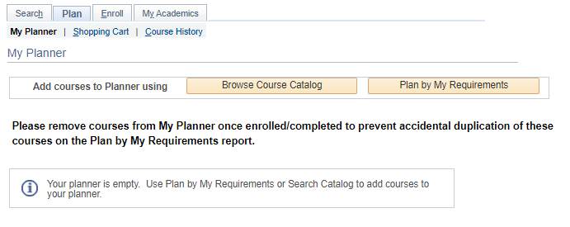

- Scroll through the Advisement Report to find the sections marked Not Satisfied. A list of courses will be displayed that will go toward that requirement. Click on the course title that you want to use to complete the requirement.

- Review the Course Details, including the Enrollment Information which will include prerequisites if any and the course description.
  - Click on View Class Sections to find out if any sections are being offered in the upcoming term. A section will open up below.

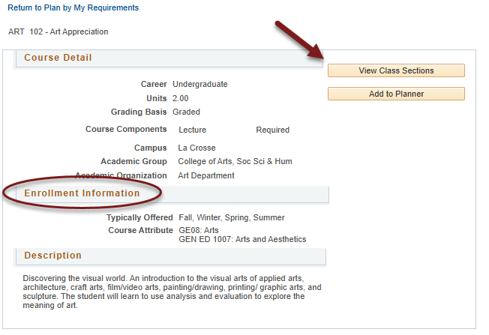

  - Be sure to look at the Terms Offered menu to see what terms are available. You can change terms by selecting another one and clicking Show Sections.

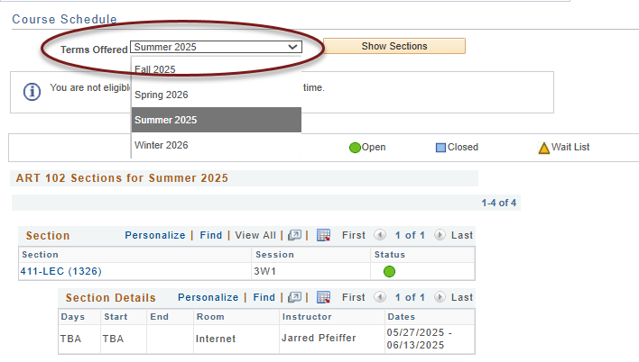

  - To estimate whether a class will be offered in a future term not available yet, review the Typically Offered information. Please note that the typically offered information is an estimate from the department on the next time the course will be offered, but it is not guaranteed.

- Scroll back to top of page and click Add to Planner if you'd to add that course to your plan.

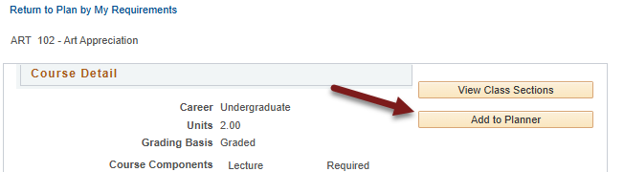

- A confirmation message will display at the top saying the course was added to your planner

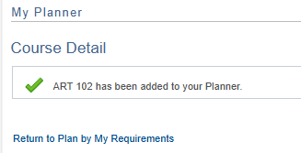

- To add additional courses, select Return to Plan by My Requirements and repeat the steps.

- To move courses to specific term, return to the My Planner screen using the My Planner tab at the top.

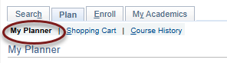

- After being added to the planner, courses are listed as Unassigned. Select the course using the checkbox, and then select the appropriate term from the "move selected courses to Term" dropdown menu. Click Move.

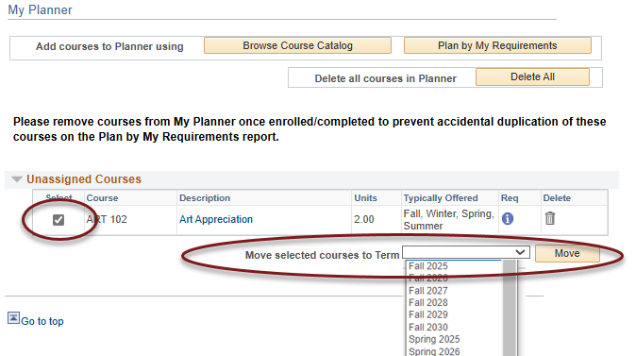

- You'll see a confirmation message that your move was successful and the course listed underneath the term.

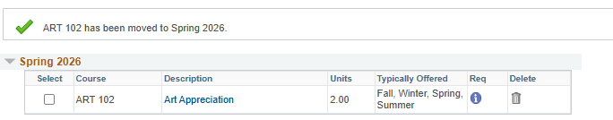

- After adding all the courses to your Planner, click the Plan By My Requirements to see the My Planner Advisement Report with these courses added. If the course satisfies the requirement, that section will now be closed. Click on the arrow to expand the section and review. The course will display with a star in the Status and act as a marker to satisfy a requirement even though the course has not been taken yet. If the course has been assigned to a term, the planned term will display in the When column.

Important: Your regular Advisement Report does not show your planned courses (courses with a blue star). Only the Plan By My Requirements/My Planner Advisement Report will include them.

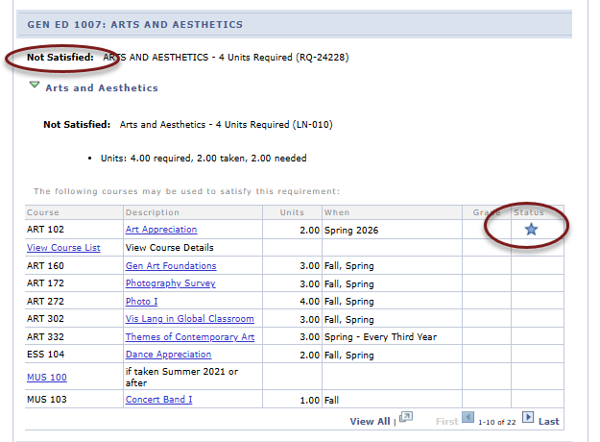

Registering in Planned Courses

Schedule Planner
Only planned courses assigned a term in WINGS are available in Schedule Planner. Unassigned courses are not available.

- Click on the link to Schedule Planner in your WINGS Student Center and select the correct term.

- Click +Add Course to add courses from My Planner to your schedule.

- Select the My Planner tab and review the courses listed. Only courses that you have assigned to that term in WINGS will appear as an option. Select the course and click +Add.
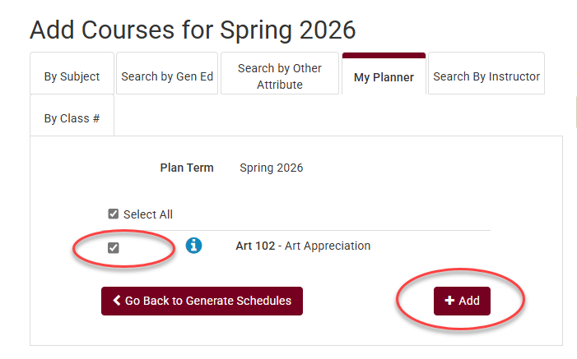

- Add more courses to your list or click Go back to Generate Schedules.

- Click Generate Schedules to view possible schedules.
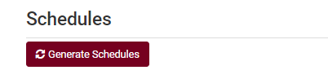
- From the generated schedules, click View to see a schedule in the weekly calendar grid and to move to the next step.
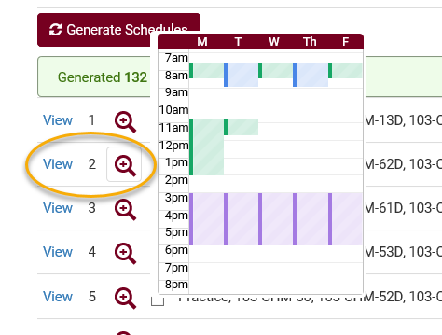

- On the potential schedule page, when you are ready to add to shopping cart, click Send to Shopping Cart near the top of the page. Once it is in the shopping cart, you can register as soon as your appointment starts. More directions on how to generate schedules and register can be found on the WINGS help page.
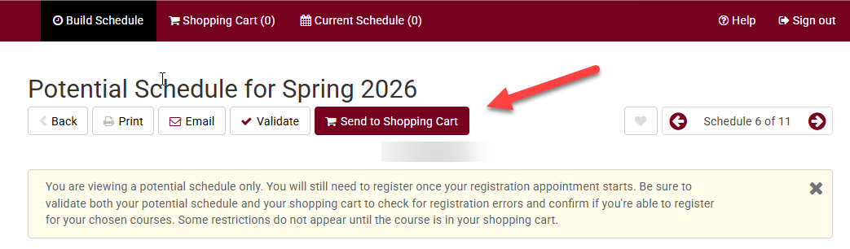

WINGS
In WINGS, courses both assigned to that specific term and unassigned can be added to the shopping cart.

- Log into WINGS and select Plan in the Academics section. Or select Academic Planner from the Other Academic Information drop-down menu in the Academics section.
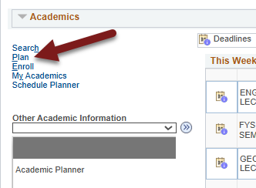

- Navigate to the shopping cart using the tab at the top.
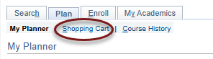

- Select the correct term and then select My Planner in the left options and click Search.

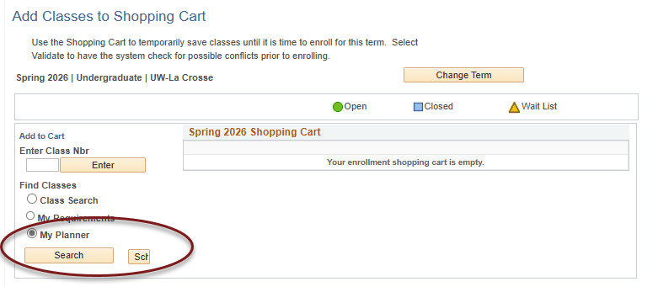

- Courses that are available for that term will display and can be added by clicking Select at the right.

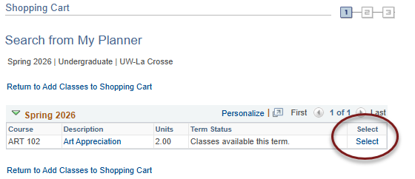

Tip: If an error message comes up saying "You are unable to enroll at this time, the time period for enrolling in that term has passed," recheck what term you are in and click on Shopping Cart at the top to select a different term.

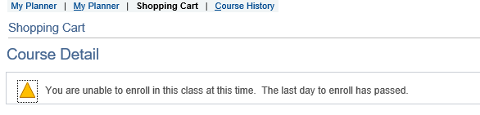

- Review the Course Details for the selected class. Scroll down to view the sections that are available and look at the Status to see if they are open, closed, or wait listed. Click the Select button to choose a section.
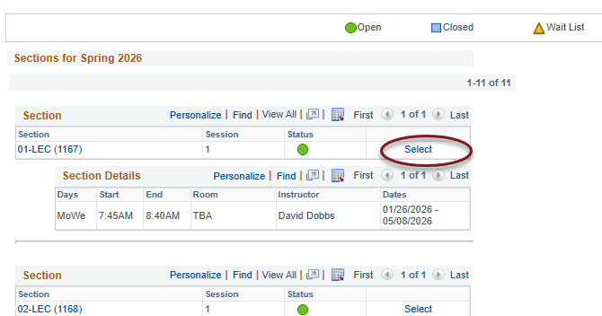

- If the class is full but has a wait list (yellow triangle icon), select the Wait List if Class is Full box. You don't need to check it if the class is open.

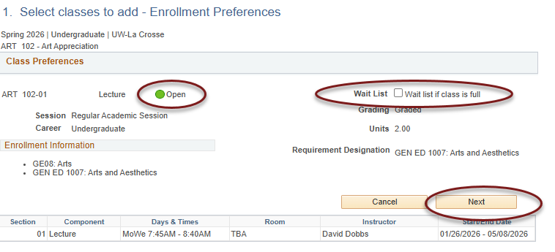

- Click Next. The course has now been added to your cart. The shopping cart in Schedule Planner has also been updated.

- To finish registering in WINGS, checking the box next to the class and clicking Enroll. Or you may click on Schedule Planner to continue registering through that application.

View Course Placements (and other milestones)

A. View course placements only
- In your WINGS Student Center, navigate to the Course Placement Results section on the right and click on Details.
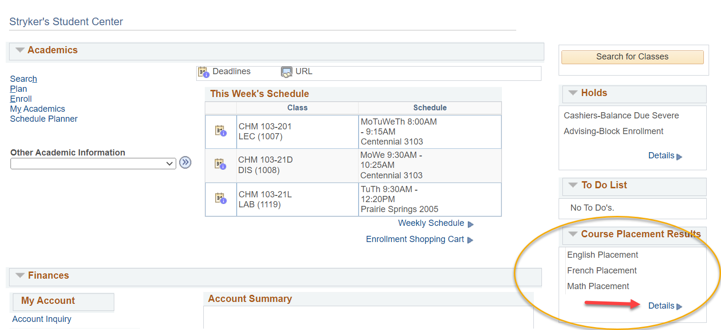

- The course you can enroll in, based on your scores, is listed under Milestone Level.

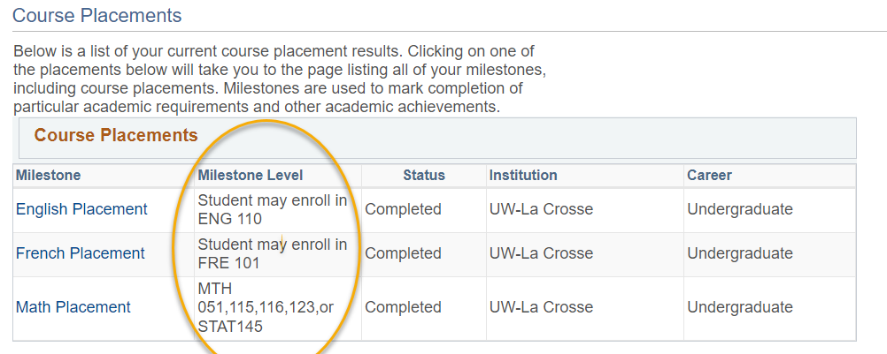

- If you click on the name of the placement, such as English Placement in the above example, it will take you to the page with all milestones listed, including non-placement milestones if you have any.

- If you don't have any placement milestones, the Course Placement Results section will say "no placements."

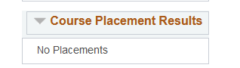

B. View all milestones, including course placements
- In the Academics section of your WINGS Student Center, select Course Placements & Milestones from the dropdown menu. Then click the arrow to go to the page.
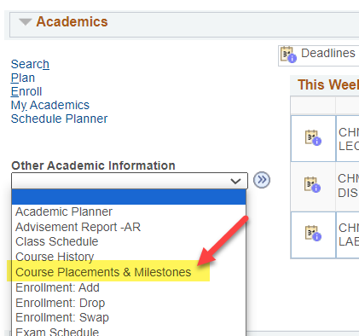

- This is the Course Placements & Other Milestones page, and it shows all milestones awarded, including course placements. Milestones are used to mark the completion of selected academic requirements and other academic achievements. Milestones besides course placements that a student might earn include:
- Successful admission into a college or program
- Music audition completed
- Completion of a portfolio
- Completion of other non-course requirements
- Microcredential earned

- The milestones display in one long list. The advantage of viewing them on this page is that you can see the date they were completed and any other milestones.

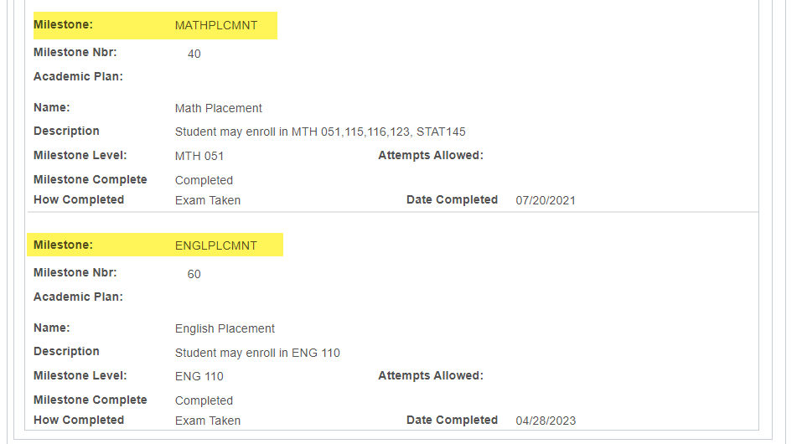

Viewing Your Term Grades & GPA

- In the Academics section of your Student Center, select Grades from the drop-down menu. Click the double arrow Go button.

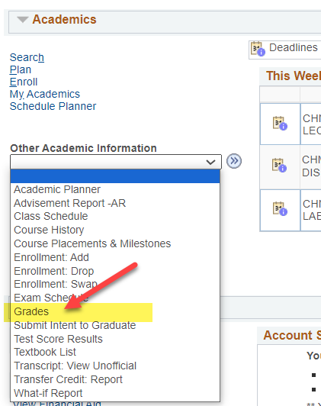

- The next screen shows the Enroll and Term Information tabs selected. The system defaults to the most current term. Click on Change Term to select another term, but keep in mind that your most current GPA can only be seen on the most current term.
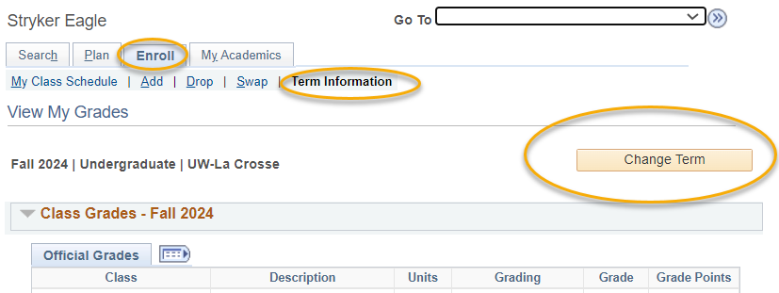

- Grades and GPA for that term will appear in the Class Grades and Term Statistics sections.
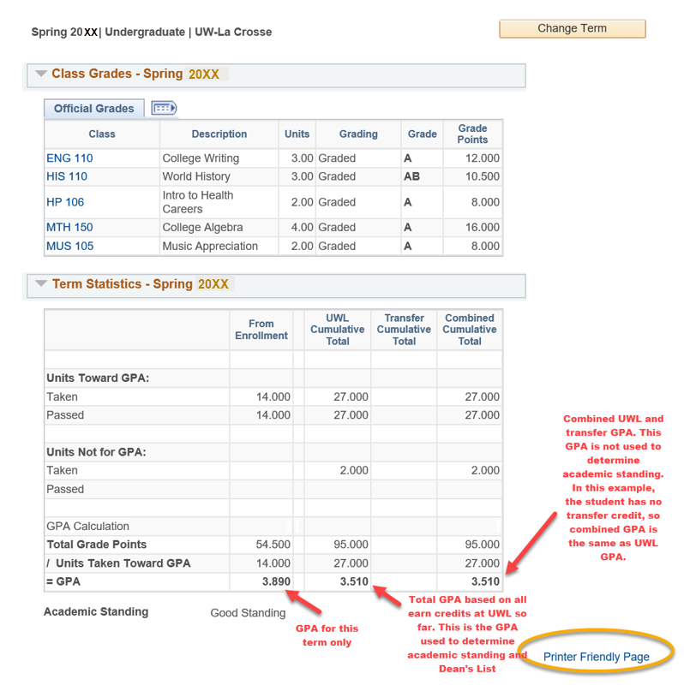

- The Term Statistics section shows several different GPAs. The GPA for the term is in the From Enrollment column. Your cumulative UWL GPA at the end of that term is in the UWL Cumulative Total column. UWL uses the UWL Cumulative GPA for determining academic standing, honors, athletic eligibility, and other verifications.

- The other GPAs are:

  - Transfer Cumulative: GPA using only your transfer credits
  - Combined Cumulative: GPA using both UWL and transfer credit together

- Major GPA: To find the GPA calculated just from courses in your major, check your Advisement Report (AR). Your major GPA will be in section that lists your major's requirements.
- To look at a different term, click the change term button at the top.
- To view all terms on one page, go back to your main page and select Transcript: View Unofficial. Detailed directions on pulling up your unofficial transcript are separate.

View Your Transcript

A transcript is a copy of your academic record at UWL, listing all courses, credits, grades, academic standing, GPA, honors, and degrees in one report. An official copy has the school seal, Registrar's signature, and other securities to prevent tampering. An unofficial copy does not have signatures or many of the other securities, although it is still secured from being released without permission

      - In the Academics section of your Student Center, select Transcript: View Unofficial from the drop-down mention. Click the double arrow button.

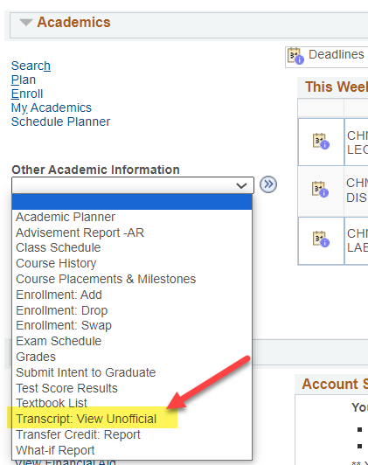

      - On the next screen, click Unofficial Enrollment (Both) for Report Type. Do not leave this blank or the transcript will not come up.

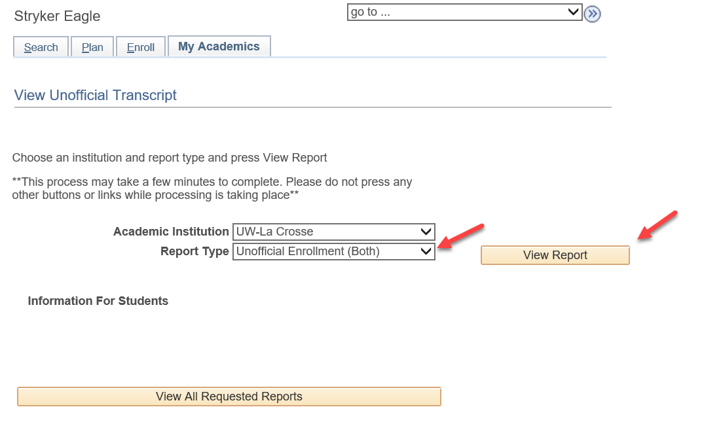

      - Click View Report.
      - A new window or tab should pop up displaying the transcript.

Tip: If a new window or tab does not come up, you might have a popup blocker on in your browser. Go to your browser options and turn off the blocker or add wings.uwlax.edu to the list of acceptable sites.

      - You may save the unofficial transcript as a PDF file to your computer or print it. On your WINGS window, you will see the history of the times when you have requested to view this report.
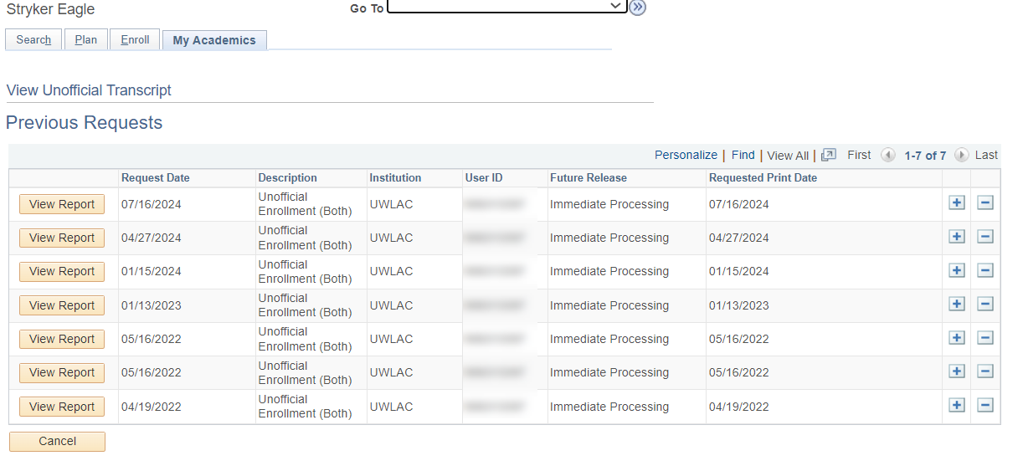

      - To order an official transcript, there are two places in your WINGS you can click on.
        - Go to the Enrollment Resources section in the bottom right of your Student Center homepage and click on Official Transcript. A new window or tab will pop up with the start of the official transcript form.

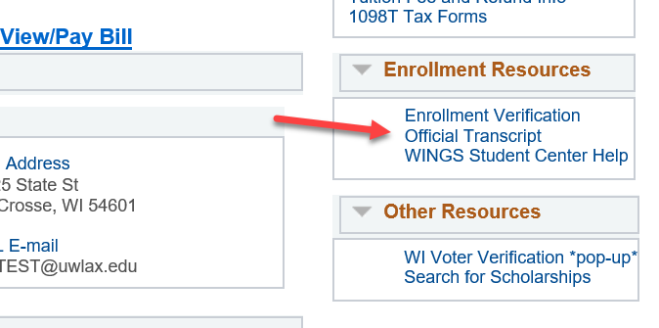

OR
        - Click on the Official Transcript link in the left-hand menu, then click on Official Transcript again. A new window or tab will pop up with the start of the official transcript form. Select either electronic (PDF) delivery through secure email or paper (hard copy) delivery through US Postal Service.

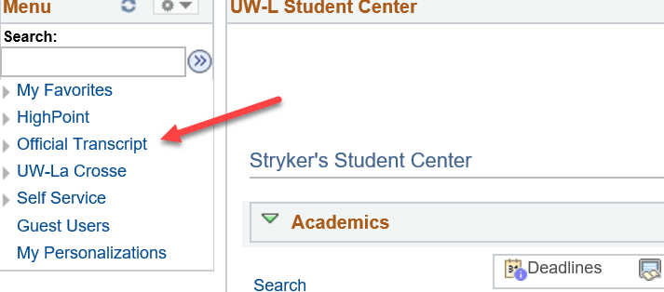

      - There is a fee for each official copy sent. You can pay with a credit or debit card.

More information about ordering an official transcript is on the Records & Registration office's transcript webpage.

View Transfer Credit Report

- In the Academics section of your Student Center, select Transfer Credit: Report from the drop-down menu. Click the double arrow Go button.
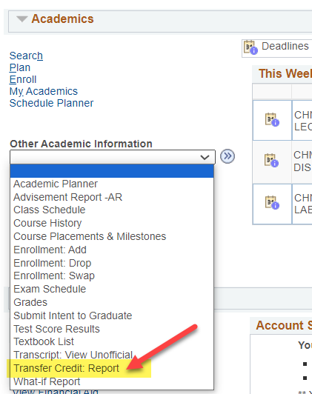

- View your report.
  - The example below shows credits transferred in from Southwest Minnesota State University and North Dakota State University under the Course Credits section.
    - Grades that start with 'T' are transfer grades.
    - Incoming Course is the course name/number from your prior school.
    - The Equivalent Course is the name of which UWL course will be awarded. If the course is labeled GEL, that is a general, non-departmental elective. If the course has a subject code followed by 0's (e.g. ECO 000C or MUS 0001NL), the course is an elective in that particular subject/department. The letter(s) at the end indicate whether the credit counts toward a General Education category.
  - The example below shows no test credits, such as departmental exam credit, AP, IB, or CLEP. If you had any of these credits it would be in the Test Credits section.
  - The example below shows no other kinds of transfer credits, such as retroactive credit. If you had any of these credits, they would be in the Other Credits section.
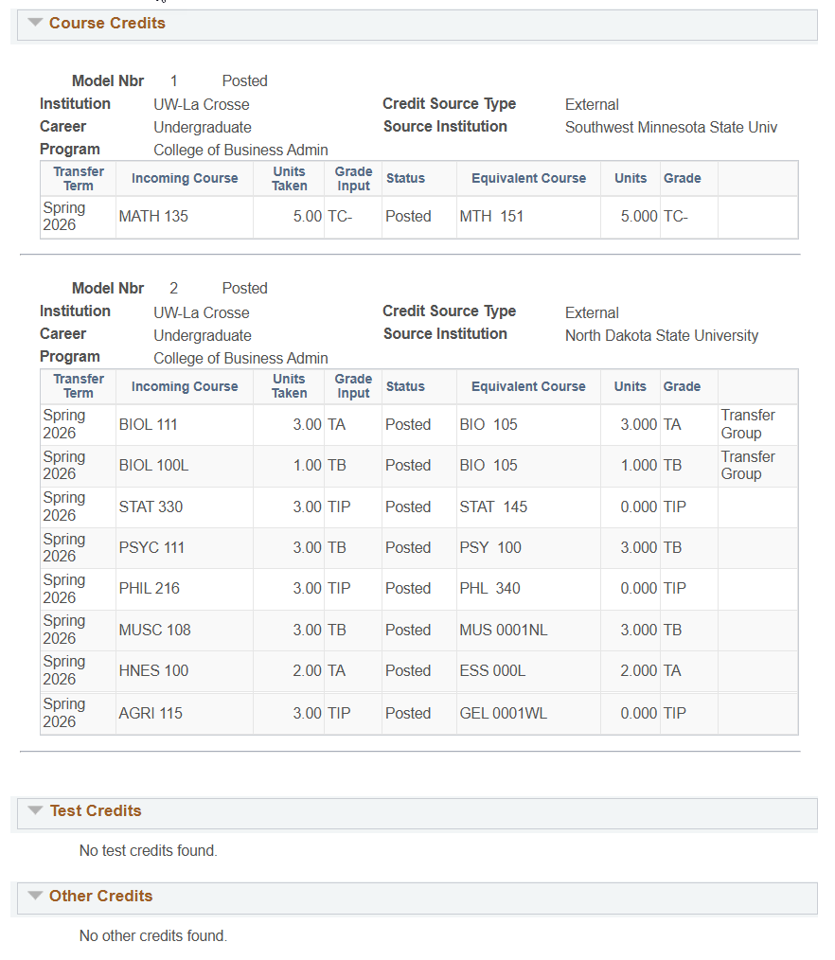

What If Advisement Report Guide

Considering switching or adding a major, minor, or certificate? The What-If Report creates a tentative academic Advisement Report using your in-progress and completed courses. The What If also allows future courses to be added so you can see how they will affect the requirements.

- In the Academics area of your Student Center, select What-If Report from the Other Academic drop down and click the arrow.

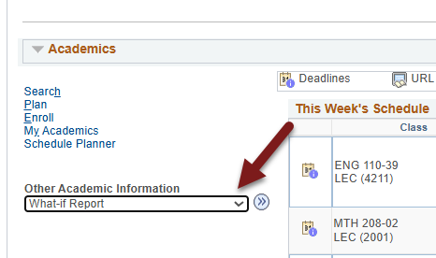

- Click on Create New Report.

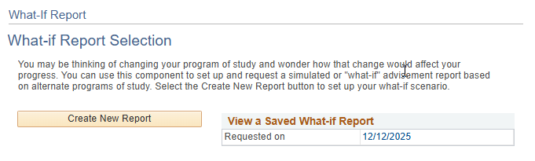
If there is a saved report, you can view it by clicking the date. It will include the classes you registered in or completed since the report was first run, using the criteria you entered originally. Only one report can be saved at a time, and it will always be the last report run. To change what majors/minors are included on the report, create a new report.

- On the Create a What-if Scenario page, the Program Scenario section defaults to your current college/school and your first three majors/minors (if you have that many).

The below sample student is currently a Chemistry major in the College of Science and Health. This student was admitted in the Fall of 2025, so the report uses the degree requirements approved for that year.

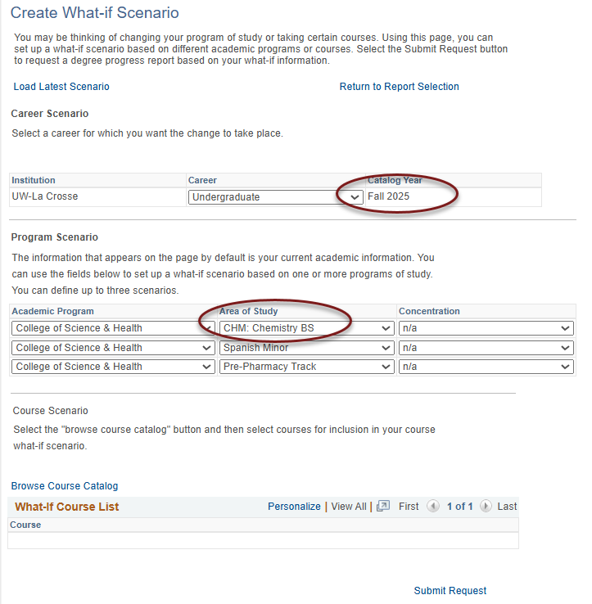

- Next, select up to three plans under Area of Study. Our sample student wants to see how a second major in Biology would change the Advisement Report, keeping the Spanish minor.
  - The Academic Program is the UWL college or school your primary major is in. The Academic Program will remain the College of Science and Health for all three lines because the primary major of Chemistry is in the College of Science and Health.
  - Your primary major always goes in the first row.
  - 2nd majors, minors, pre-professional programs should go in the next two rows.
  - The options under Area of Study are restricted to those available for that college/school. For example, no CBA majors will show up if the College of Science and Health is selected.
  - The Concentration options will always say n/a because the different emphases and concentrations are options under the Area of Study.
  - The majors/minors/programs available are based on the catalog year. Newer majors/minors may not be available if they were created after you first started at UWL. If you are aware of a new major but can't find it, contact your advisor or your college dean's office for assistance.

Changing majors/minors only:

- If you don't need to add any future courses, click Submit Request.

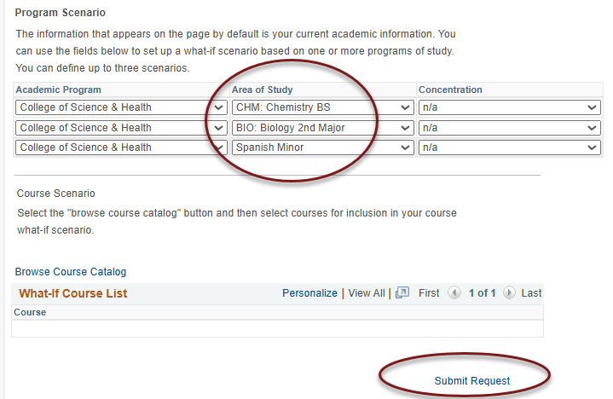

- A what-if advisement report will be generated using the majors/minors you selected. Once you have reviewed the AR, click Cancel at the bottom to return to your Student Center and start over.

Adding in future courses you might take:

- To see whether a certain course will satisfy a requirement in the AR on the What-If Scenario page, before submitted the request, scroll to the Course Scenario section and find the course using the Browse Course Catalog link.

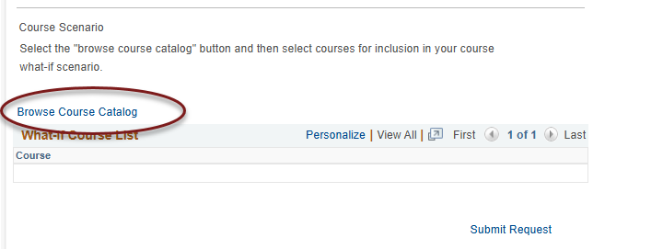

- Select the subject prefix using the alphabetical links at the top.
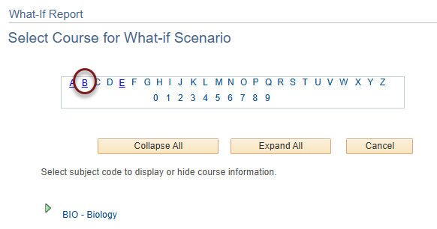

- Then click on the green arrow next to the subject to see the list of courses for that subject.

- Select the course's title to see the Course Details or click Select to add the course. Please note the typically offered information is an estimate, and courses are not guaranteed to be offered in those terms.
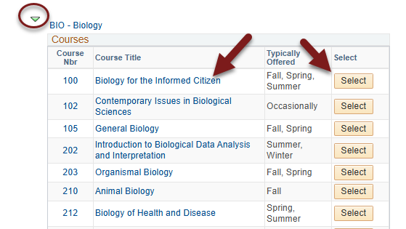

- On the Course Detail screen, use the View Class Sections to see if it will be scheduled in the next semester and learn more about the course. Note: you can't add individual sections of the course to the report.

- Click Return to Select Course for What-If Scenario to go back and select the course to add to the report.

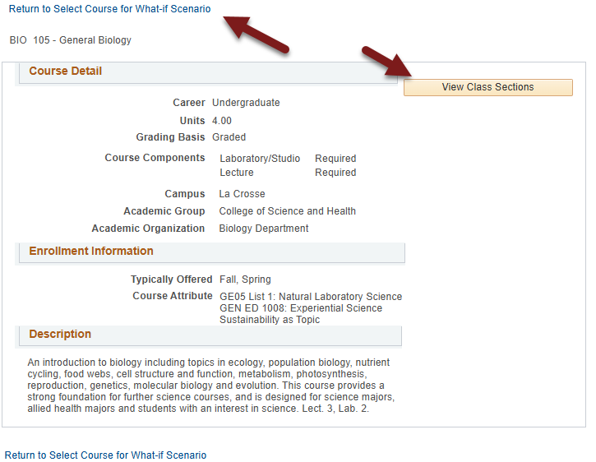

- Once selected, the course will appear on the What-If Scenario page in the Course Scenario section.

- Choose the term in which you plan to take the course. Entering the correct term helps keep track of when you plan on taking the course. However, you can run the report with the defaulted term. Important: The terms listed do not indicate when the course will actually be offered.

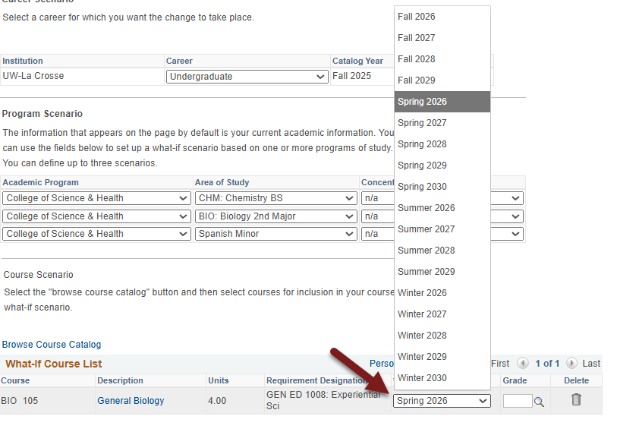

- If getting a certain grade in a class is necessary to satisfy a requirement, enter in a grade. Example: CBA students must earn a "C" or better several core courses to complete the college core.

- If needed, use the trash can icon to remove the course.

- When ready, click Submit Request. Like with the My Planner AR, if the course satisfies a requirement, that section will now appear closed. Use the green arrow to open sections if needed and see the course. A question mark is in the Status column to indicate it might be taken.

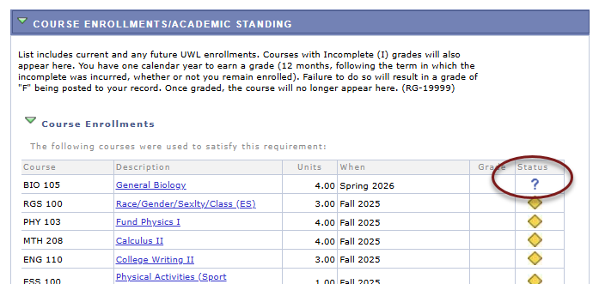

If the course doesn't meet any requirement, it will fall into the Courses Not Allocated section, which is normally a collapsed section.

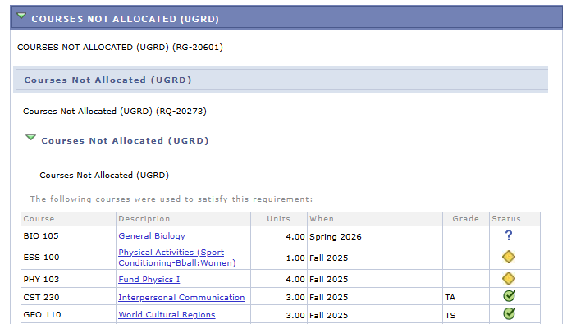

All courses in the AR fall into the Course Enrollments/Academic Standing section at the top and the first 120 credits in the University Requirements for Graduation section.

Your Course History
Your course history is a list of all courses you have taken at UW-La Crosse, any credits that have been awarded as transfer credit, retroactive credits (if any), and test credits from AP, CLEP, or IB tests.

- Login to WINGS. In the Academics area, select Course History from the Other Academic Information drop down menu and use the double arrow Go button to continue.
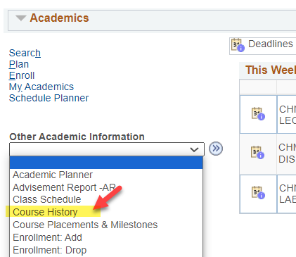

- You may sort the list by course, description, grade, status, term, or units (credits). Grades with a "T" are transferred grades or grades awarded for test credits. TIP means the course is in progress, and we do not have your final grades on file.

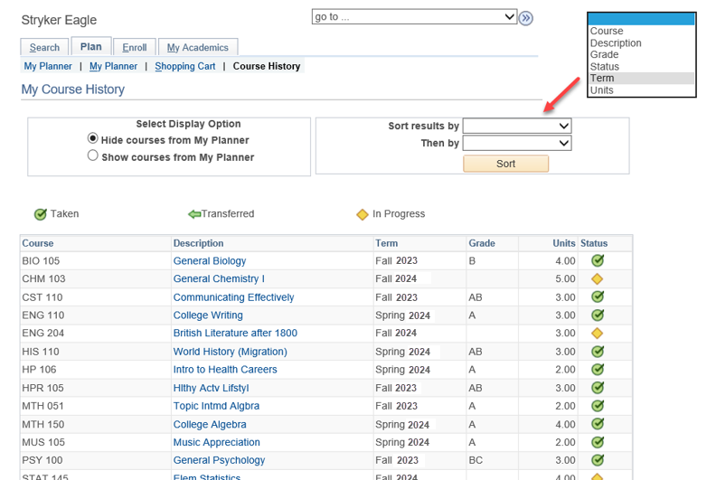

Where to Find Your Current College (Program) & Major/Minor
- Login to WINGS. In the Academics area, select the My Academics link on the left.

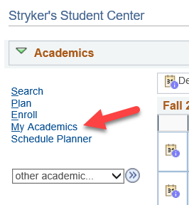

- Your college and major will appear in the box on the right-hand side. Your career level of undergraduate or graduate is listed on the Career line. Colleges & schools are listed on the Program line.

To request a change, submit a Change of Major/Minor form. It takes 5-10 business days for a change of major/minor request to be processed. For questions about your major, contact your college Dean's Office.

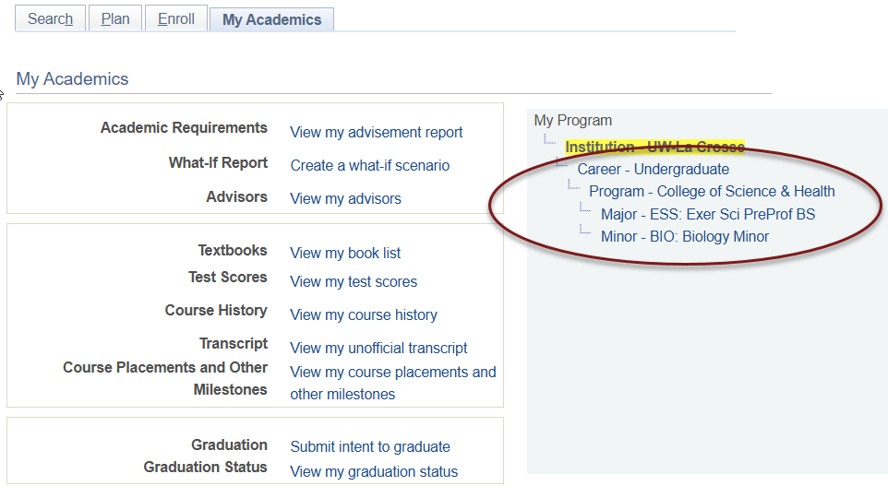

How to Submit Your Intent to Graduate
Submitting your intent to graduate indicates you want to be notified about Commencement information, that your degree requirements are almost completed and a credit check on your record is needed, and that you want to be notified about other important information for soon-to-be graduates.

You should notify UWL of when you expect to graduate graduate when it is within the next calendar year. Please submit your expected term of graduation by the start of your final term at the latest.

The deadline for your name to be printed in the Commencement program is November 1st in the Fall (for the December ceremony) and April 1st in the Spring (for the May ceremony). Students graduating in the summer participate in the May ceremony and Winter graduates participate in the December ceremony.

Directions
- In the Academics area of your Student Center, select Submit Intent to Graduate from the Other Academic Information drop-down menu. Click the double arrow Go button.

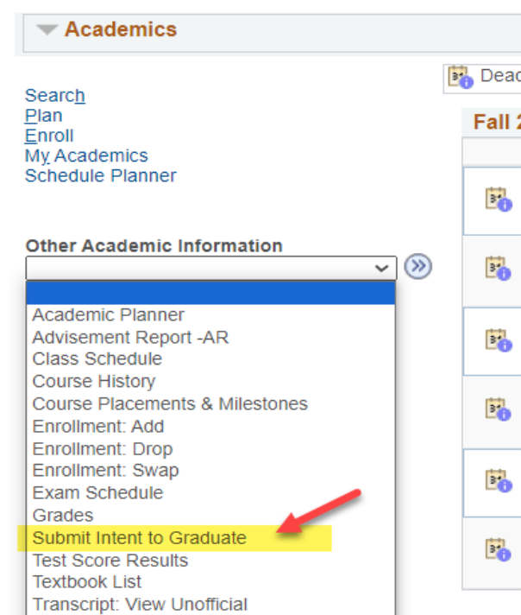

- Review the degree program, major and minor to make sure they are correct. If they are not, contact your College Dean's office for assistance or submit a Change of Major form.

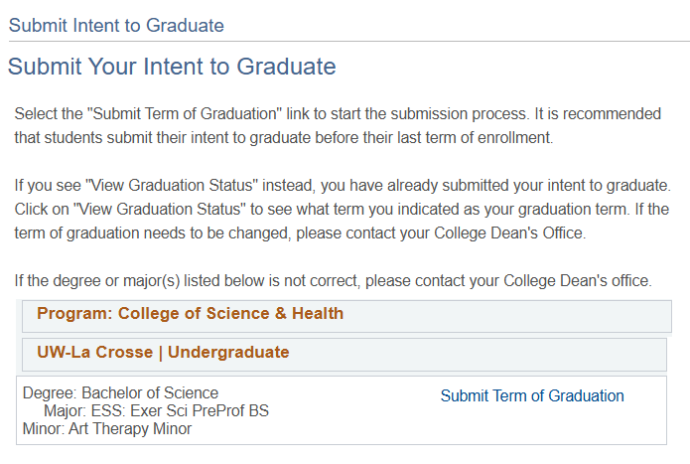

- Click on the Submit Term of Graduation link next to the degree program from which you are graduating.

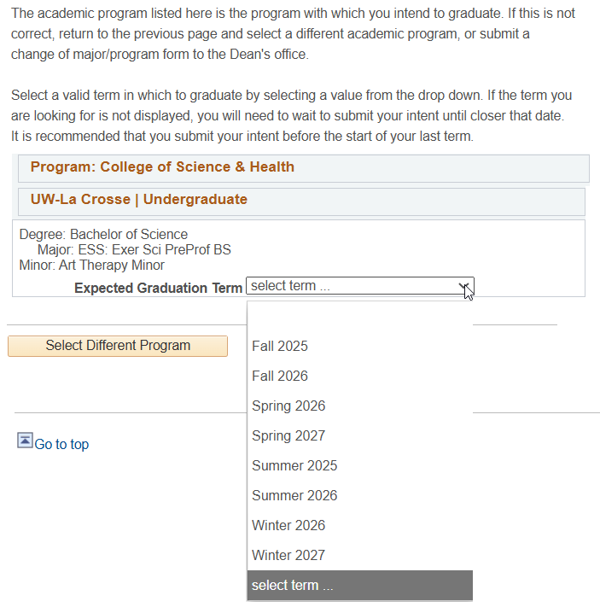

- Select your expected graduation term and click Continue. Please note that the terms are listed alphabetically, so be careful to select the correct term. If the future term you are searching for is not available, return in a semester and see if it is available then.

- Another section will appear with information about Commencement, your diploma, and what will happen to your netID and email after graduation. The full information provided is listed at the end of these directions.

- Read the information and then click Continue at the bottom.

- Confirm the term you selected.

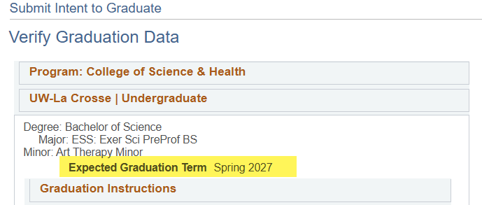

- Click Submit Application at the bottom of the screen.

- A message should appear that says, "Submit Confirmation: you have successful submitted your intent to graduate." This indicates you are done.

You can also verify that term was submitted correctly by clicking on the My Academics tab at the top of the page. Select View my graduation status at the bottom of the list of links. The status will say "Submitted Intent to Graduate" if you have already completed this. Note the expected graduation term listed. If that term is incorrect, contact your College Dean's office.

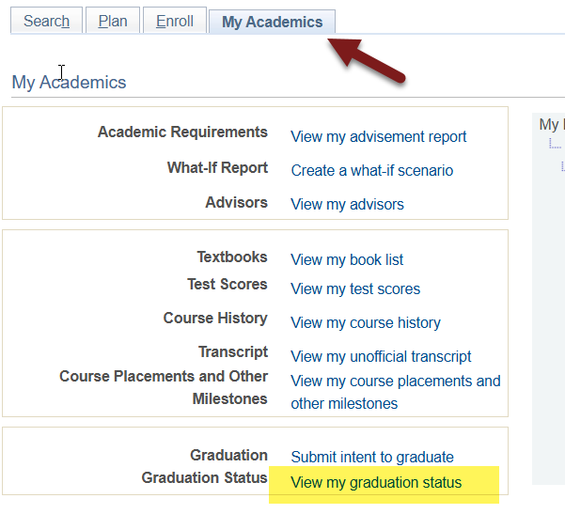

Graduation Instructions:
Read the below information to learn more about Commencement, diplomas, and your net ID and email after graduation. This information is shown in WINGS when you are submitted your intended term of graduation.

If you need to change your graduation term to a different term, you must contact your dean's office.

Information regarding the upcoming Commencement ceremony is available on UWL's Commencement website. The ceremony will be held at the La Crosse Center. Summer graduates participate in the May ceremony, and Winter Intersession graduates participate in the December ceremony.

Your diploma will be mailed to your Home address. Please verify/update that information before the end of your last term at UWL.

Please also update your "personal" Email Address in WINGS to a non-UWL email before the end of your last term at UWL. Your digital diploma will be sent to your personal email address. To have access after graduation, your personal email address must be a non-UWL email.

**Important: Your UW-La Crosse Net ID will be deactivated approximately 6 months after graduation. This will remove your access to WINGS, UWL email account, personal files, data on OneDrive, and other resources accessed with your Net ID account. The data will be deleted and will not be retrievable. You will receive notice of the pending deletion two to four weeks prior to the process. Please note that Canvas access ends when your last class is finished.

Besides updating your addresses, please take the actions below that apply to you to ensure a smooth transition after graduation:

- Use your last term of enrollment to start transitioning to a personal email address for job and graduate school applications.
- Update any non-UWL accounts created with your UWL email address to a personal email. For example, if you have used Parchment Transcript Services to order an official transcript, make sure your email address on that account has been changed to a personal, non-UWL email. Another common example is to check that your Google account is using a non-UWL email.
- Copy and save the data you would like to save from your OneDrive, email (messages and contacts), and other UWL systems to your own personal computer or storage device before you leave UWL. Copy and save any data from Canvas you need now, before the end of your last term of enrollment.
- Within a few months of your degree being posted, download a copy of your unofficial transcript from WINGS for future use.
- (Undergraduates only) Make note of your major GPA from your Advisement Report as this may be requested when applying for graduate school.

Your legal name will be printed on your diploma and in the Commencement program unless a Degree Name is submitted. If you wish your name to appear differently, go to the "Personal Information" area of the Student Center and click on the "Names" link. Click the "Add a New Name" button. Choose the name type of "Degree." Enter the name as you wish it to appear on your diploma. Save. Please submit this change by April 1st for Spring graduation and November 1st for Fall graduation to have that name reflected in the Commencement program. International students and other students intending to work or study in another country must use their legal name (as it appears on the transcript/VISA) to avoid complications with proof of degree.

Finding Your Registration Appointment

- Locate the Enrollment Dates box on the right-hand panel of your WINGS Student Center.
  - Shopping Carts: The appointment for your shopping cart is listed first. Shopping cart appointments allow you to add courses to your shopping cart in preparation for your registration appointment. If you only see a shopping cart appointment, the registration appointment has not been assigned yet. The displayed appointment is for the very next term. That is often the Winter or Summer Session.
  - Click the Details link under the Enrollment Appointment to see additional terms.

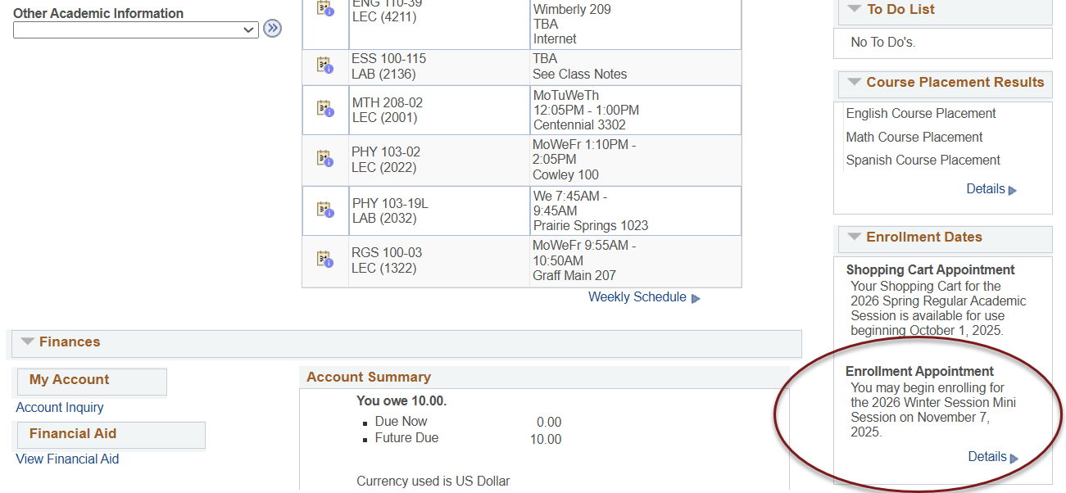

- Select the term you would like to see the details on and click the Continue button.

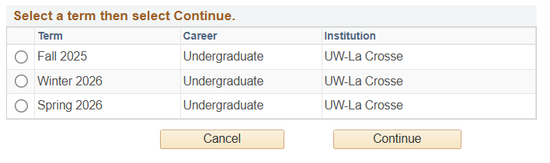
- In the Enrollment Appointments section, your registration date is located in the Appointment Begins column. The appointment is the date and time you may start registering. You can continue to register up through the start of the term (the Appointment Ends day and time). The Open Enrollment Dates below are the first days of each class session in which you still add/drop without permission.

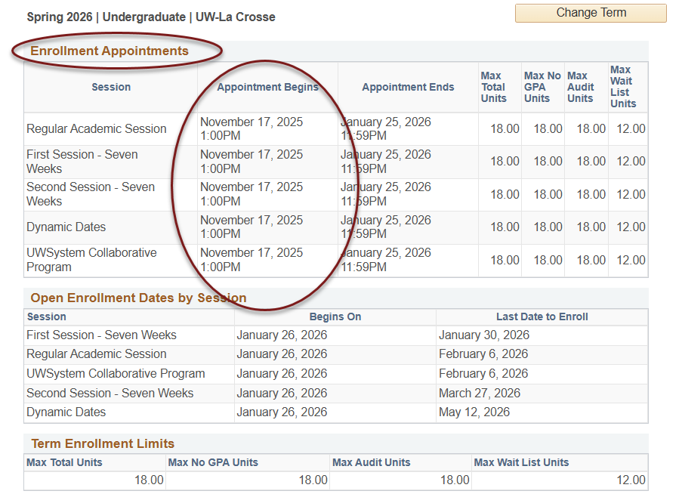

- Click the Change Term button at the top to view another term.

Please note:
- Registration appointments are set by the number of credits a student has earned by the week before registration. Larger numbers of credits go first. Special, non-degree seeking students go last.
- Appointments do not include credits you are currently taking (in-progress courses), either at UWL or at another school.
- Earned transfer credit will count if the course has a final grade and the transcript has been received by UWL.

Search for Classes/Create a Schedule in Schedule Planner

You may start searching for classes as soon as the next term's schedule is made public. However, shopping carts and validation appointments are not immediately available. Shopping carts must be activated before you can save courses to them. They will be activated 1-2 days after the schedule comes out. A shopping cart appointment will show up in your WINGS in the Enrollment Dates section.

Please note: Schedule Planner's layout adjusts to the device you are using. The below pictures are based on laptop/desktop view. On a mobile device, the Add Course, Breaks, and Generate Schedules sections may show up as separate tabs at the bottom.

- Click on the Schedule Planner link from your WINGS Student Center. A new window/tab will come up.

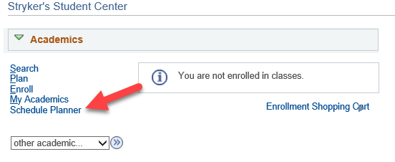

  - If you are taken to a page with a button that says Open Schedule Planner, click on that button.
  - If you are taken back to your main Student Center page, there may be an issue with your browser. Try clearing your cache or use a different browser.

- Choose the term you are interested in and click Save and Continue.

- You are now on the Build Schedule screen.

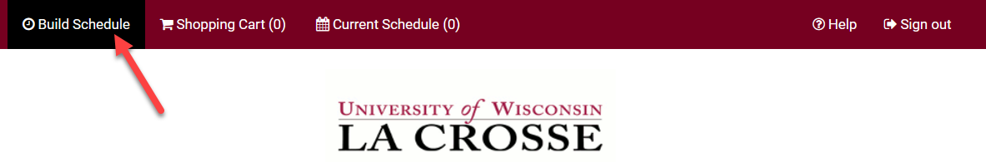

- The filters at the top affect your search results. Click on the Change button to update your filters.
  - Course Status: limits results to open courses (courses that still have seats available) or to both open & full courses
    - Setting the Course Status to Open Classes Only means you will only see classes that have open seats. Change the Course Status from Open Classes Only to Open & Full if the course is not in your first results.
    - Classes that require permission to get in may be set to 0 seats. Sections that are full with a waitlist are also labeled full or closed.
  - Sessions: keeping all checked provides the best results.
    - To limit options to only classes that run the entire semester, only check the Regular Academic Session.
    - To add a shorter class, choose one of the shorter sessions.
    - Dynamic Dates means the class can have an unusual start and/or end date.
    - Summer term has many more sessions to choose from. Be sure to select the session that is offered at the right time for your schedule.
  - Term: There is often more than one term available, so check that this is set correctly before searching.
  - Instruction Modes:
    - In-Person (or On-Campus or Face-to-Face): Course takes place in a physical classroom.
    - Hybrid (both In Person & Online), a.k.a. Blended: Course takes place in both a physical classroom and online. This combination of online and in-person elements is based on meaningful learning strategies that best serve an instructor’s pedagogical goals and objectives. While a percentage is not mandated, hybrid courses are traditionally 30% to 50% of seat time replaced with online components.
    - Online Asynchronous: Students do not meet in person at a physical site. All content and course activities take place online. Although there are deadlines for students by which they need to complete work, there are no requirements for a specific date/time when the student must be available.
    - Online Synchronous: Students do not meet in person at a physical site. All content and course activities take place online. Some or all of the class occurs in real time. Online elements can be required (e.g., a lecture or exam) or optional (e.g., office hours or discussion times). The course is listed as online in the timetable and a meeting date/time will be scheduled or in the notes. Enrolled students should schedule other classes/activities around that time.
    - Independent Study: Students work out with their instructor when they meet and what topic they will study. This type of course always requires instructor approval to register. First years and sophomores vary rarely have this type of course.
- Use +Add Breaks to build in activities to schedule around such as lunch, practice, or work. You can limit it to one term or select Ongoing to keep the break there for every term.
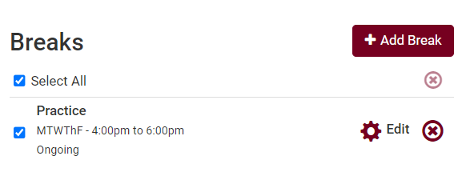
- Click +Add Course to find and add courses to use in a schedule.
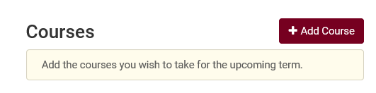
- Search for specific courses on the Add Course screen. When you have found the course you want, click +Add Course. The course will be placed in the Desired Course section so you can search for more courses to add. If you change your mind about a course you've added, you can use the red X to remove it.

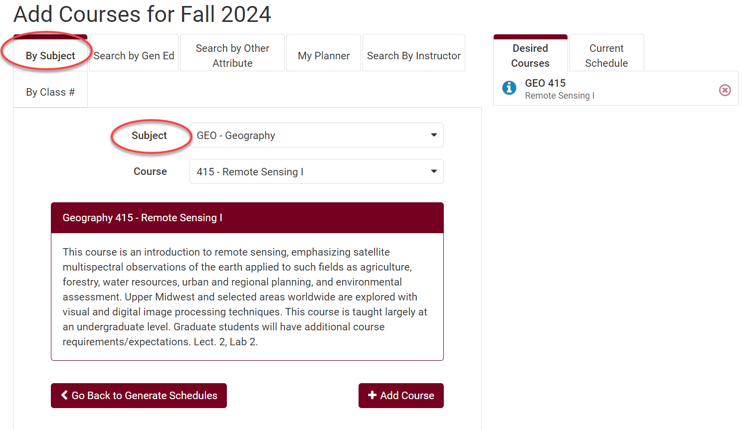

  - By Subject – search using the subject prefix.

    - Topics - If the course has a topic, an additional field will appear in the search. You must select a topic and can only add one topic at a time. To add multiple topics, add the course multiple times to your list, each time a different topic.

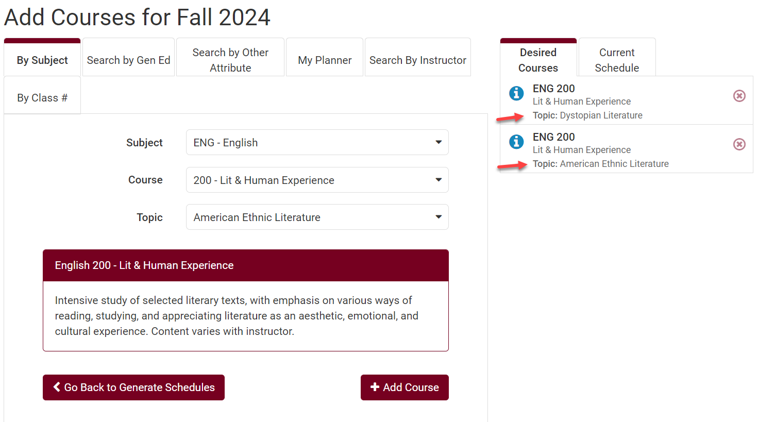

    - To see the description for the individual topic, add it to the Desired Courses list. Then click Go Back to Generate Schedules. Under Courses, click on the Sections icon next to the course and then select the blue information icon next to one of the sections.

  - Search by Gen Ed - search by General Education Program categories. Search by one category at a time because a course can only be in one Gen Ed category. Searching by multiple categories means Schedule Planner is looking for a course that is in both categories.

Important: students who started at UWL in the Summer of 2025 or later follow the 2025 General Education Categories. These new categories begin with GEN ED 1001, GEN ED 1002, etc. Students who started at UWL in Spring of 2025 or earlier follow the General Education Categories that start with GE01, GE02, etc. Please refer to your Advisement Report to see which categories you need to satisfy.

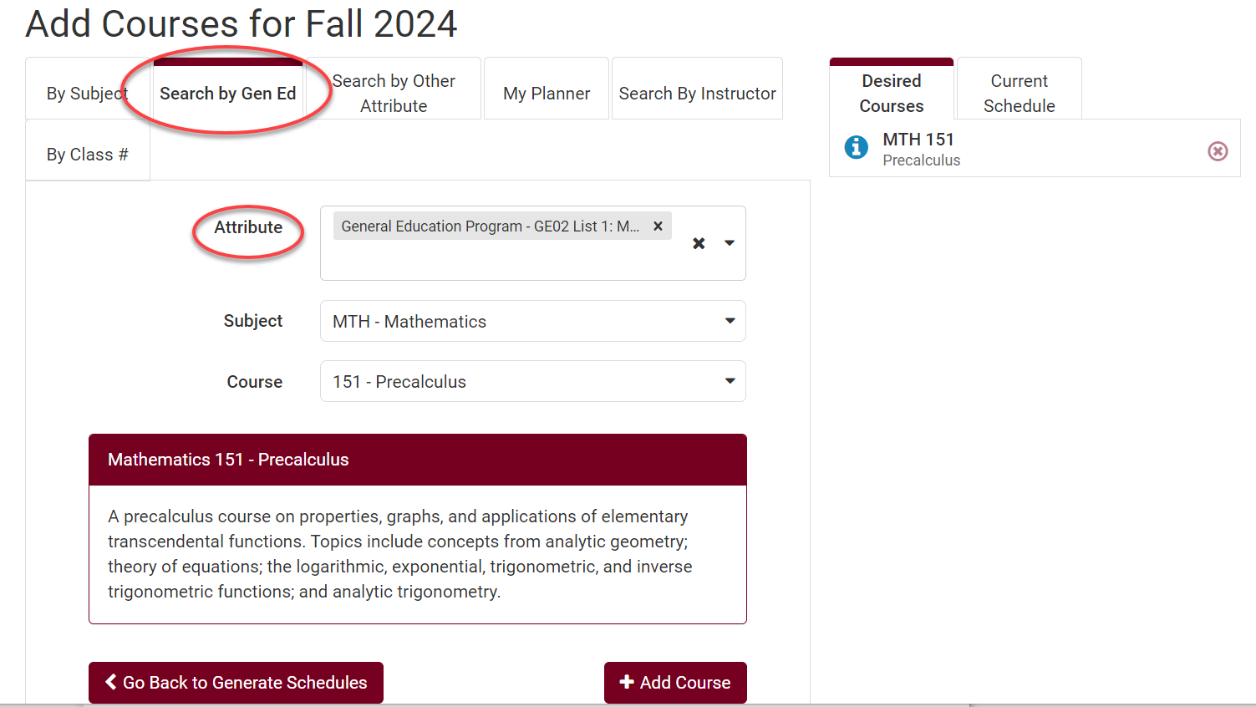

  - Search by Other Attribute options:
    - Community Engaged Learning courses

    - Sustainability As Core Theme – sustainability is the main theme of the course

    - Sustainability As Topic – sustainability will be a subtopic in the course

    - While you can add more than one attribute to search at the same time, the course must have both attributes to show up in the results. Very few courses have more than one of these attributes.

  - My Planner - courses you have put into the Academic Planner (a.k.a. Plan by My Requirements) in WINGS and assigned to this term. Unassigned courses (not assigned to a term) do not appear in Schedule Planner. See the My Planner directions for more information.

  - Search by Instructor – all classes taught that term by that instructor. Instructors are listed alphabetically by first name.

  - By Class # - search using the 4-digit class number for the specific section you want, if you know it.

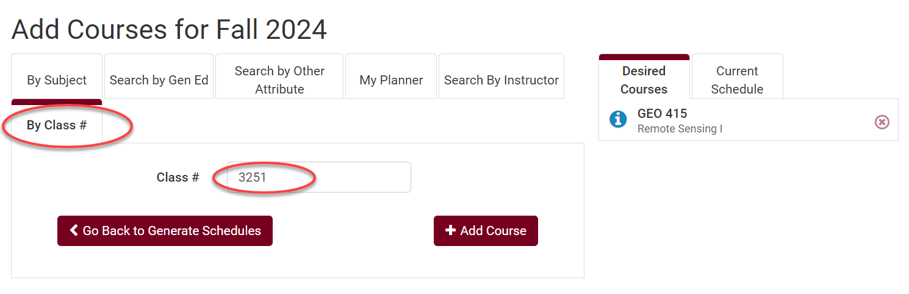

- Click Go back to Generate Schedules when you're done adding courses. The courses you chose will appear under the Courses section.

- Limit schedule options to specific sections by using Sections, the gear icon next to each course in the Courses list.
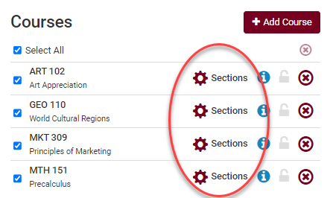

  - Filter by time: Click on Sections. Uncheck the sections you don't want or leave them all checked to generate more schedules. Note whether there are still open seats available in your desired section or any open waitlist seats.

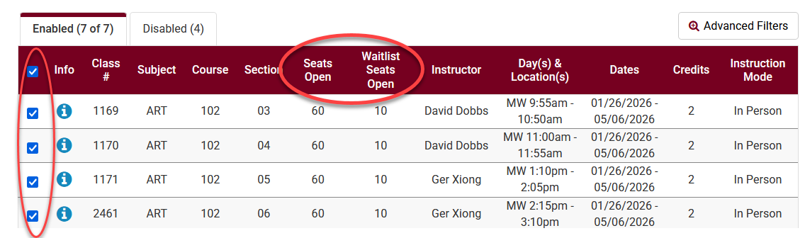

  - Find the closed sections with active waitlists which seats: Change Course Status filter on the Build Schedule page is set to Open & Full so you can select the class you find. Then click the Sections gear icon.
    - If there are any seats left on an active waitlist, the Waitlist Seats Open number will be higher than 0. A zero means the class either does not have a waitlist or the waitlist is full.
    - To find the number of students already on the waitlist, click the blue information next to the Class #. There will be a Waitlist Enrollment number.

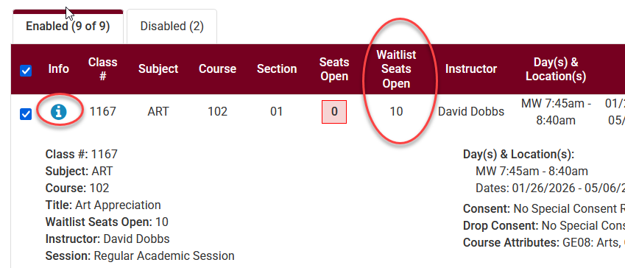

  - Filter by instructor: Click on Advanced Filters. Select the instructor you would like and save filter. Make sure the remaining sections with seats are selected.

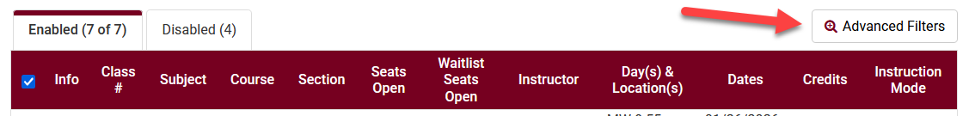

Tips when using Sections filters:
- If you have the Course Status set to include only open classes on the main page, closed sections will display on the Disabled tab.
- Before making changes to Sections, click the Generate Schedules button (see step 10), so that you can see the largest number of possibilities first. Getting too specific before you know what is available may make it difficult to find an open schedule.
- If too many filters are selected, it is possible to end up with zero possible schedules. In that case, go back and adjust your selected filters.
- See how many seats & waitlist seats are available in all sections of a course by clicking on the Sections. If the Waitlist Seats Open column also says 0, check if a waitlist exists by clicking the blue information icon. A Waitlist Enrollment number will display if there is a waitlist.
- If the Course Status filter is set to both open and closed sections, use the checkboxes under Sections to uncheck any closed sections that don't have a waitlist or have a full waitlist.

- Click on Generate Schedules to view potential schedules based on the courses, filters, and breaks or filters you have selected. The example below has generated 51 possible schedules.

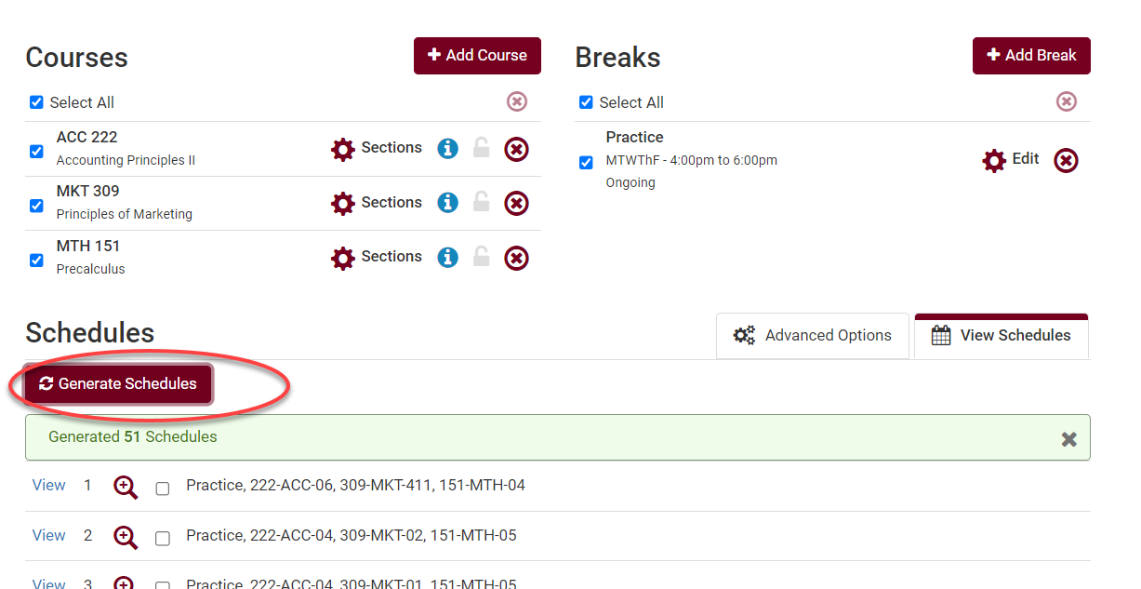

- Hover over the magnifying class to see a miniature view of the weekly schedule. Click on the blue View link to see the large view.

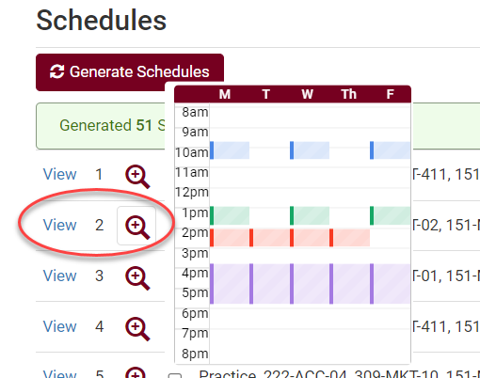

- On the Potential Schedule view, click through the various schedules using the arrows at the top right.

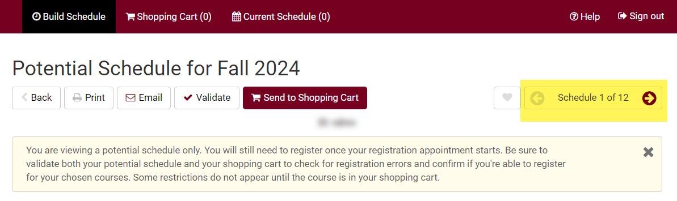

- Review the possible schedules.

  - Click the blue information icon to review section Details. If there is a prerequisite, it will be labeled Enrollment Requirement. If permission is required to enroll, it will be indicated next to Consent.

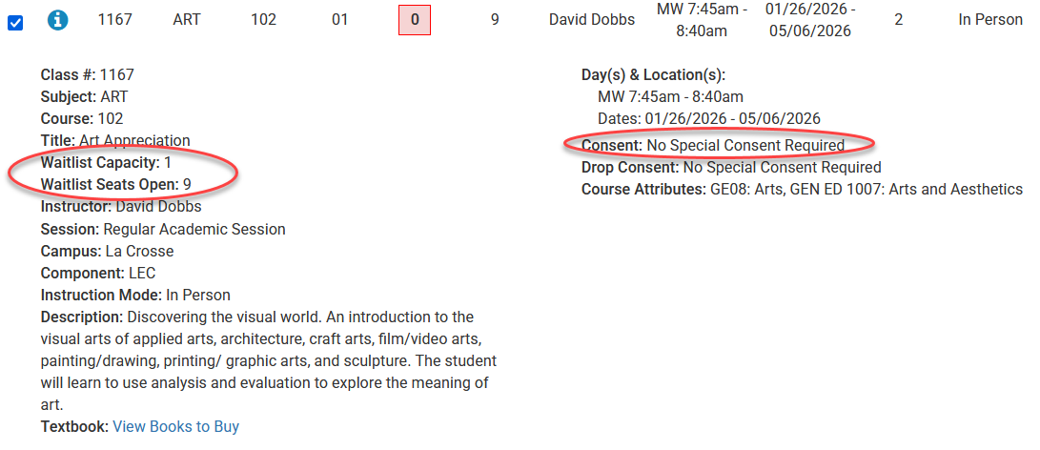

  - Creating Favorite Schedules: see the Favorite Schedules in Schedule Planner directions for more information.

Creating Favorite schedules allows students to save multiple schedules as options to be ready for their registration appointment. This makes it easy to see whether seats are still available in your preferred schedules and saves time if you need to make changes because you won't need to drop classes out of the shopping cart first to generate new schedules.

- Once you have chosen a schedule, click Validate to see if you meet the prerequisites for the courses. If you do not meet the prerequisites, you cannot enroll in the course. If you see a red X, the accompanying message explains why you cannot enroll in the course. If you have questions about the message, contact your academic advisor or the Records office.

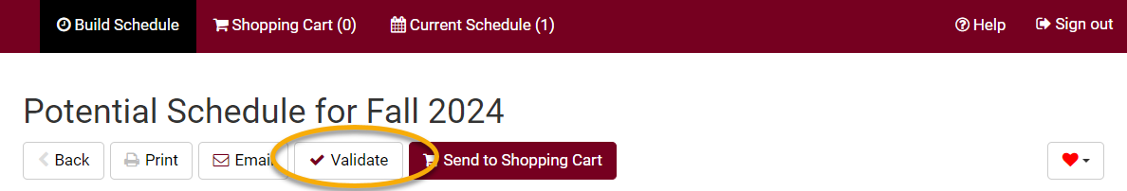

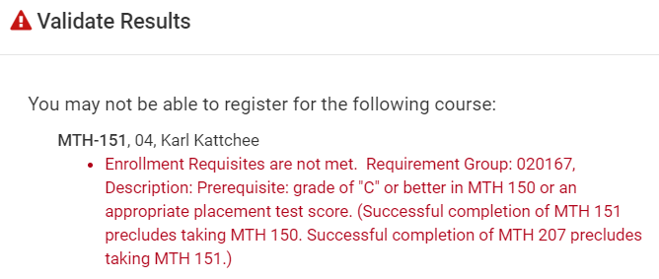

Tip: Validate a second time after putting your schedule in the shopping cart when its time to register. Some errors cannot be detected until the course is in the shopping cart.

- If satisfied with the schedule but not ready to register, mark it using the Favorite heart icon at the top and give it a name you will remember. When it is your time to register, go to that Favorite and then click Send to Shopping Cart.

- If you are ready to register, you may send a generated schedule directly to your Shopping Cart.

- If you need to make changes, click Edit Cart to remove some or all courses from your cart.

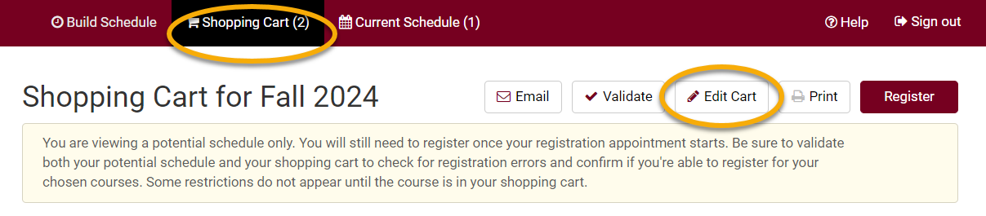

- If your schedule is ready, click Register from the Shopping Cart tab and follow the directions on screen. Review the Register Using Schedule Planner directions for more details.

  - Your selected courses must be in your shopping cart before you can register.
  - Having a course in your shopping cart does not reserve a seat in the class.

Search for Classes/Using the Shopping Cart in Your WINGS Student Center

You may start searching for classes as soon as the next term's schedule is made public. However, shopping carts and validation appointments are not immediately available. Shopping carts must be activated before you can save courses to them. They will be activated 1-2 days after the schedule comes out. A shopping cart appointment will show up in your WINGS in the Enrollment Dates section.

  - Click the Search for Classes button in the top right-hand corner of your Student Center.

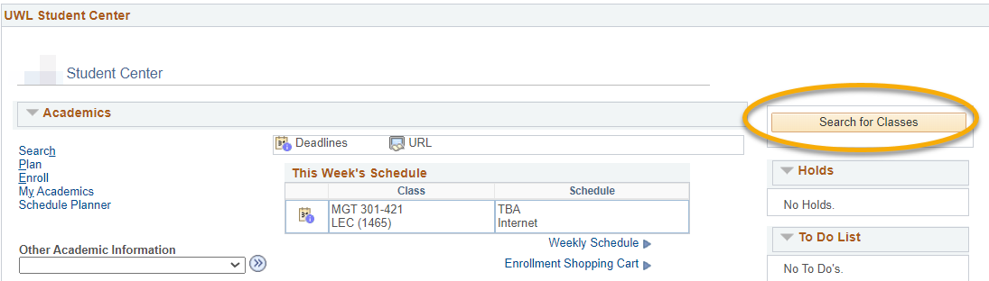

  - On the next page, the Search and Search for Classes tabs are selected.
  - Note the other tabs for future reference. You can use them when managing your Shopping Cart and planning your courses (Plan); enrolling, dropping, and swapping classes (Enroll); and looking at other details of your academic record (My Academics).
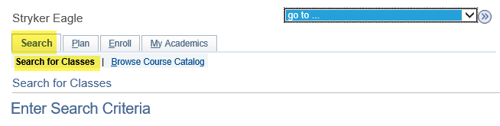
  - The search defaults to a term. To search another term, click the drop-down list, and select another term.
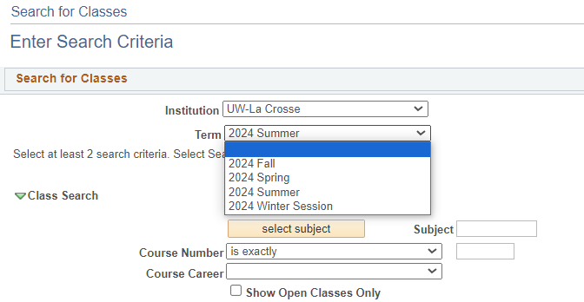

  - Click the Select Subject button in the Class Search section. If you already know the course prefix, type the prefix in the Subject field and skip ahead to step 8.

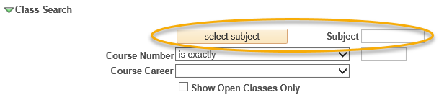

  - In the A-Z list, click the first letter of the subject you would like to search.
  - Click the Select link next to the subject you would like to search. Do not select a subject without a description; those are prefixes that are no longer active.
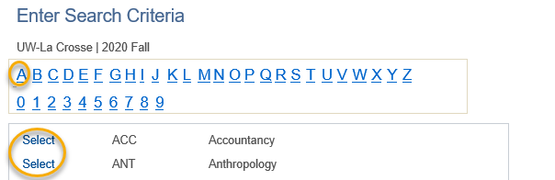

  - The subject you select from the A-Z list should now appear in the Subject field under the Class Search section.
  - If you know the exact course number you are searching for, enter it into the corresponding box and skip ahead to step 14. Otherwise, go to step 9.
  - Select either Graduate or Undergraduate for Course Career.
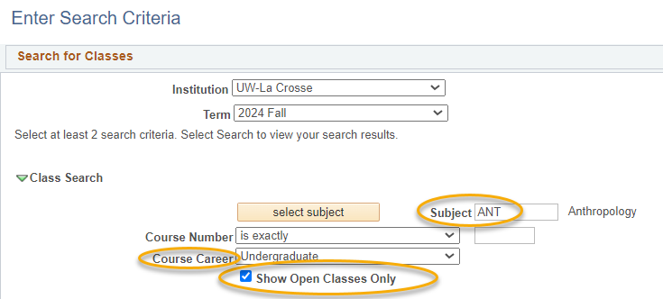

  - The box marked Show Open Classes Only might be checked. Classes closed but which have open seats on a waitlist only show up if this is unchecked.

  - To narrow down search results, select additional search criteria such as: meeting time, day of the week, instructor last name, class number, course title keyword, minimum or maximum units, session, mode of instruction, or requirement designation.

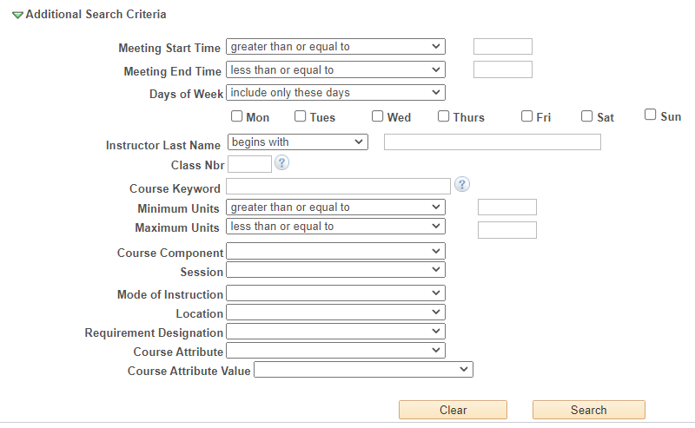

  - Definitions of criteria:
  - Class Nbr - is the 4-digit number assigned to each individual section of the course (not the same number as the 3-digit Course Number) to identify a specific section. Students sometimes get this from an instructor or advisor to direct you to the exact section you need, but it is also listed in the section details.
  - Minimum/Maximum Units - number of credits the course should be
  - Session – to find a course scheduled for a certain length of time
    - For half-semester courses, select either First Session - Seven Week or Second Session - Seven Week.
    - For summer courses, the 3 four-week sessions are most commonly use. However, there are also many other lengths of classes including twelve-week, three-week, six-week, eight-week sessions, and many Dynamically Dated courses. Dynamic Dates are dates that don’t conform to the other session dates in the term. These classes can be much longer or much shorter than average.
  - Mode of Instruction –
    - In-Person (or On-Campus or Face-to-Face): Course takes place in a physical classroom.
    - Hybrid (both In Person & Online), a.k.a. Blended: Course takes place in both a physical classroom and online. This combination of online and in-person elements is based on meaningful learning strategies that best serve an instructor’s pedagogical goals and objectives. While a percentage is not mandated, hybrid courses are traditionally 30% to 50% of seat time replaced with online components.
    - Online Asynchronous: Students do not meet in person at a physical site. All content and course activities take place online. Although there are deadlines for students by which they need to complete work, there are no requirements for a specific date/time when the student must be available.
    - Online Synchronous: Students do not meet in person at a physical site. All content and course activities take place online. Some or all of the class occurs in real time. Online elements can be required (e.g., a lecture or exam) or optional (e.g., office hours or discussion times). The course is listed as online in the timetable and a meeting date/time will be scheduled or in the notes. Enrolled students should schedule other classes/activities around that time.
    - Independent Study: Students work out with their instructor when they meet and what topic they will study. This type of course always requires instructor approval to register. First years and sophomores vary rarely have this type of course.
  - Course Attribute and Course Attribute Value - to narrow down results to a specific type of attribute. UWL has attributes indicating if the course is in a General Education category, a Community Engaged Learning course, or a sustainability related theme or topic. Once you choose an attribute, narrow down the results further by selecting a related Attribute Value.
Important: students who started at UWL in the Summer of 2025 or later follow the 2025 General Education Categories. These new categories begin with GEN ED 1001, GEN ED 1002, etc. Students who started at UWL in Spring of 2025 or earlier follow the General Education Categories that start with GE01, GE02, etc. Please refer to your Advisement Report to see which categories you need to satisfy.

  - Click the Search button when you are ready to see the results.
  - If notified that the search will return over 50 classes, click Cancel to modify your search criteria or click OK to see them all.

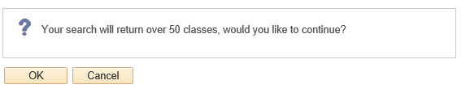

  - Review search results:
  - If you did not enter the exact number of the course you are looking for, all courses that meet your criteria will appear on this page.
  - Open courses have a status marked with a green circle, while closed courses are marked with a blue box. The yellow triangle is on closed courses that have open waitlist seats. Remember, waitlisted courses only appear if Show Open Classes Only is unchecked.

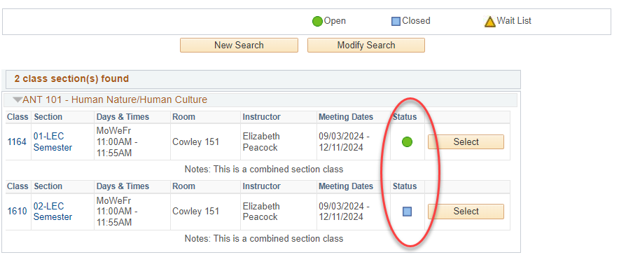

  - To view more information on a particular course, click the linked Section number. Or you can add the class to your Shopping Cart right away by clicking Select.

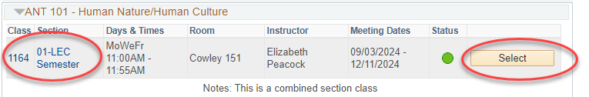

  - Clicking on the linked section number shows the Class Detail page. Information includes number of credits (units), class capacity, available seats left, waitlist information, enrollment requirements (prerequisites), and the course description.
- A course's prerequisites will display in the Enrollment Information section as Enrollment Requirements. If there are no enrollment requirements, the section does not have prerequisites.
- Class Attributes are often the general education category that the course satisfied.
- If the section is part of a combined section, it shows the combined sections' capacity and available seats in all sections. Which sections are combined are also shown. Combined classes normally do not have waitlists.

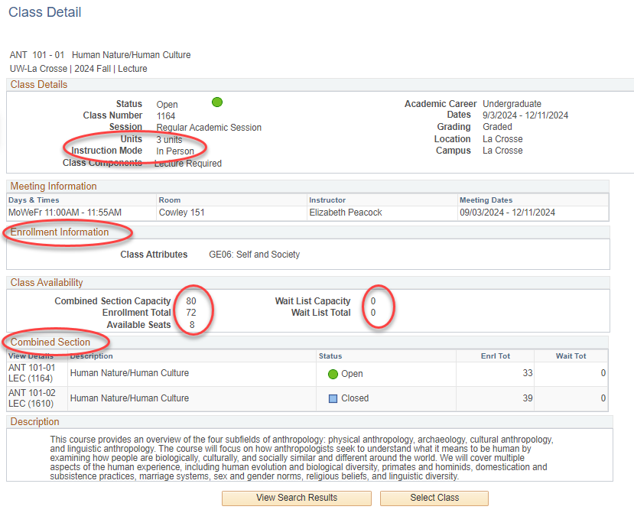

- Links to Class Notes and textbooks are on both the Search Results page and the Class Details page.
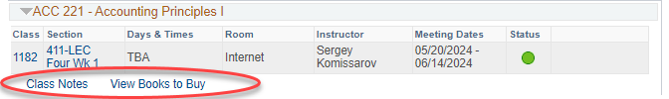

- Class Notes explain anything else the student may need to know about the class, including additional fees that may not be refundable.
- The View Books to Buy link takes you out of WINGS. The booklist does not appear until two weeks before the term starts. The complete textbook list for your registered classes is also available from the drop down list in the Academics section of your Student Center at that time. If there is no Textbook List link, the booklist is not available yet for the term.
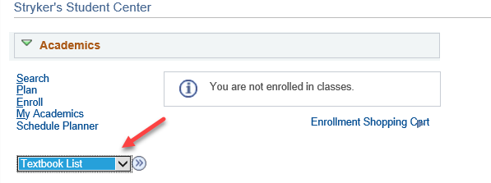
  - Return to the previous page by clicking the View Search Results button.
  - Click the Select button to add the section to your shopping cart.

Important: putting a class in your shopping cart does not reserve you a seat in the class. There are additional steps to registration after the courses are added to your cart. The additional steps only be completed once your registration appointment starts. There are separate directions on "How to Register for a Course using WINGS."

      - For classes with multiple component options such as CHM 103 and CHM 104, you must first select the lab and then select the related section on the Related Class Sections screen. For CHM 103 and 104, the lecture will automatically be added depending on what lab you selected. A small number of other classes offer similar choices in their registration.

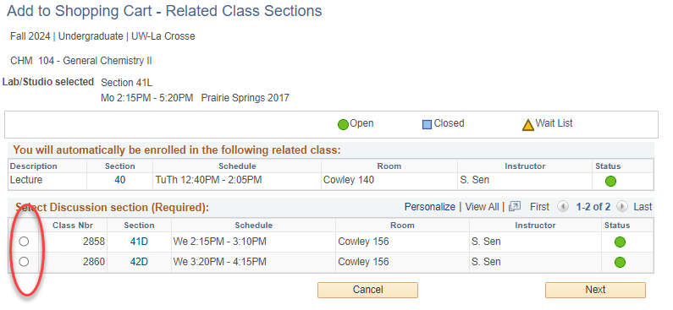

      - If the class is full, you may add yourself to a waitlist by clicking Waitlist if class is full. If there is no option, there is no waitlist set up for this class.

Important: If the class is already in your shopping cart but you didn't check the waitlist box, you will have to drop it out of the cart and add it back in so that you can check the waitlist box. Open waitlist seats are not available for every section. The section will have an orange triangle if it has available waitlist seats.

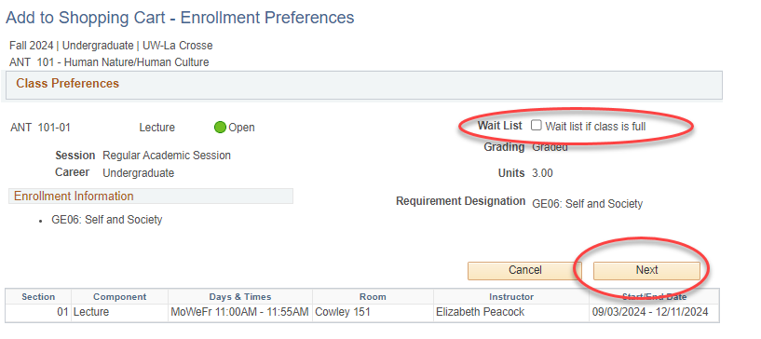

  - Click Next. A green check mark and message at the top means you successfully added the course to your cart.
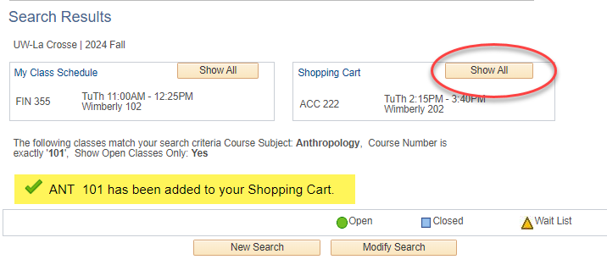

  - To add additional courses, click the New Search or Modify Search buttons and repeat steps.
  - To return to your WINGS shopping cart later, use the enrollment shopping cart link on the WINGS home screen. You can also get to it while you are searching for classes by clicking on the Plan tab, and then the Shopping Cart subtab.

Validating Your Schedule
in Schedule Planner
(a.k.a. checking the prerequisites)

Use the validation feature to check whether you meet all the course prerequisites before you register instead of during the enrollment process. This option gives you more time to make changes to your shopping cart and to obtain any needed overrides before your registration appointment begins.

Directions:
- Develop and save a schedule with one or more courses following the steps in Search for Classes/Creating a Schedule using Schedule Planner.
- Click on the View link next to a potential schedule that you like.
  - If you already have courses in your shopping cart, go directly to the shopping cart by clicking Shopping Cart in the top bar. (If you are on a mobile device, this might be at the bottom.)

- Click Validate.

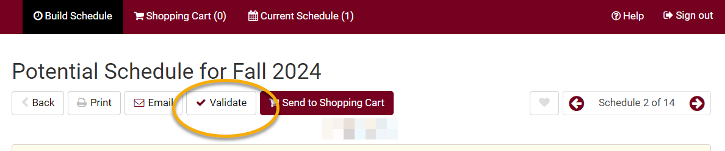

- Review your results and read the messages. Some common messages:

  - A green checkmark means you will be able to register into the course.

  - Hold on record means there is a hold that must be removed before you can register. The most common holds are 1) an advising hold which can be removed after talking with your advisor and 2) a cashiers hold for an outstanding bill which must be paid before you can register. You can see what the hold is by going to your WINGS Student Center and viewing the Holds section on the right.

  - If you receive an Enrollment requisites are not met error, review your Course History to figure out which course or requirement you might be missing. Speak with the department/instructor offering the course if you have questions about the prerequisites.

  - Consent Required means you will need permission from the instructor to get into the class.

  - If you receive a message that starts with "This course has been taken previously," check your Course History to verify if you received a "D" or "F" in that class.

    - For undergraduates, only UWL classes that have been graded with a "D" or an "F" can be repeated at UWL, unless you are allowed to earn credit multiple times in the class. You can repeat a UWL course with any grade at another school. If you received a "C" or higher in a UWL course and register to repeat it, you will be dropped from the class before the start of the term if you do not drop yourself first.
    - If you have transfer credit for the course, you can repeat the course at UWL, but the transfer credit will need to be removed from your record as you usually cannot earn credit twice for a class. Contact Records and Registration at records@uwlax.edu if you would like to repeat a transfer course at UWL.

- The message “The Requirement Designation Option was set to "YES" by the enrollment process” means that the course is a general education or writing emphasis course. If there is a green check mark with it, there is no problem.

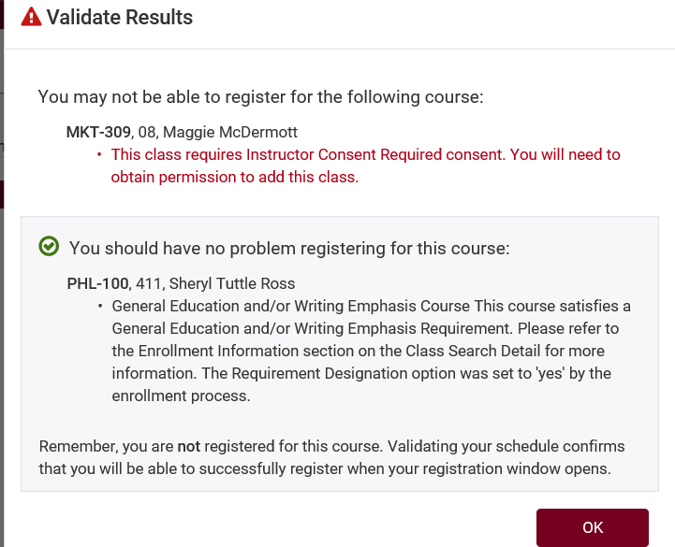

- Change or keep courses, as needed.

- If you add or change courses, be sure to validate again to catch any new errors.

Remember:
- Validate twice! – once when you first build your schedule and again the day before or day of your registration after putting your courses in the shopping cart. Things may have changed between these two dates, plus some issues are not visible until the courses are officially in the shopping cart.
- If the class is closed, check for a waitlist. If there is no waitlist, you may contact the instructor to ask for an override, but please note that the instructor may not approve an override. Many classes do not have the capacity to add additional students.
- If you have questions about registration, contact your advisor or the Records and Registration Office in 117 Graff Main Hall or at records@uwlax.edu, 608.785.8951.

Register for a Class using
Schedule Planner

- Click the Schedule Planner link under the Academic section of your Student Center.
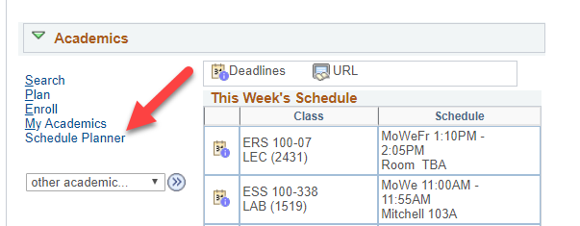

- Select the term that you are registering for and click Save and Continue.

- Search and add courses to your potential schedules by following the steps in the Search for Classes/Creating a Schedule using Schedule Planner" directions.

- Check the courses you'd like to generate a schedule for from your Course list and then click Generate Schedules.

- Review schedules to find the one you like best and click View to see more details.

  - If you have already developed a schedule and saved as a Favorite, go to the Favorites tab to find the schedule, and click View. (More details on how to create a Favorite schedule are in the "Favorite Schedules in Schedule Planner" directions.)
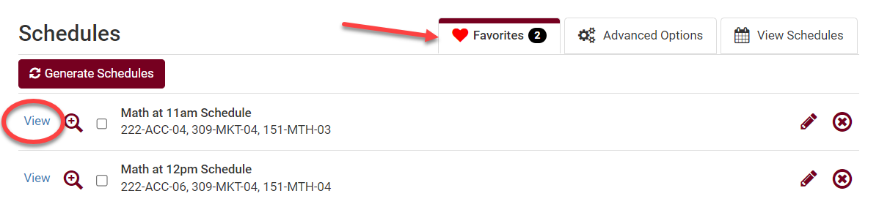
  - When reviewing potential schedules, keep an eye out for sections that are closed with no seats in the class and no seats on the waitlist. You will not be able to get into these classes without an override.
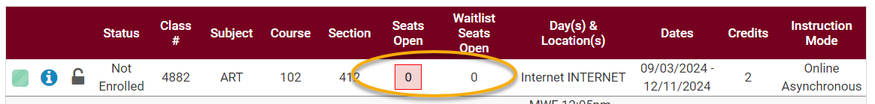
- If you are ready to register into the selected class schedule, click Send to Shopping Cart.
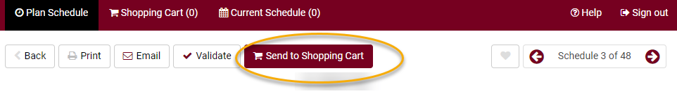

- Review & validate the courses in your Shopping Cart.
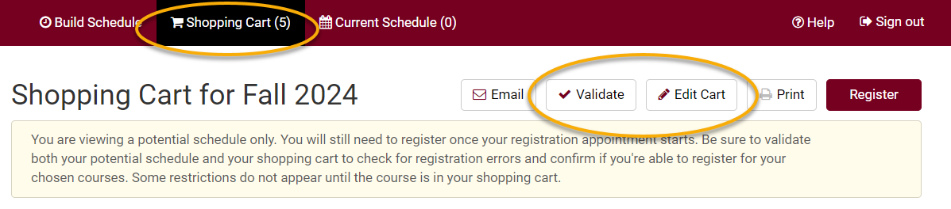
  - Click Validate to verify that you meet the prerequisites before registering.
  - Review your results.
    - A green check mark indicates there should not be a problem registering for those courses, as long as nothing on your record changes.
    - A red warning icon indicates that there is a prerequisite, time conflict, or instructor permission issue. Read the message for further information on the error and how to resolve it.

  - Before registering, drop any courses you do not want from your shopping cart, as the system will attempt to register you into all courses in your shopping cart.
    - Click Edit Cart.
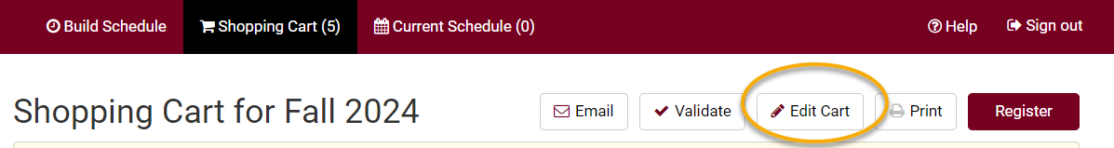

    - Check the Remove from Cart box next to the course and click Save.
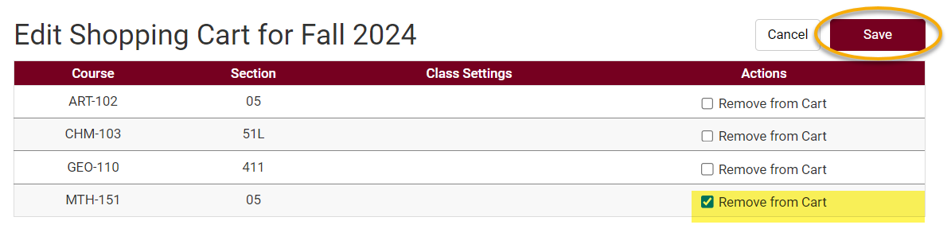
  - To add another course, go back to the Build Schedule page, add another course to your list, and generate a new schedule.

- If your shopping cart is ready and your registration appointment has started, go to your Shopping Cart and click Register.
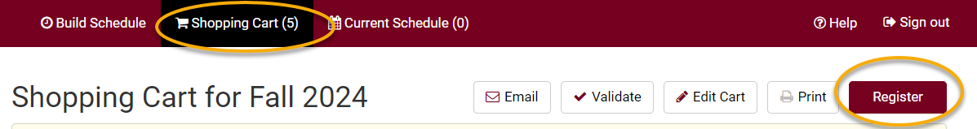

- The Terms and Conditions notification and agreement will appear, which relate to your financial obligations to the university. Click the link to read the terms and conditions. When ready, click Agree and Continue.
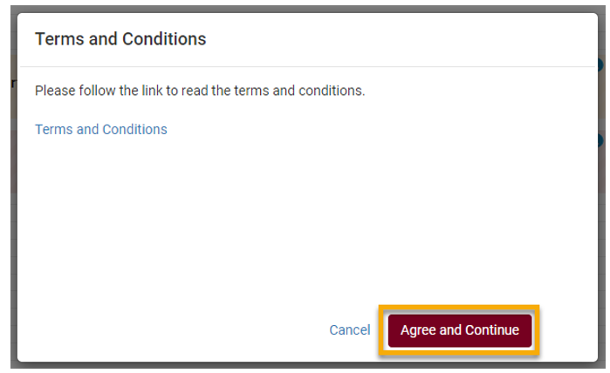

- Next, click Continue to confirm that you want to register for this schedule.
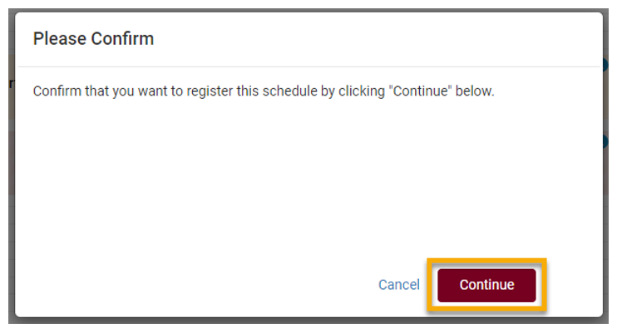

- Review your Registration Results.
  - A green check mark means you successfully registered in the course.
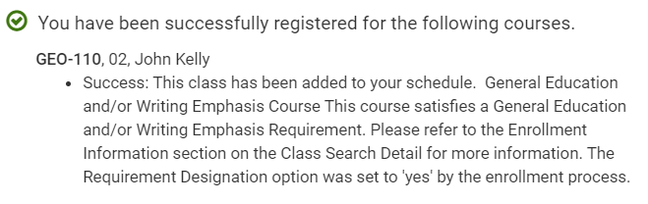
  - A red warning sign means you have not been registered in the course. Read the full message to understand why. If you have questions about the error you received, contact the Records and Registration Office for assistance.
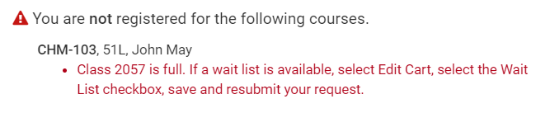
- View your registered schedule to ensure your schedule is as expected. This is found on the Current Schedule tab in Schedule Planner or by looking up your Class Schedule in WINGS.
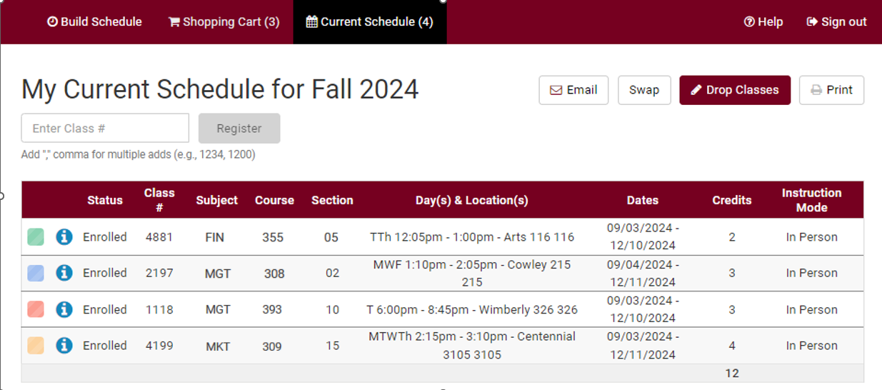
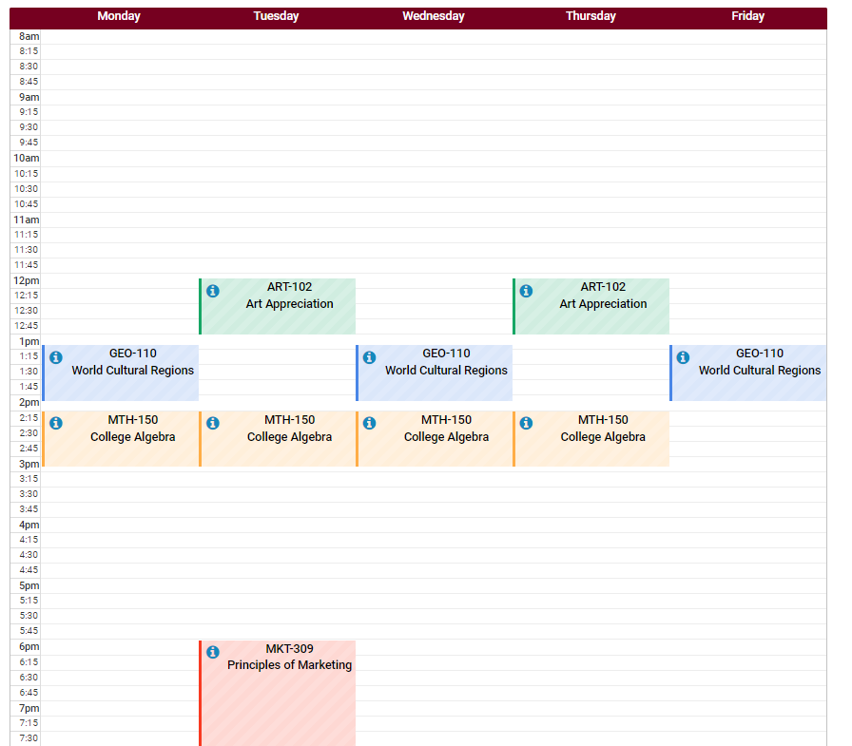

- After registering, you may change your schedule through the start of the term. Deadlines are determined by the length of the class.
  - To drop enrolled classes:
    - Click on Current Schedule tab in Schedule Planner. Click Drop Classes.
    - Check the Drop box next to the course or courses you wish to drop.
    - A message will pop up about the non-refundable registration fee and a reminder to return your textbooks within 24 hours.
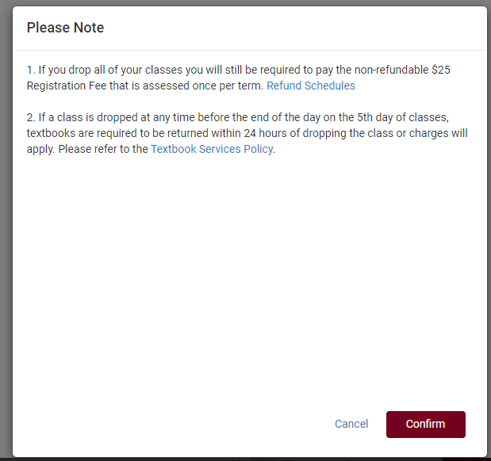
    - Click Confirm.
    - Save.
    - Please note, you can also drop courses through your WINGS by clicking on the Enroll link, selecting the Drop tab, and following the directions.
    - More detailed directions on swapping can be found in the "Dropping in Schedule Planner" directions.

  - To swap enrolled classes:
    - Use the Swap button found on the Current Schedule tab.
    - Select a class already in your schedule.
    - Search for the class you want to switch into using the By Subject, Shopping Cart, or By Class # options.

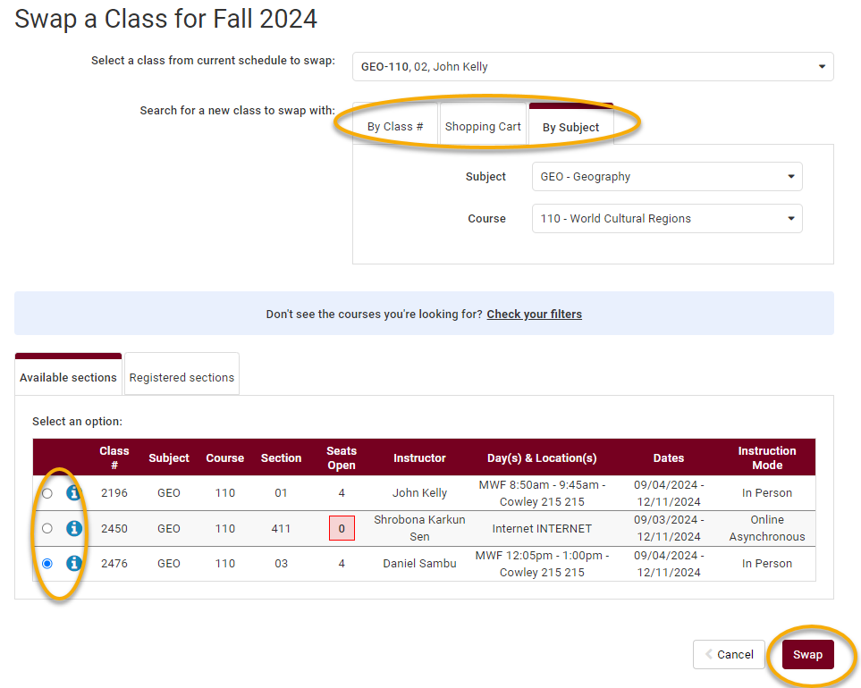
    - If the results provide multiple sections, select the one that will work in your schedule, keeping an eye on whether there are open seats in that section or not. To see if there is a waitlist option, click the blue information icon next to the section and look for Waitlist Seats Open.
    - Review the swap and click Swap if it looks good. Confirm that you want to keep swapping and click Swap again.
    - Review messages. If it was successful, you will see a green checkmark. If was not successful, you will see a red warning icon. Review the error before attempting to swap again.
    - More detailed directions on swapping can be found in the "Swap a Class Using Schedule Planner" and "Swapping onto a Waitlist in Schedule Planner" directions.

- View your course schedule after you register to ensure you have successfully enrolled in your desired courses. In Schedule Planner, that is the Current Schedule tab. In WINGS, that is Class Schedule in the drop-down menu.

Please note:
- After the fifth day for Fall & Spring semesters, you need instructor permission to add their class, even if it has a seat available. The last day to add with permission for a full semester class is the 10th day of classes.
- Winter and Summer terms have shorter deadlines. Classes shorter than full semester also have shorter deadlines.
- Swapping: Swapping into a course with an open seat will automatically drop you from the first course. Swapping onto a waitlist seat means you will stay in the class you intend to drop unless you get into the waitlisted class.
- Overrides: Classes that are closed or have prerequisites that are not satisfied can only be enrolled in with permission from the instructor, department, and/or dean's office, depending on what is being overridden.
    - Overrides can be given electronically up through the 10th day. Students must login to Schedule Planner and register themselves before the deadline after obtaining an override.
    - Closed classes will still appear closed; if you have an override, you will be able to register anyway.
- If a class is dropped any time before the end of the day of the 5th day of classes, textbooks are required to be returned within 24 hours or charges will apply.

Questions?
- Questions about what courses to sign up for, contact your advisor or the Academic Advising Center in 1209 Centennial Hall or at advising@uwlax.edu.
- Questions about an error or have trouble registering, contact the Records and Registration Office for assistance at records@uwlax.edu or 117 Graff Main Hall.

Register for a Class using WINGS

- Login to WINGS and click Enroll in the Academic section.
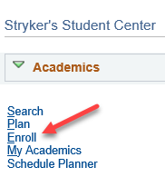

- Make sure you are on the Enroll tab and the Add subtab.
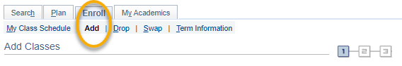
- Select the term that you are registering for and click Continue.
- On the Select Classes to Add screen, the Shopping Cart is the section next to the blue box in the middle. If you have registered in some classes already, they will be in the Class Schedule section.
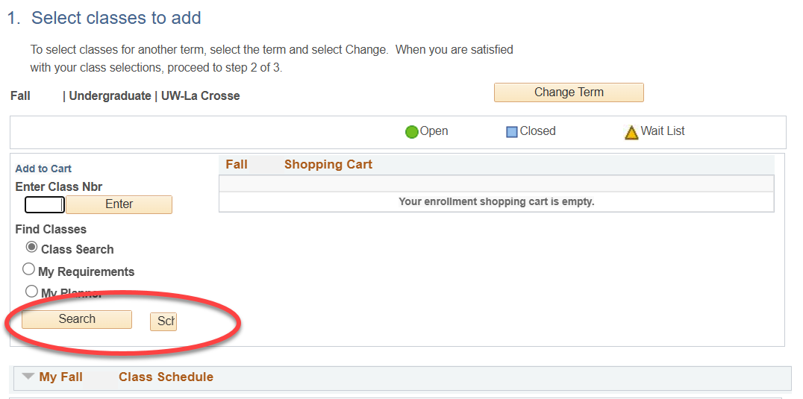

- If you haven't yet, add the desired courses to your Shopping Cart following the steps in the "Search for Classes/Using the Shopping Cart in WINGS Student Center" directions. The course must be in your Shopping Cart before you can register.

- Once you have your courses in the shopping cart, review course shopping cart. The system will attempt to register you for everything in your cart. You may want to remove any classes you aren't sure about or which conflict with another class clicking on the garbage can icon.
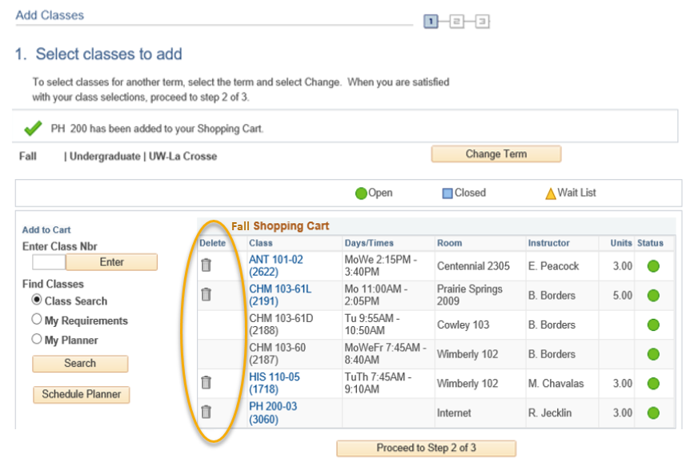

- When your shopping cart is ready, click Proceed to Step 2 of 3.
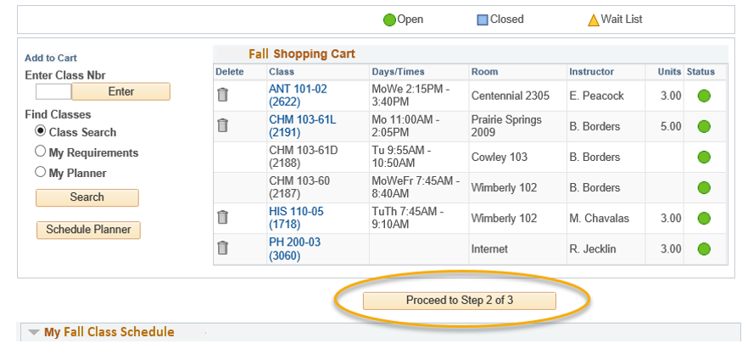

- Review the courses that you wish to add.
  - If you attempt to enroll in courses that conflict with each other, WINGS will automatically enroll you in the one that appears first in the Cart. You will receive a time conflict error for the other one.
- Confirm the list is correct and click Finish Enrolling. Important: this is not the final step!
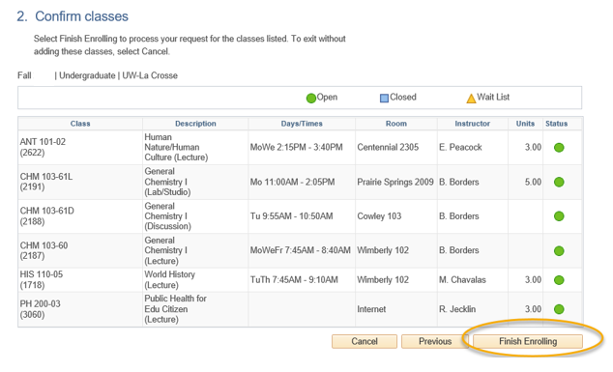
- Next, the Terms and Conditions agreement will appear, which relate to your financial obligations to the university. Click the link to read the terms and conditions. You will be taken to the full agreement listed on the Cashier's website.

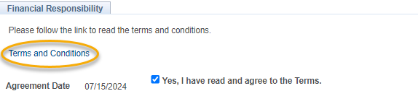
- When ready, check the box next to "Yes, I have read and agree to the Terms" to agree to the terms and continue. Then click the link titled "Continue. You will have to click Finish Enrolling again."
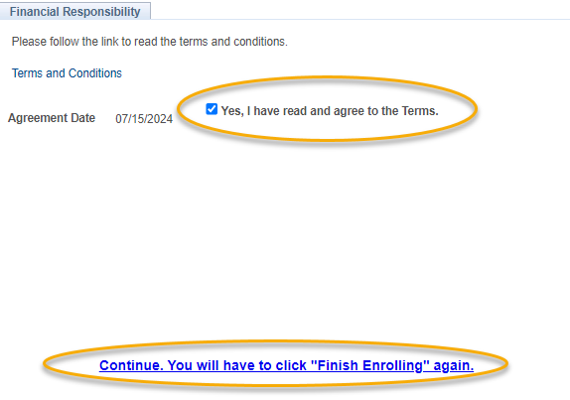

- The Confirm Classes (step 2) page will appear again. Click Finish Enrolling.
- View your results.
  - A green check mark means you successfully registered in the course.
  - A red X indicates that you have not been registered in the course. Read the full message to understand why. If you have questions about the error you received, contact the Records and Registration Office for assistance.
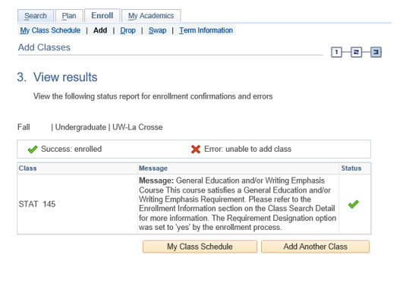

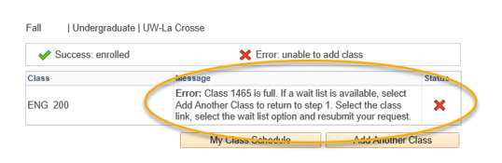

- View your registered schedule to ensure your schedule is as expected. Click on My Class Schedule underneath the results table.

- After registering, you may change your schedule through the start of the term. Deadlines are determined by the length of the class.
  - Review the "Dropping in WINGS" directions for more info on dropping an enrolled class.
  - Review the "Swapping A Class in WING"S or the "Swapping onto a Waitlist in WINGS" for more information on swapping.

Please note:
- After the fifth day for Fall & Spring semesters, you need instructor permission to add their class, even if it has a seat available. The last day to add with permission for a full semester class is the 10th day of classes.
- Winter and Summer terms have shorter deadlines. Classes shorter than full semester also have shorter deadlines.
- Swapping: Swapping into a course with an open seat will automatically drop you from the first course. Swapping onto a waitlist seat means you will stay in the class you intend to drop unless you get into the waitlisted class.
- Overrides: Classes that are closed or have prerequisites that are not satisfied can only be enrolled in with permission from the instructor, department, and/or dean's office, depending on what is being overridden.
- Overrides can be given electronically up through the 10th day. Students must login to Schedule Planner and register themselves before the deadline after obtaining an override.
- Closed classes will still appear closed; if you have an override, you will be able to register anyway.
- If a class is dropped any time before the end of the day of the 5th day of classes, textbooks are required to be returned within 24 hours or charges will apply.

Questions?
- Questions about what courses to sign up for, contact your advisor or the Academic Advising Center in 1209 Centennial Hall or at advising@uwlax.edu.
- Questions about an error or have trouble registering, contact the Records and Registration Office for assistance at records@uwlax.edu or 117 Graff Main Hall.

Drop a Class in Schedule Planner

- Click on the Schedule Planner link from your WINGS Student Center.

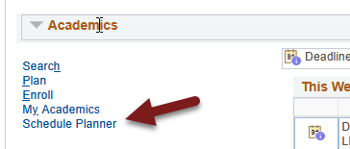

- Go to the Current Schedule in the top tab in Schedule Planner and click on Drop Classes.

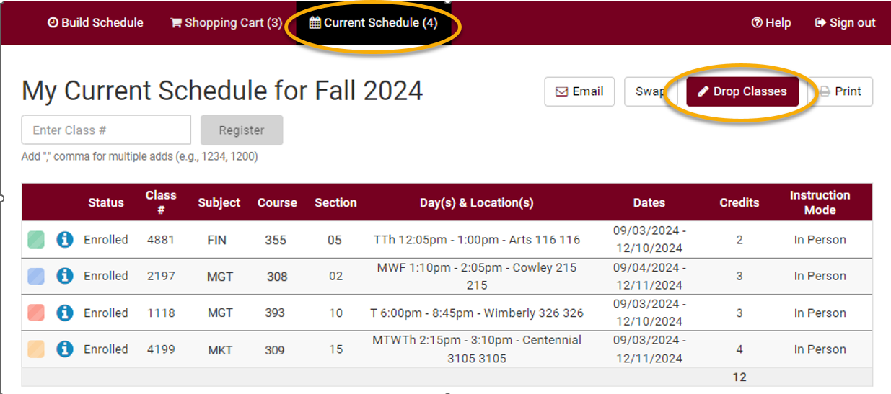

- Check Drop next to the course and click Save.

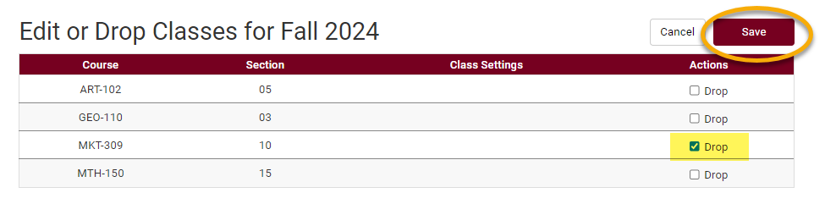

- Messages will pop up with important notifications and warnings.
  - Textbooks must be returned within 24 hours if course is dropped within the first 5 class days or you will incur a fine.
  - If you drop all of your classes, you will still be required to pay the non-refundable $25 fee which is assessed once per term.
  - Withdrawing from a course may change your situation in other ways. Review the considerations for withdrawing from a course before continuing.

- If you still want to drop the class(es), click Confirm.
- On the next window, click Save.
- Review your course schedule on the Current Schedule page to make sure everything is correct.

Please note:

- If you receive an error when trying to drop, read the error message to find out why.
  - You cannot drop below 1 credit on your own. For example, if you are taking one class over the summer, you cannot drop it without help.
  - If you want to drop all classes for a Fall or Spring term after the term has started, this is considered withdrawing from the University. In that case, please contact the Student Life office at studentlife@uwlax.edu. If you are dropping all classes in Summer or Winter, please contact the Records and Registration office.
- After the first 10 days of a semester (deadline is shorter for shorter classes & Winter/Summer), you will receive a "W" grade if you drop a class. "W"s indicate a withdrawal and do not affect GPA.
- The academic deadlines for your classes can be found by clicking on the calendar icon next to the course in your schedule in WINGS, or on the Records and Registration Dates and Deadlines page.
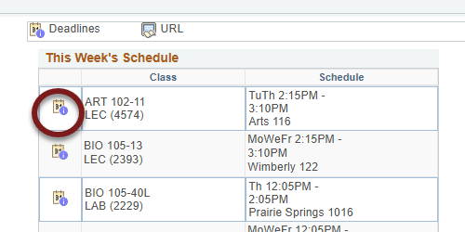

- Refund dates are set by the Cashier's office and are often different than the academic drop deadlines. Tuition for 12-18 credits remains the same in the fall/spring terms. Check the Cashier's website for the dates.
- Questions? If you have questions about what courses to sign up for, please contact your advisor or the Academic Advising Center in 1209 Centennial Hall or at advising@uwlax.edu. If you have a question about an error you are getting or you have trouble registering, contact the Records and Registration Office for assistance at records@uwlax.edu or 117 Graff Main Hall.

Drop a Class in WINGS
      - Click the Enroll link in the Academics section at the top of the page
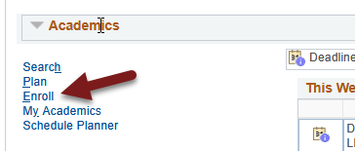

      - Select the Drop tab.
      - Select the appropriate term and click the Continue button. (This step will not be necessary if there is only one active term.)
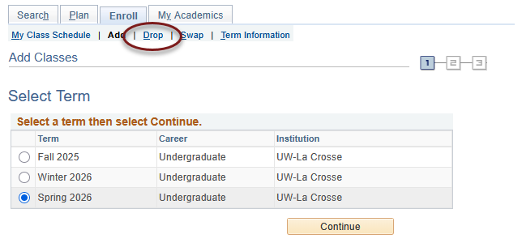

      - Read the caution at the top in red and consider your options.
- Textbooks must be returned within 24 hours if course is dropped within the first 5 class days or you will incur a fine.
- If you drop all of your classes, you will still be required to pay the non-refundable $25 fee which is assessed once per term.
- Withdrawing from a course may change your situation in other ways. Review the considerations for withdrawing from a course before continuing.

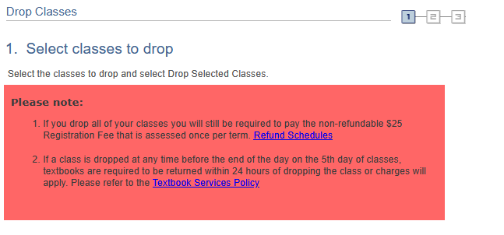
- If you still want to drop the class(es), select the course(s) you wish to drop and click Drop Selected Classes.

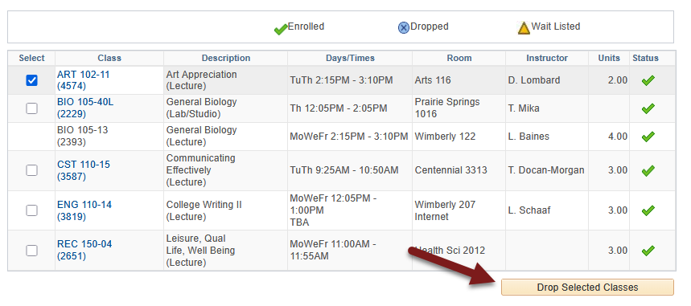

- On the next screen, confirm that the course is correct and click Finish Dropping.
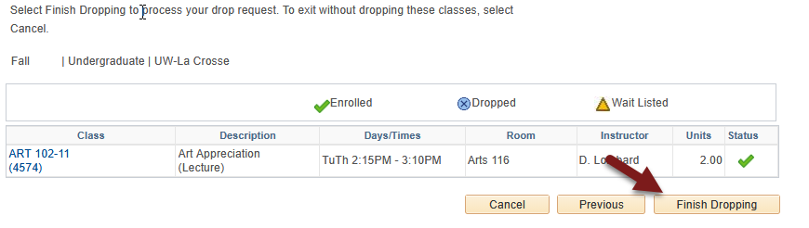

- View your results.
  - A green check mark in the status field indicates that you have successfully dropped that course.
  - A red indicates that you have not successfully dropped the course. If you received a , you no longer have permission to drop the course on your own. Read the error text to find out why. If you have further questions about why you could not drop, contact the Records and Registration Office.

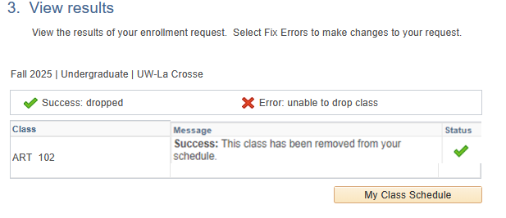

- View your course schedule after this step to ensure that you have successfully dropped all desired courses. Click on the My Class Schedule button underneath the results table.

Please note:

- If you receive an error when trying to drop, read the error message to find out why.
  - You cannot drop below 1 credit on your own. For example, if you are taking one class over the summer, you cannot drop it without help.
  - If you want to drop all classes for a Fall or Spring term after the term has started, this is considered withdrawing from the University. In that case, please contact the Student Life office at studentlife@uwlax.edu. If you are dropping all classes in Summer or Winter, please contact the Records and Registration office.
- After the first 10 days of a semester (deadline is shorter for shorter classes & Winter/Summer), you will receive a "W" grade if you drop a class. "W"s indicate a withdrawal and do not affect GPA.
- The academic deadlines for your classes can be found by clicking on the calendar icon next to the course in your schedule in WINGS, or by checking the Dates and Deadlines page on the Records & Registration website.

- Refund dates are set by the Cashier's office and are often different than the academic drop deadlines. Tuition for 12-18 credits remains the same in the fall/spring terms. Check the Cashier's website for the dates.
Questions? If you have questions about what courses to sign up for, please contact your advisor or the Academic Advising Center in 1209 Centennial Hall or at advising@uwlax.edu. If you have a question about an error you are getting or you have trouble registering, contact the Records and Registration Office for assistance at records@uwlax.edu or 117 Graff Main Hall.

Swap a Class Using Schedule Planner

  - See also "Swapping onto a Waitlist in Schedule Planner."

- Click the Schedule Planner link under the Academic section of your WINGS Student Center. A new window/tab will come up. If you are taken to a page with a green button that says Open Schedule Planner, click on that button.

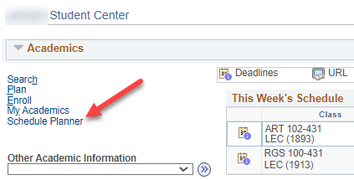

- Select the correct term for your current schedule and click Save and Continue.

- Select and register into your 2nd choice class, if you haven't already, following the Register for a Class in Schedule Planner directions.

Tip: How to figure out if class has a waitlist on the Build Schedule page
- Go to Add Course section and search for course. If you know all sections are full, you will need to first change the Course Status filter to Open & Full to find the course in the search.
- In your Course list, click on Sections.
- There will be a column called Waitlist Seats Open indicating the number of waitlisted seats available. If the course has no waitlist seats left or doesn't have a waitlist at all, it will say 0.
- Click on the blue circle with an 'i' (Section Details) next to the subject to see more information on that section. If there is a waitlist with students on it, there will be a Waitlist Enrollment line. You can also see the Waitlist Seats Open number in the Section Details.
- If there is no Waitlist Enrollment in the details and the Waitlist Seats Open column is at 0, the section does not have a waitlist.

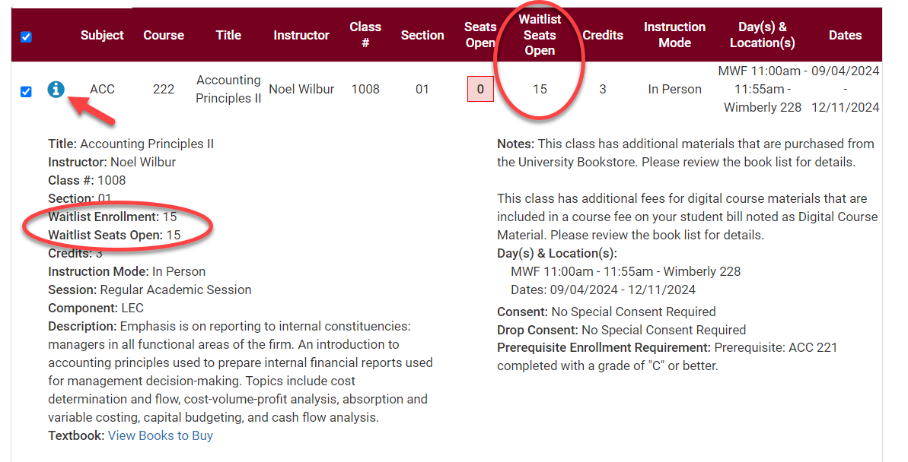

- Go to Current Schedule at the top.

- Click on the Swap button on the Current Schedule page. This will take you to the Swap page.

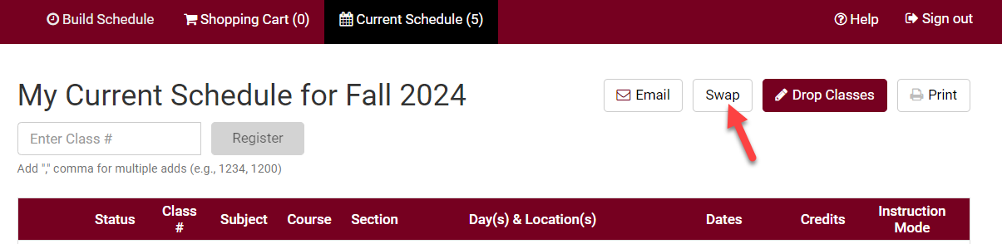

- From the drop down, select the class to be dropped from your current schedule.

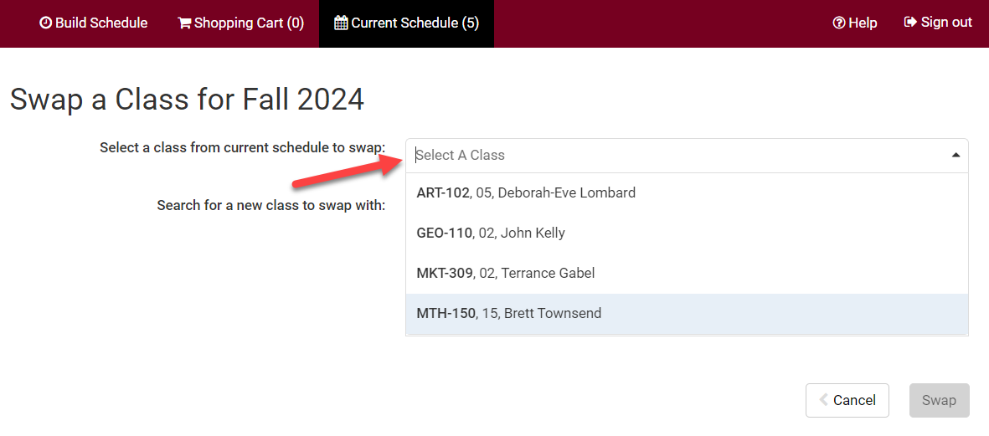

- Search for the class to be added using class number, what's in your shopping cart, or by subject.

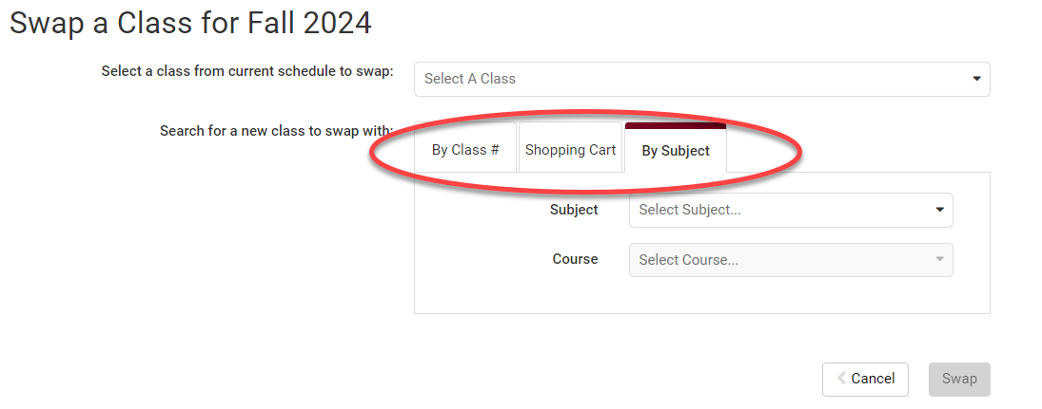

- Review your results. Click on the blue information icon to see if the section has a wait list. Waitlist Enrollment appears if there are students on the waitlist. Waitlist Seats Open appears if there are open waitlist seats. If there is no Waitlist Enrollment and no Waitlist Seats Open, the section does not have a waitlist.

- Select the section you want to add and click Swap.
  - If the Swap button is greyed out instead of red, check that you've selected a course in the "select a class from current schedule to swap" question above.
  - If you can't find the section or course you are looking for, check the Session filter at the top of the Build Schedule page.
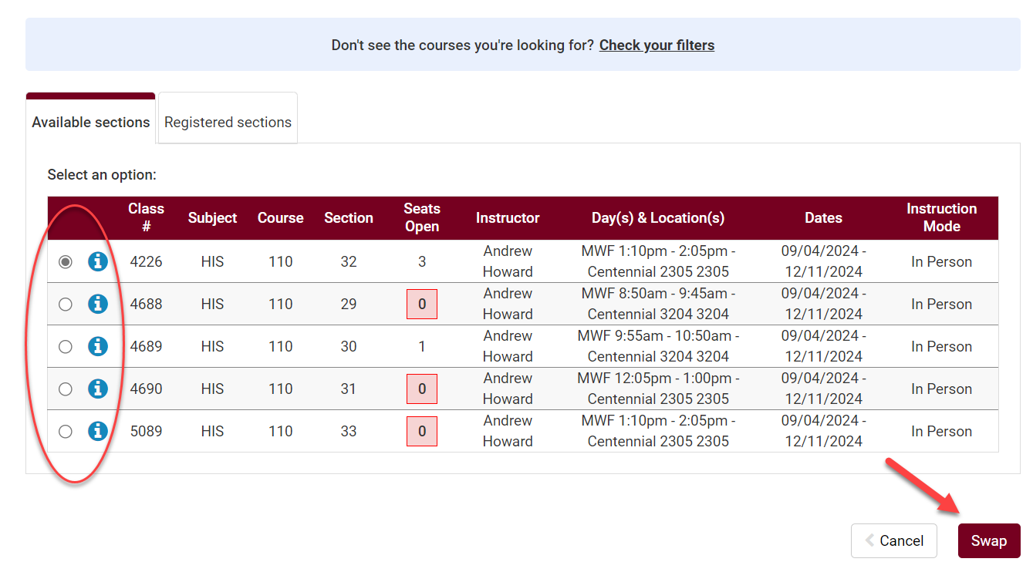

- A message will pop up asking you to confirm. Click Swap to confirm your swap or click Cancel to start over.

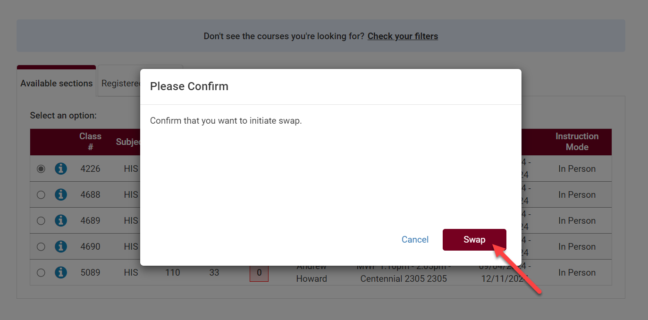

- Review messages:
  - If you are successful in swapping a course, you will get a green checkmark and a success message. Click OK.

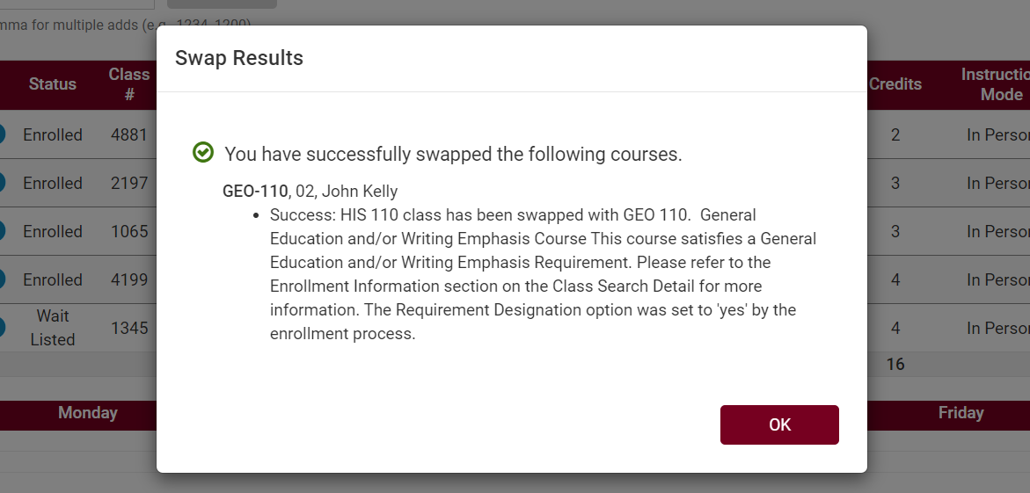

  - If there is an issue, an error message will explain why the swap cannot occur.

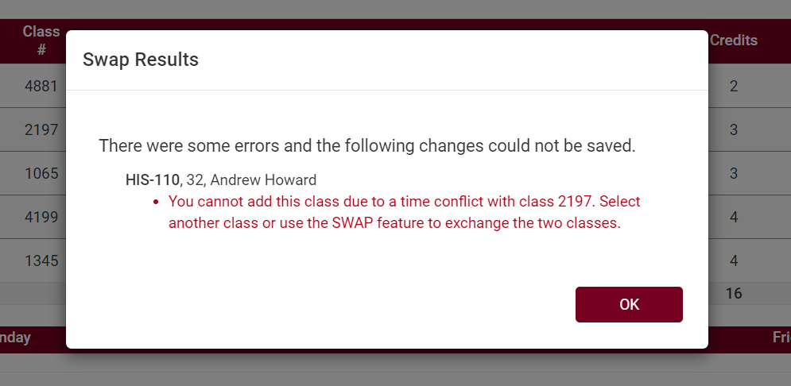

  - If there are no open seats in a class and the wait list wasn't selected, you will get a message that the course is full.

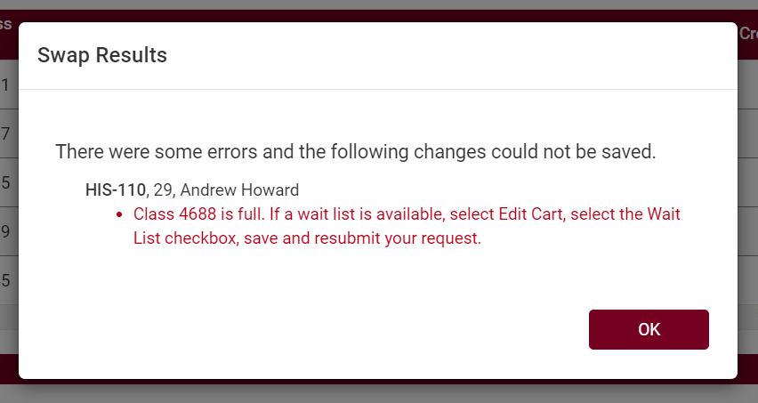

    - If the course does not have a wait list, you will need to find a different section. Or you check with the instructor to see if they are allowing any overrides.
    - If the course has a wait list, you can try the swap using these methods:
      - If the course is in your shopping cart, go to the Shopping Cart, select Edit Cart, and click Wait List?. Then try swapping again.
      - If the course was not in your shopping cart, try the swap again and be sure to select the box next to Wait List? on the next page that comes up after clicking Swap.
    - See Swapping onto a Waitlist in Schedule Planner directions for more info.

Please note:
- Swapping is most useful when you don't want to drop a class unless you can get into another class at the same time.

- Waitlists end at the start of the term, but you can still swap into open classes through the 10th day of classes for a full semester course.

- If you have any questions about the waitlist or swapping, contact your advisor or the Records and Registration Office at records@uwlax.edu or 117 Graff Main Hall.

Swap a Class in WINGS

*See also Swapping onto a Waitlist in WINGS.

- In your WINGS, click the Enroll link under the Academics section.

- Select the term and click the yellow Continue button.

- Select the Swap tab. Then choose the course from your schedule that you would like to swap out from the select from your schedule drop-down menu.

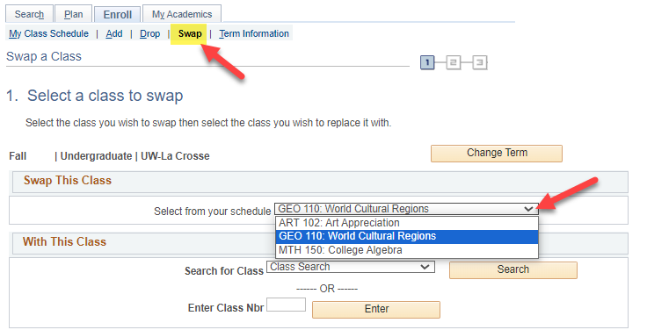

- Search for the course that you would like to swap it with by clicking Search or by entering the four-digit Class Nbr that is assigned by WINGS to individual sections.

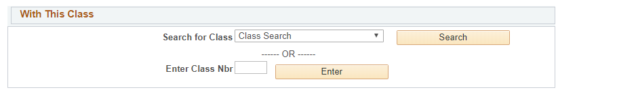

- If you entered the Class Nbr, click Enter. If you found the section in the search, click Select next to the section you want.

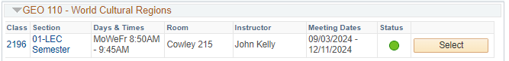

- Review the section to see which one of the following applies:
  - If it is open, it has a green circle. Click Next to continue.
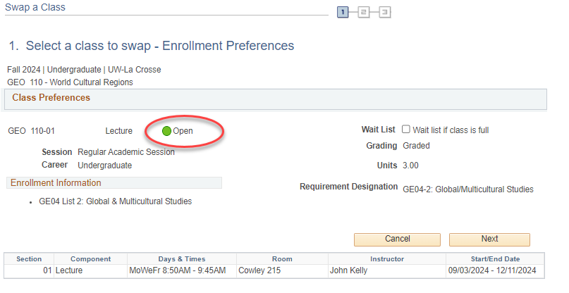

  - If the section is closed (no seats available), there will be a blue box at the top. You will not be able to swap with this class unless you have an electronic class permission (a.k.a. override). If you have an override, click Next to continue.
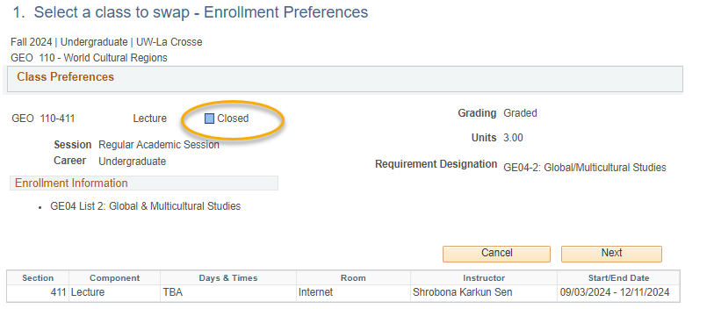

  - If it is closed but has a waitlist, it will have a yellow triangle. To get on the waitlist for a class with a yellow triangle during the swap, select the waitlist if class is full option. Click Next to continue.
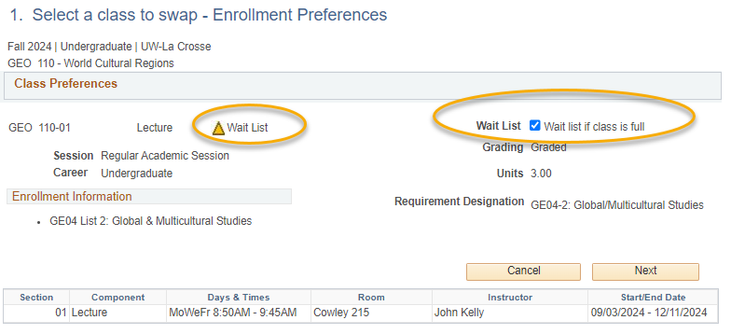

- Review the swap and then click the Finish Swapping button if you are ready to continue. Or click Cancel to start over.

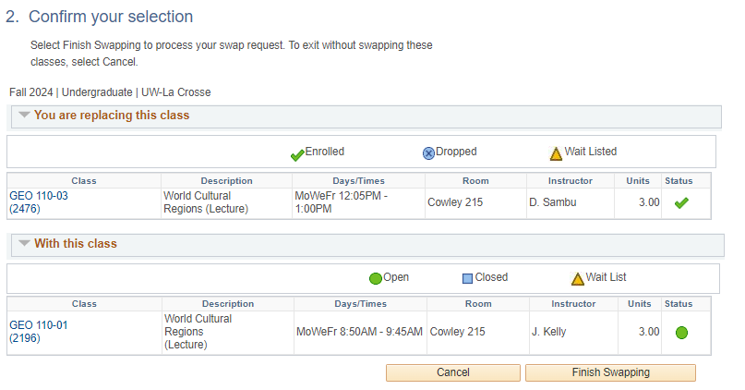

- View results.
  - A green check mark in the status field indicates that you have successfully swapped courses.
  - A red indicates that you have not successfully swapped. If you received an , review the error text to understand why. If you need help understanding why the error, contact the Records and Registration Office.

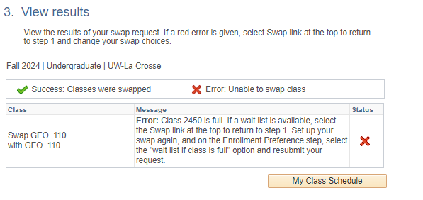

- Review your class schedule to ensure that you have successfully swapped your courses.
- Some reasons why it might not swap:
  - There is a time conflict in your schedule with the class you are swapping into.
  - The class is full, or the waitlist is full.
  - The class you are swapping out of or into has linked sections such as a discussion or lab that are causing conflicts or don't have a seat, even though there is a seat in the lecture.

Please note:
- Swapping is most useful when you don't want to drop a class unless you can get into another class at the same time.

- Waitlists end at the start of the term, but you can still swap into open classes through the 10th day of classes for a full semester course.

- If you have any questions about the waitlist or swapping, contact your advisor or the Records and Registration Office at records@uwlax.edu or 117 Graff Main Hall.

Class Schedule Calendar View

See it in Schedule Planner
- Login to WINGS.
- Use the Schedule Planner link on your home page, under the Academics area.

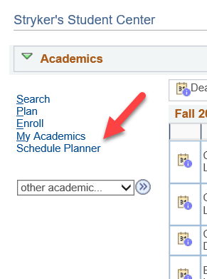

- If another screen opens before Schedule Planner, click on the Open Schedule Planner button.
- Select your term. Save and continue.
- Select Current Schedule from the ribbon at the top

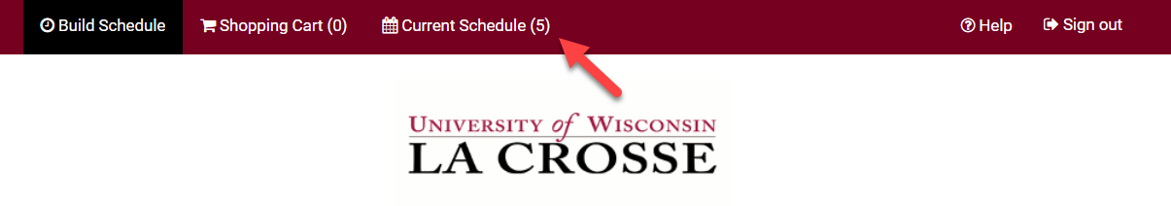
- The Current Schedule page has your enrolled classes in a list at the top, with the modes of instruction listed in the far-right column. Scroll down to view the weekly calendar of your schedule.
  - Classes that have no set meeting times are included in the list at the top, but not in the calendar view. Some examples are classes with individually arranged meetings or online asynchronous classes.
  - Waitlisted classes have a status of Wait Listed in the top list. They are also included in the weekly calendar, but remember, you are not enrolled in a wait listed class until the status changes to Enrolled.
  - To drop a class from your current schedule, select the Drop Classes button in the top right, below the ribbon. Drop dates will apply.
  - To print, select the Print button in the top right corner, below the ribbon.

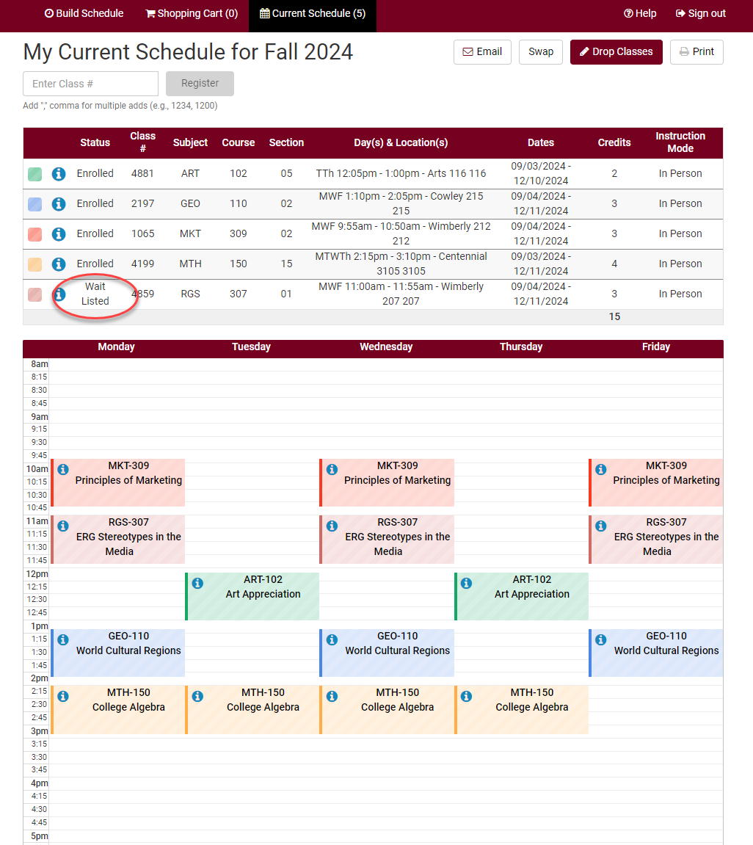

See it in WINGS Student Center
- Login to WINGS.
- In the Academics area of your home page, select the Weekly Schedule link.

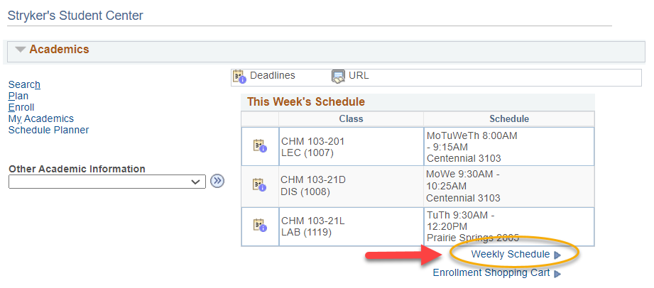
- If asked, select the correct term.
- The Weekly Calendar View option will be selected at the top. You can switch to the List View to view your courses in a list instead.

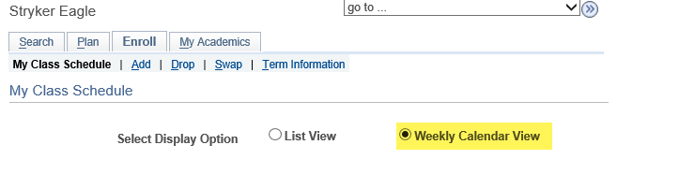

- To make sure you are seeing the correct schedule, check the dates being displayed in the Show Week of line. Use the Previous Week or Next Week fields to adjust to see a specific week (especially for summer courses).
  - For Fall schedules, the first week starts on a Tuesday. To see your week with Monday included, use the Next Week button to move ahead to the first full week.
  - Classes that have no set meeting times are listed below the weekly calendar. Examples are classes with individually arranged meetings or online asynchronous classes.
  - You may print by using the print options in your browser.
- If you see orange or a yellow warning icon, that may indicate a time conflict, but it may also indicate the class is using multiple rooms or that two classes are splitting the hour on the grid. Look closely at the times to make sure there is no conflict. If there is no conflict, you don't need to be concerned. If there is a conflict, contact the Records and Registration office for help.

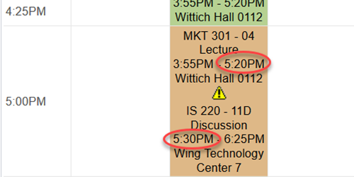

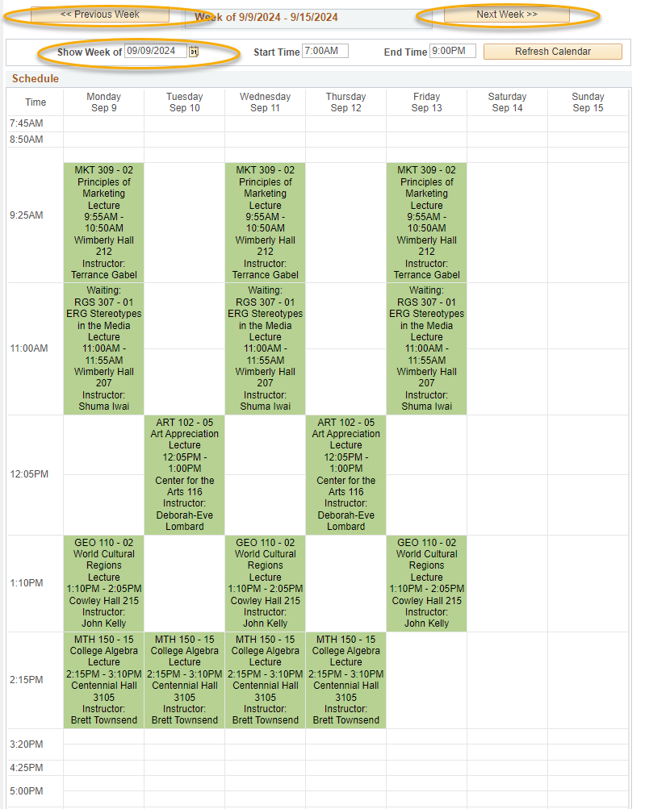

Final Exam Schedules

Your individual Final Exam Schedule will be available in WINGS mid-way through the semester. Each class should also list when your final exam is in the syllabus.

- Log into WINGS and open the drop-down menu in the Academics section. Select Exam Schedule and click on the arrow button.

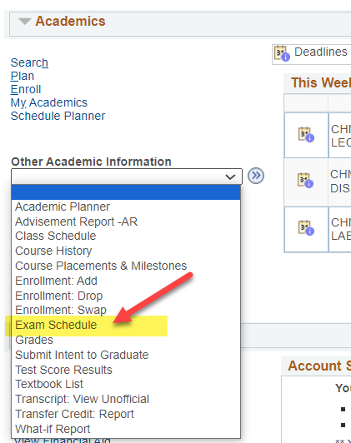

Alternate way to find it: There is also a link to your final exam schedule from your normal Weekly Schedule page. Your normal class schedule and final exam schedule have to be viewed in separate calendars.
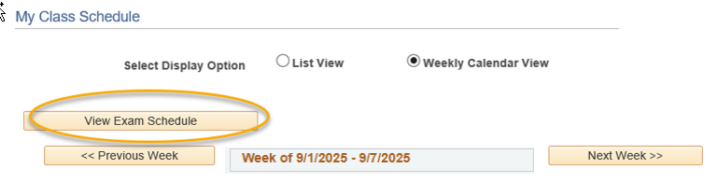

- If the schedule has not been entered yet, the message will say "an exam schedule is not available for this term."

- If the schedule has been entered, your courses will be listed with the dates, times, and assigned rooms for the final.

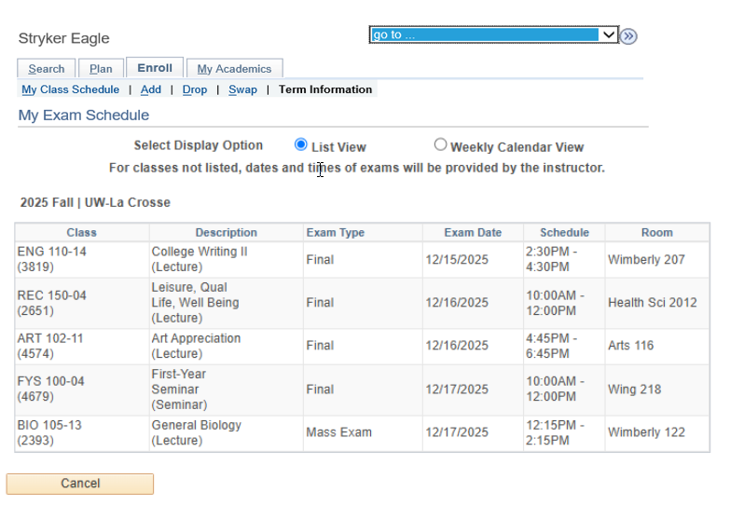

Important: For classes not listed, dates and times of exams will be provide by the instructor. Check your syllabus or with your instructor to be sure.

- Click on the Weekly Calendar view option at the top to see the times in a calendar grid. Remember, the calendar grid goes by weeks.

Important: In the Fall, finals week starts in one week and ends in the next. Use the Next Week/Previous Week buttons to change weeks.
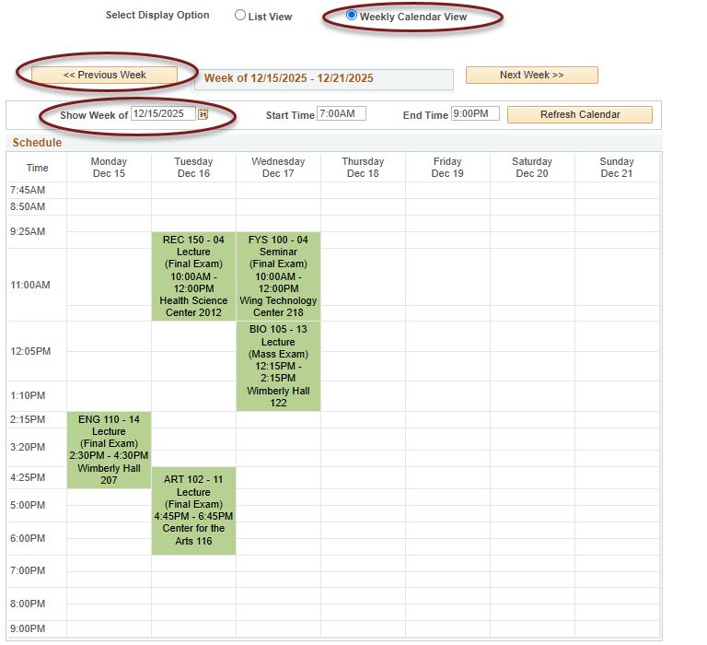

Academic Deadlines for Your Classes
The upcoming academic deadlines for the semester are listed on the Records & Registration's Dates and Deadlines page. You can also find them in your class schedule in the WINGS Student Center as shown below.

Deadlines are prorated for shorter classes, meaning the deadlines will also be shorter. If your class is not the normal semester length, use the below method for finding the exact drop dates.

Please note that tuition refund dates are not always the same as the academic deadline to drop a course. The Cashiers Office lists the refund deadlines in each refund schedule for the term.

Finding the deadlines from your schedule
- Login to WINGS. A list of your enrolled classes for the current or upcoming term show on your home page, in the Academics area.

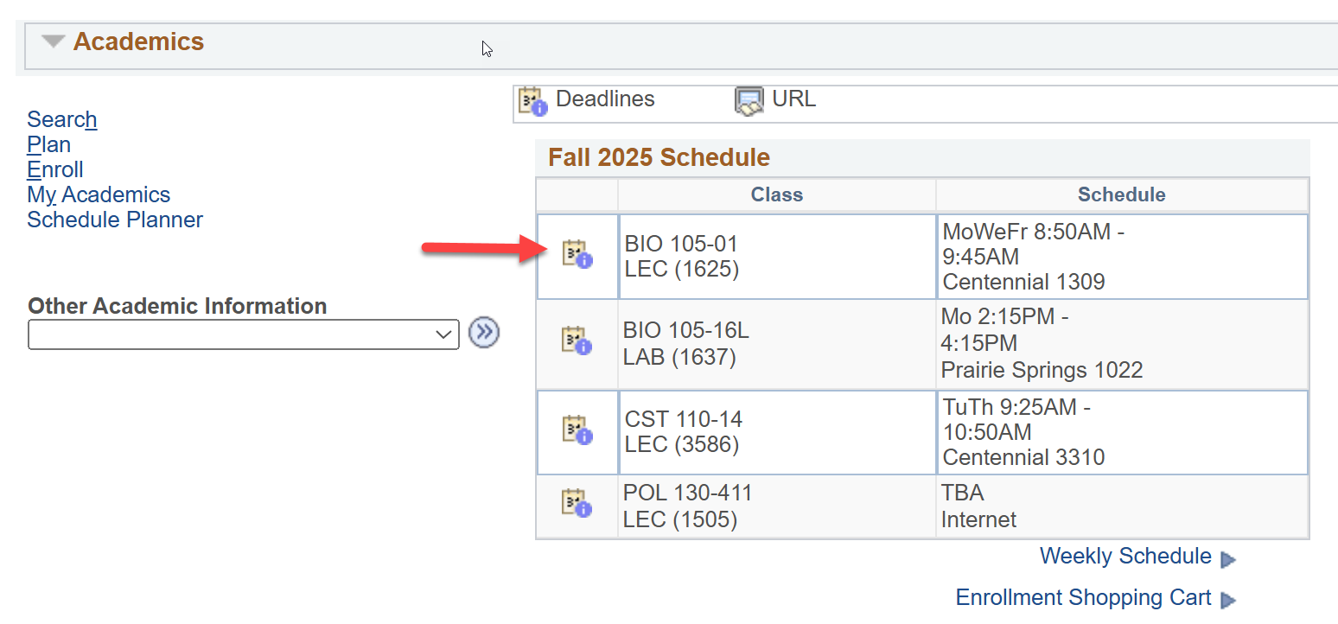

- The Academic Calendar Deadlines icon is the number 31 inside a box with a small circle with an "i" in the corner, and it is meant to represent a calendar page. Select the icon next to the class you are checking.

  - If you are registered into two terms and want to look at the dates for a class in a future term, click on the Other Academic Information drop down in the Academics area.
  - Select Class Schedule.
  - On the next page, select the correct term.
  - There will be a Deadlines icon in the line above each class listed.

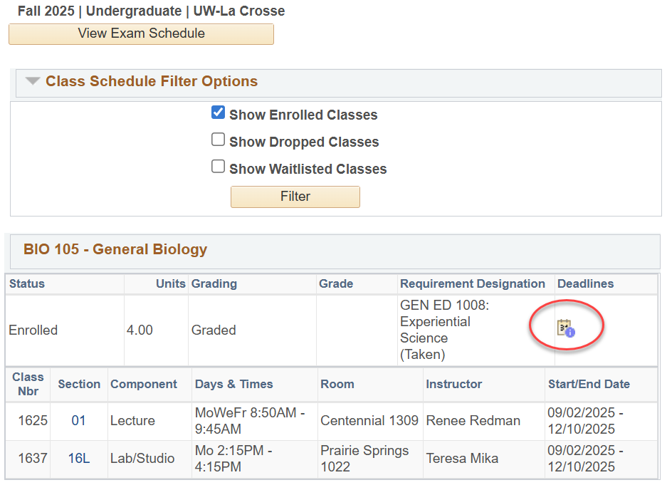

- After clicking on the Deadlines icon, a page will come up with a list of applicable academic deadlines for that specific class. The definitions of each deadline are listed below.

Definition of deadlines
- Drop Calendar section
  - Drop – Retain Record:
    - Last day to drop without a "W" grade.
    - A class dropped on or before this date will not appear on your transcript.
  - Drop with Penalty:
    - Last day to drop with a "W" grade.
    - A class dropped after the Drop-Retain Record date and on or before this date will appear on your transcript with a grade of "W."
- Cancel & Withdrawal Calendar section
  - Cancel:
    - Day before the class starts.
    - If it is the last course in your schedule, the last day to drop the course without officially withdrawing from UWL.
  - Withdraw without Penalty:
    - Last day to drop without a "W" grade and same date as the Drop-Retain Record.
    - A class dropped on or before this date will not appear on your transcript.
    - The official date of withdrawal will be recorded on your transcript if you withdraw from all classes at UWL after the term starts.
  - Withdraw with Penalty:
    - Last day to drop with a "W" and same date as Drop with Penalty.
    - Your instructor or advisor's permission is required to withdraw after the Withdraw without Penalty date (a.k.a. after the change of schedule period).
    - A class dropped after the Withdraw without Penalty date and on or before this date will appear on your transcript with a grade of "W."
    - The official date of withdrawal will be recorded on your transcript if you withdraw from all classes at UWL after the term starts.
  - Withdraw with Greater Penalty:
    - Last day to withdraw from all classes at UWL without a medical reason or military orders.
    - Withdrawal from the university is not allowed after the three-quarter point of the term, except for documented medical reasons or active-duty military orders.
    - A grade of "WP" or "WF" will appear if the withdrawal falls after the last day to drop with a "W" date. A grade of "WF" is calculated as an "F" in the GPA.
    - The official date of withdrawal will be recorded on your transcript if you withdraw from all classes at UWL after the term starts.

Considerations when withdrawing from a class

Offices that can assist
- Office of Student Life
  - When to contact
    - Withdrawing from all spring/fall classes
    - Withdrawing from Winter class and not coming back in Spring
    - Withdrawing from your last Summer class and not coming back in the Fall
  - Contact information
    - studentlife@uwlax.edu
    - 608.785.8062
    - 149 Graff Main Hall
- Office of Records and Registration
  - When to contact
    - Withdrawing from Winter class but coming back in Spring
    - Withdrawing from last Summer class but coming back in Fall
    - Any questions about dropping a course
  - Contact information
    - records@uwlax.edu
    - 608.785.8951
    - 117 Graff Main Hall

Register onto a Waitlist in Schedule Planner
  - - Without a Swap -

To register onto a wait list using Schedule Planner:

- Open Schedule Planner and set your Course Status filter to Open and Full to get all courses. Schedule Planner does not show closed classes in the search results when the filter is set to Open Classes only.

- Find the class you want following the Search for Classes in Schedule Planner directions and add to your Course lists on Build Schedule page.

Tip: How to figure out if class has a waitlist on the Build Schedule page:
- Go to Add Course section and search for course.
  - If you know all sections are full, you will need to change the Course Status filter to Open & Full to find the course in the search.
- In your Course list, click on Sections.
- There will be a column called Waitlist Seats Open indicating the number of waitlisted seats available. If the course has no waitlist seats left or doesn't have a waitlist at all, it will say 0.
- Click on the blue circle with an 'i' (Section Details) next to the subject to see more information on that section. If there is a waitlist with students on it, there will be a Waitlist Enrollment line. You can also see the Waitlist Seats Open number in the Section Details.
- If there is no Waitlist Enrollment in the details and the Waitlist Seats Open column is at 0, the section does not have a waitlist.

- Click Generate Schedules and review until you find the right one. Click View.

- Once you have selected the potential schedule, click Send to Shopping Cart.

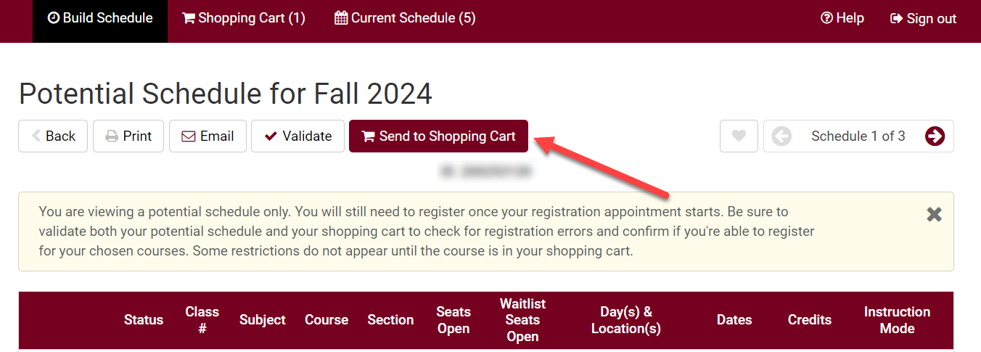

- As you add to the shopping cart, each section with an available waitlisted seat will show up with a "Waitlist?" option.

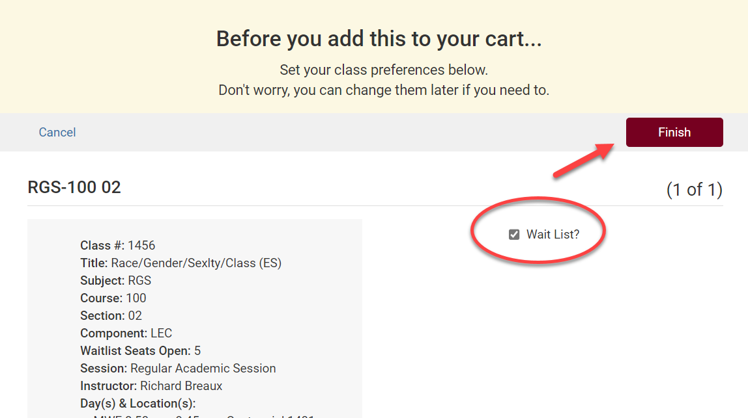

- Checkmark the Waitlist? box and click Finish.

Tip: Use the SWAP feature in your WINGS Student Center to get on a waitlist if you want the system to drop you from a different class if a seat opens up in this one. See Swapping onto a Waitlist in Schedule Planner.
- Click Register and proceed through the registration steps.

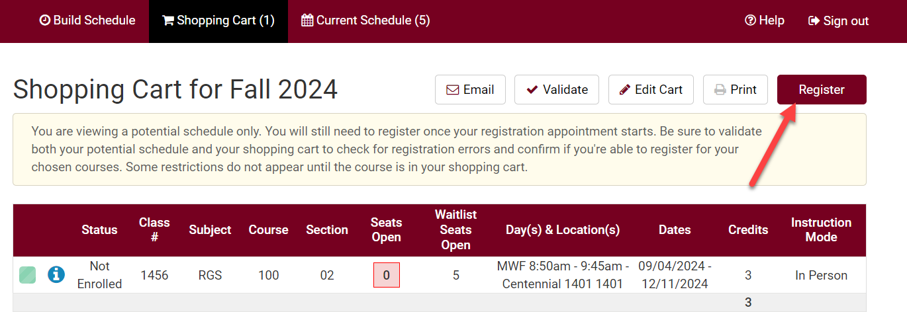

- Review your results.
  - If successful, you will receive a message with a position number (1 being highest).

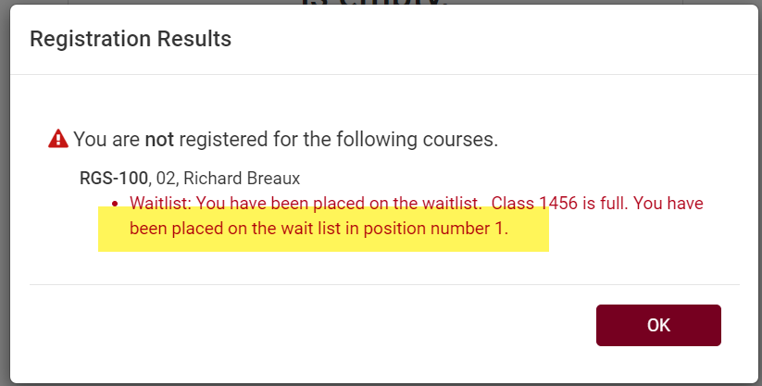

  - If you forgot to check the waitlist box, you may get a message saying the course is closed with directions on how to get on the wait list.
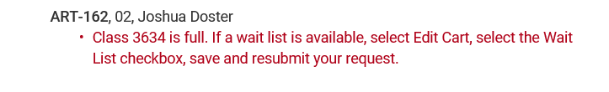
  - If you get a "class is full" message at registration, return to your Shopping Cart and click Edit Cart to see if the section has waitlist as an option. If the section has a waitlist with seats available, the Waitlist? box will appear for you to check. Click that box and then Save.
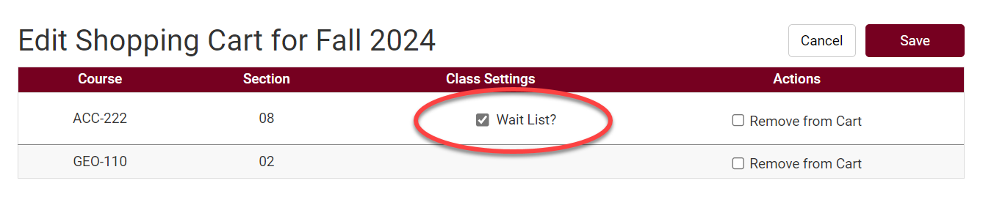
  - Then click the Register button again.

- The waitlisted class will display in your class schedule, under the Current Schedule tab, with a status of Waitlisted.

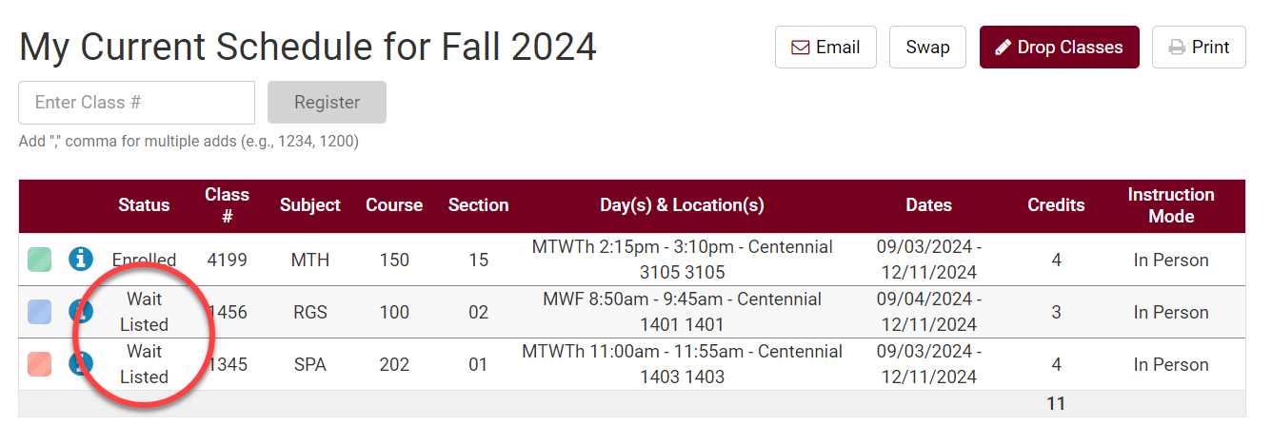

See the Swapping onto a Waitlist in Schedule Planner section for directions on how to swap with a waitlist. See the Waitlist FAQs for more information about how waitlists work.

Swapping onto a Waitlist in

Schedule Planner

The class you want is closed but has a waitlist. You don't want to drop your 2nd choice unless you get into your 1st choice. What do you do?

Enroll using Swap - this puts you on the waitlist of your 1st choice and identifies which class to drop if you get in. If a seat becomes available and you are enrolled in the class successfully, WINGS will drop your backup class at the same time. If you never get enrolled into your 1st choice, you remain enrolled in your 2nd choice.

Directions:
- Click the Schedule Planner link under the Academic section of your WINGS Student Center. A new window/tab will come up. If you are taken to a page with a green button that says Open Schedule Planner, click on that button.

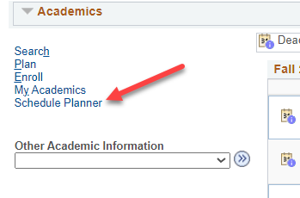

- In Schedule Planner, select the correct term for the current schedule and click Save and Continue.

- Register into your 2nd choice class, if you haven't already.

Tip: How to figure out if class has a waitlist on the Build Schedule page
- Go to Add Course section and search for course.
  - If you know all sections are full, you will need to change the Course Status filter to Open & Full to find the course in the search.
- In your Course list, click on Sections.
- There will be a column called Waitlist Seats Open indicating the number of waitlisted seats available. If the course has no waitlist seats left or doesn't have a waitlist at all, it will say 0.
- Click on the blue circle with an 'i' (Section Details) next to the subject to see more information on that section. If there is a waitlist with students on it, there will be a Waitlist Enrollment line. You can also see the Waitlist Seats Open number in the Section Details.
- If there is no Waitlist Enrollment in the details and the Waitlist Seats Open column is at 0, the section does not have a waitlist.

- Go to Current Schedule at the top.
- Click on the Swap button on the Current Schedule page. This will take you to the Swap page.

- From the drop down, select the class that should drop from your schedule if you get into the other class.

- Search for the class with the waitlist by class number, shopping cart, or subject.

- Review your results.
  - Click on the blue information icon to see if the section has a wait list. A Waitlist Enrollment appears if there are students on the waitlist. Waitlist Seats Open appears if there are open waitlist seats. If there is no Waitlist Enrollment and no Waitlist Seats Open, the section does not have a waitlist.
  - If you can't find the section or course you are looking for, check the Session filter at the top of the Build Schedule page.

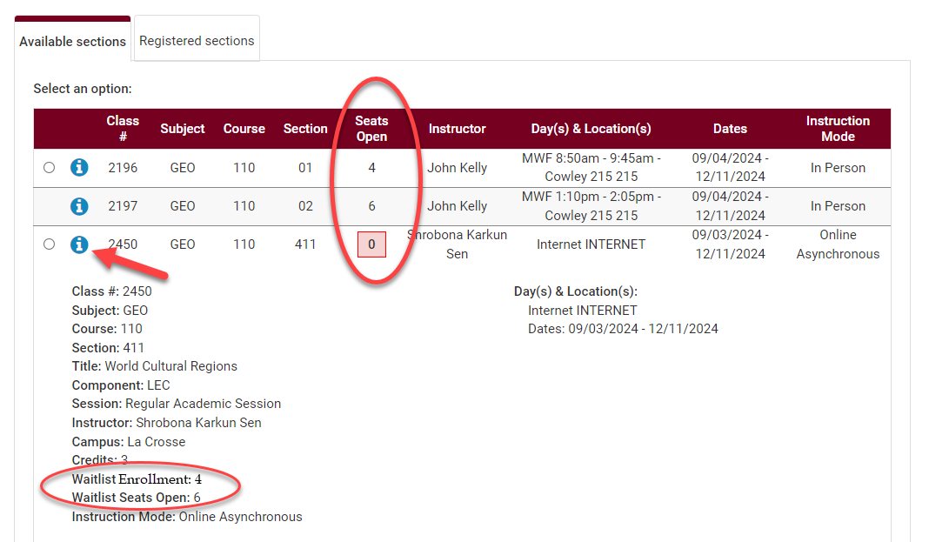

- Select the class section you want to swap and click Swap.

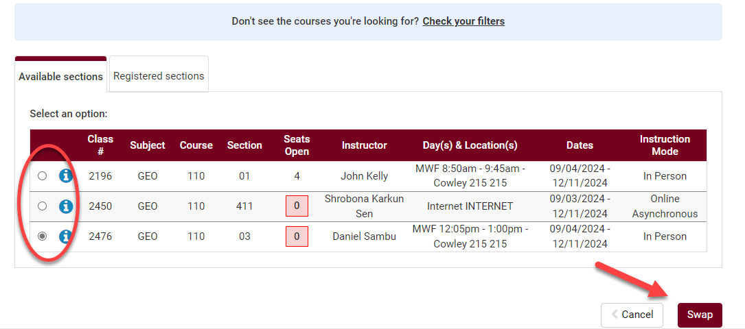

- When there are waitlist seats available, the next screen will show the section details and a Wait List? box. Check the Wait List? box and click Finish.

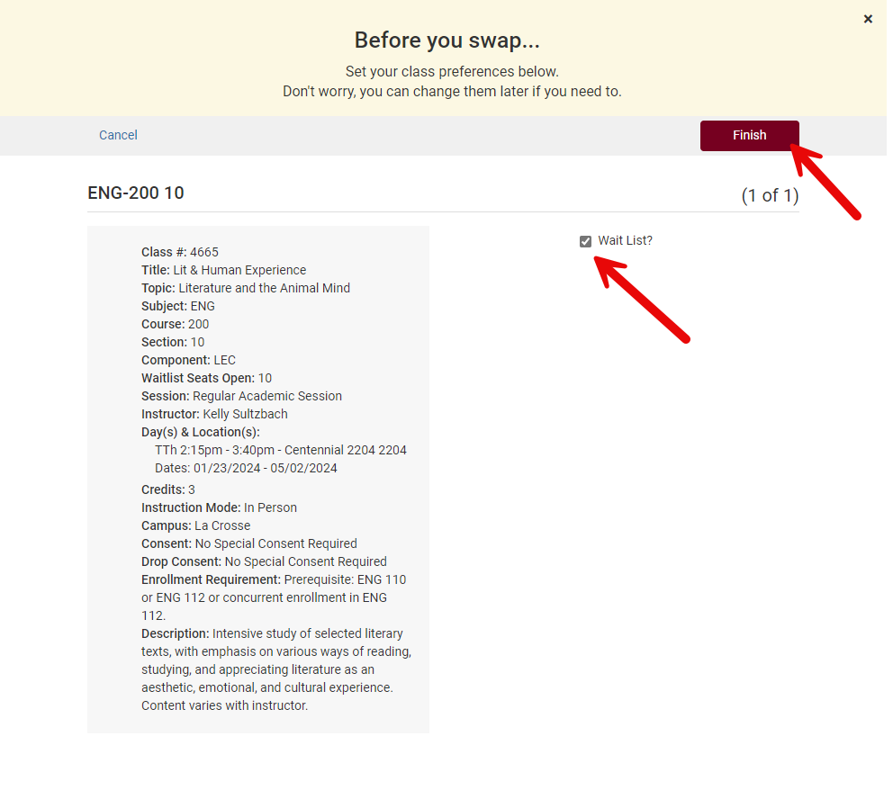

- A message will pop up asking you to confirm. Click Swap to confirm your swap or click Cancel to start over.

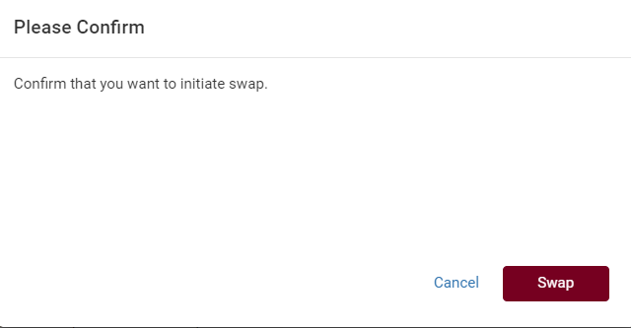

- A Swap Results message will provide your position number on the wait list if it worked.
  - Note your waitlist number.
  - Ignore the part that says there were some errors and the following changes could not be saved. It refers to the registration part of the transaction, not the add to the waitlist part. If you are given a wait list number, your waitlist swap set up worked.

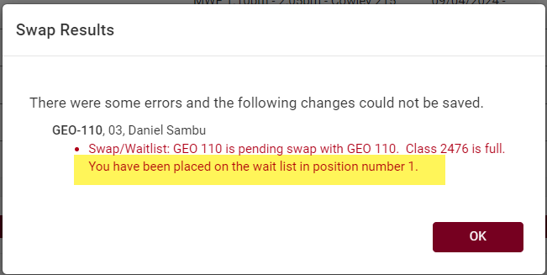

- If you are successfully enrolled later from the waitlist, a notification email will be sent. If WINGS tries to register you later but is not able to, a notification email will be sent letting you know about the error. The email will include what the error was.

Please note:
- Swapping is most useful when you don't want to drop a class unless you can get into another class at the same time.

- Remember, the system allows you onto the wait list as long as there is a seat and you meet prerequisites. However, the system will not register you if you have a time conflict, you are missing prerequisites, or the course will put you over the 18 credit maximum. Always check your schedule before adding yourself to a waitlist.

- Waitlists end at the start of the term, but you can still swap into open classes through the 10th day of classes for a full semester course.

- If you put yourself on the waitlist without using the swap and want to use it after, you'll have to drop yourself off the waitlist first and then re-add using the swap.

- You cannot swap onto a waitlist if the section does not have a waitlist.

- See the Waitlist FAQs for more information about how waitlists work.
- If you have questions about or need assistance swapping, contact the Records and Registration Office at records@uwlax.edu or 117 Graff Main Hall.

Register onto a Waitlist in WINGS
  - - Without a swap -

How to see if class has a waitlist:
- Go to the Add Course section and search for course.
  - If you know all sections are full, you will need to change the Course Status filter to Open & Full to find the course in the search.
- In your Course list, click on Sections.
- There will be a column called Waitlist Seats Open indicating the number of waitlisted seats available. If the course has no waitlist seats left or doesn't have a waitlist at all, it will say 0.
- Click on the blue circle with an 'i' (Section Details) next to the subject to see more information on that section. If there is a waitlist with students on it, there will be a Waitlist Enrollment line. You can also see the Waitlist Seats Open number in the Section Details.
- If there is no Waitlist Enrollment in the details and the Waitlist Seats Open column is at 0, the section does not have a waitlist.

How to register onto a wait list:
- Open Schedule Planner and set your Course Status filter to Open and Full to get all courses. Schedule Planner does not show closed classes in the search results when the filter is set to Open Classes only.

- Find the class you want following the Search for Classes in Schedule Planner directions and add to your Course lists on Build Schedule page.

- Click Generate Schedules and review until you find the right one. Click View.

- Once you have selected the potential schedule, click Send to Shopping Cart.

- As you add to the shopping cart, each section with an available waitlisted seat will show up with a "Waitlist?" option.

- Checkmark the Waitlist? box and click Finish.
Tip: Use the SWAP feature in your WINGS Student Center to get on a waitlist if you want the system to drop you from a different class if a seat opens up in this one. See Swapping onto a Waitlist in Schedule Planner.
- Click Register and proceed through the registration steps.

- Review your results.
  - If successful, you will receive a message with a position number (1 being highest).

  - If you forgot to check the waitlist box, you may get a message saying the course is closed with directions on how to get on the wait list.
  - If you get a "class is full" message at registration, return to your Shopping Cart and click Edit Cart to see if the section has waitlist as an option. If the section has a waitlist with seats available, the Waitlist? box will appear for you to check. Click that box and then Save.
  - Then click the Register button again.

- The waitlisted class will display in your class schedule, under the Current Schedule tab, with a status of Waitlisted.

See the Swapping onto a Waitlist in Schedule Planner section for directions on how to swap with a waitlist. See the Waitlist FAQs for more information about how waitlists work.

Swapping onto a Waitlist in WINGS

The class you want is closed but has a waitlist. You don't want to drop your 2nd choice unless you get into your 1st choice. What do you do?

Enroll using Swap - this puts you on the waitlist of your 1st choice and identifies which class to drop if you get in. If a seat becomes available and you are enrolled in the class successfully, WINGS will drop your backup class at the same time. If you never get enrolled into your 1st choice, you remain enrolled in your 2nd choice.

Directions:
- Register into your back up course if you haven't already.

- To swap, navigate to the Enroll link or the Enrollment: Swap option in the drop-down menu of the Academics section of your homepage. Navigate to the Swap tab of the enrollment area.

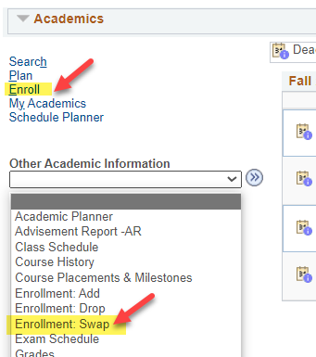

- Select the correct term.

- Choose the class to drop from the Swap This Class drop down. This is the class to be dropped.

- Find your first choice using the Class Search, select it from your shopping cart (course must be added to shopping cart first), or enter the 4-digit Class Nbr in the With This Class section. This is your preferred class with the waitlist. If entering the Class Nbr, click Enter when done.

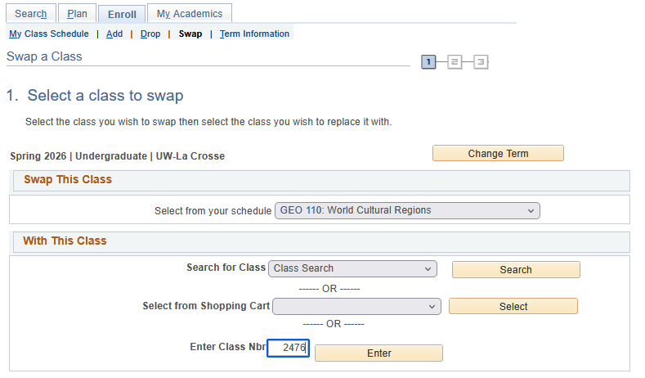

- If the class has linked lecture/lab, choose your preferred section or review the information and click Next.

- Click the box Waitlist if class is full. Then click Next.

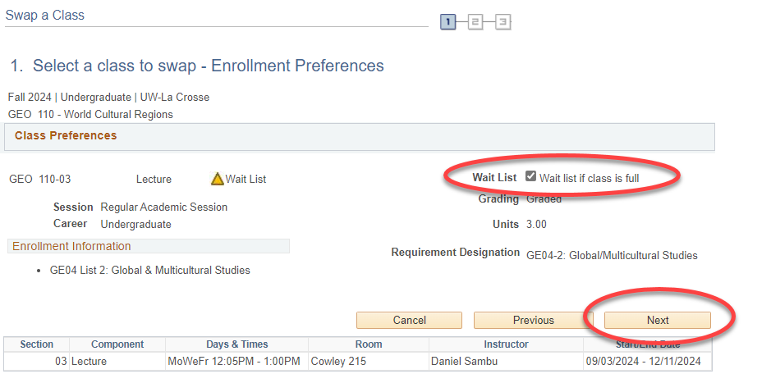

- Review the swap. When ready, click Finish Swapping.

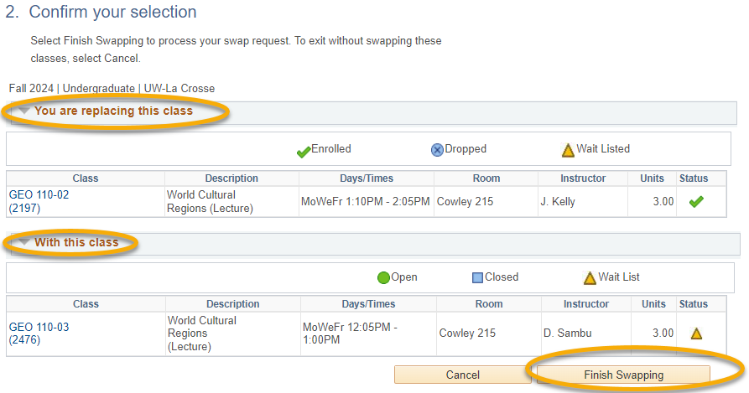

- Read the message reporting your spot on the waitlist.

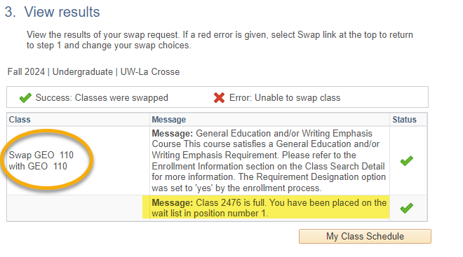
- If you are successfully enrolled later from the waitlist, a notification email will be sent. If WINGS tries to register you later but is not able to, a notification email will be sent letting you know about the error. The email will include what the error was.

Please note:
- Swapping is most useful when you don't want to drop a class unless you can get into another class at the same time.

- Remember, the system allows you onto the wait list as long as there is a seat and you meet prerequisites. However, the system will not register you if you have a time conflict, you are missing prerequisites, or the course will put you over the 18 credit maximum. Always check your schedule before adding yourself to a waitlist.

- Waitlists end at the start of the term, but you can still swap into open classes through the 10th day of classes for a full semester course.

- If you put yourself on the waitlist without using the swap and want to use it after, you'll have to drop yourself off the waitlist first and then re-add using the swap.

- You cannot swap onto a waitlist if the section does not have a waitlist.
- See the Waitlist FAQs for more information about how waitlists work.

- If you have questions about or need assistance swapping, contact the Records and Registration Office at records@uwlax.edu or 117 Graff Main Hall.

Waitlist FAQs

How does the waitlist work?

A: If you are #1 on the list and a seat opens, the auto-enroll function will try to put you in. However, you must also meet the prerequisites, and the course must be able to fit into your schedule for the auto enrollment to be successful.

You will be notified if you are enrolled in the class. You will also be notified the first time the system tries to put you in but fails. If the system cannot enroll you, it moves on to the second person on the list. Please keep an eye on your campus email for the notifications and check your schedule as well, in case the email goes astray.

Please note that waitlists end the morning of the first day of the term. After that, you can register directly into the class if there is a seat open or ask for an override from an instructor if the class is closed. Overrides are not guaranteed as space is limited.

When does the waitlist process enroll students?

A: The automated waitlist process runs three times a day at 9am, 1pm, and 5pm every day up to the day before classes start.

Am I guaranteed a seat in a class if I get on the waitlist?

A: No, getting on a waitlist is not a guarantee you will be enrolled in the class. Another student must drop out of the class before you can get in, and there is no guarantee that will happen.

How do I register onto the waitlist of my 1st choice class so that it drops my 2nd choice class if I get in?

A: Use the Swap feature in the enrollment area of your WINGS Student Center. See above directions on how to do that.

I'm on the waitlist but I didn't use the swap feature to get on. I recently received an error notification saying I couldn't be registered. What do I do?

A: Look at what error you received. If the error is about a time conflict or that the course will put you over your maximum credit load, you must drop a class for the waitlist to work. If you want to set up the waitlist with a swap at this point, you will need to drop off the waitlist and then re-register using the swap. This will put you at the end of the waitlist. Another option is to drop your 2nd choice class since you now know you are first on the waitlist and hope that another seat opens.

I am on the waitlist but got an email saying there was an error enrolling me into the course. What does that mean?

A: You are allowed to get on a waitlist even if you have a time conflict or are in another section of the class. Therefore, the top four causes of being passed over even if you are #1 on the waitlist:

  - Time conflict with another class. You may have forgotten to use the swap feature to enroll onto the waitlist.
  - Adding the class would put you over 18 credits.
  - You are already enrolled in another section of the class.
  - You may have dropped or failed a required prerequisite after getting on the waitlist. You cannot be registered into the class if you don't meet the prerequisites.

The system doesn't know you plan on dropping another course unless you use the Swap feature when registering. If you need to use the swap feature but are already on the waitlist, you will need to drop off the waitlist first to correct the set up. This means you will go to the end of the waitlist when you re-register.

How many waitlists can I be on?

A: The maximum number of credits a student can be waitlisted for is 12. The limit is the same for both undergraduates and graduates. You can be on the waitlist for multiple sections of the same class.

If you get into a section of a class and no longer need the other sections, please drop yourself off the other sections if you are waitlisted in.

How do I register if I'm on a waitlist but also received an override from the instructor? Do I need to drop off the waitlist first?

A: Drop yourself off the waitlist first then register for the class like normal. You will still see the yellow triangle.

Do not check the Waitlist OK box if there is one. It could cause an error in the process.

If you've tried to register and received an error, please ask your instructor to verify that the permission was placed correctly (i.e. on the right tab, on the right section, checking the right override permission). If you or the instructor need assistance, please contact the Records and Registration office

While swapping, I think I was dropped from my backup class. What happened?

Did you set up a swap to drop you from your backup class if you are enrolled off the waitlist for your first choice? And then later did you try to swap sections of the waitlist for your first choice? In those situations, WINGS sees the secondary swap as an enrollment and drops you from your registered class, the one you selected as "drop this class if enrolled."

The solution is to set up a separate swap for the second section of the waitlist and enter your registered class as the class to "drop this class if enrolled" in that swap. You can then go back and drop yourself off the waitlist of the section you no longer want.

You can be on the waitlist for more than one section of the same class as long as they are lecture classes without labs or lecture/lab classes where any lab can go with any discussion.

I see a seat that has been open for a while in a class that has a waitlist. No one seems to be getting in. How do I get into the class?

A: Enroll onto the waitlist. If the other students on the waitlist are not getting in, it is possible they have conflict or other issue that makes them ineligible. You may end up being the first eligible person on the waitlist and so then get the seat. But you must be on the waitlist to get enrolled if there are already other students on the waitlist.

Can I be on the waitlist for more than one section of the same course?

A. In some situations. You can be on the waitlist in multiple sections of the same course if each section is a separate class, meaning the course is entirely a lecture or entirely a lab. You can also be on the waitlist for more than one section if the course is a lecture/lab combination where any lecture section can go with any lab section, although you may have to enroll on the waitlist in separate transactions.

However, if the course is a lecture/lab, lecture/discussion, or lecture/lab/discussion where the specific labs/discussions are tied to specific lectures, you can only be on the waitlist one time for each grouping. For example: CHM 103 or 104 has lecture/lab/discussions grouped together by section number. The 10s go together; the 20s go together, etc. You can only be on the waitlist one for each group. You cannot be on the waitlist for two different labs that go to the same lecture.

How do I drop myself from the waitlist?

A: Drop from the waitlist the same way you drop a regular class, in either WINGS or Schedule Planner. It helps other students to drop off the waitlist if you no longer want or can get into that class.

How to I swap CHM 103 or 104 or swap waitlists for CHM 103 or 104?

A: CHM 103 and CHM 104 are classes that have linked lecture/labs/discussion. The linking means you can only register into the sections of lecture/labs/discussion that are grouped together by section number. So for labs in the 10s, you can only be in the lecture section 10 and one of the discussions in the 10s. If you see a lab or discussion in the 40s, you can only register into the lecture section #40.

This means swapping sections will only work in very specific situations. Students should take the following into account when making changes to their schedule:

- If you are not on the waitlist:
- You can swap a section (lab or discussion) within a specific group, if there is an open seat.
- You can swap entire linked groups (lecture/lab/discussion) as long as there is an open spot.
- Do not check the "Waitlist if class is full" box; otherwise, it will drop you from all of the sections you are already registered in.
- If you are on the waitlist:
- You can swap waitlists from one group of lecture/lab/discussion to another only if they are two completely different sets of section numbers. The swap cannot share any section numbers.

So swapping onto a waitlist for sections 30/31L/32D when you are already enrolled in sections 10/11L/12D will work,but swapping onto a waitlist for sections 10/11L/12D when you are already 10/12L/11D will not work. The system will drop you drop you from what you are already enrolled in and put you only on the waitlist for the second group of numbers.

While on the waitlist, if you want to change section numbers within the same grouping, contact the Records and Registration Office for help swapping. Our office can assist.

What are department-controlled waitlists?

A: Some departments or faculty members may use criteria other than waitlist position to determine who should be enrolled in the class. They may issue overrides (class permissions) to students they choose to enroll. In this situation, the waitlist only keeps track of your name and does not enroll you. You need to register yourself if the department sends you their approval. The Chemistry and Biology departments are examples of departments that give electronic permissions based on the waitlist.

Can I get on a waitlist after the term has started?

A: Not in WINGS. The waitlists in WINGS are erased on the first day of the term. However, you can still ask the instructor for an override (electronic permission). You can register into a closed class with instructor consent through the 10th day of class, for a full semester course.

Find Your Position on the Wait List

- In the Academics section of your WINGS Student Center, select Class Schedule from the drop-down menu. Click the double arrow button.

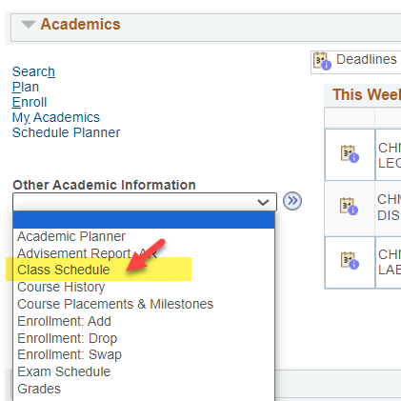

- In the List view, switch the filter options to Show Waitlisted Classes and click Filter.

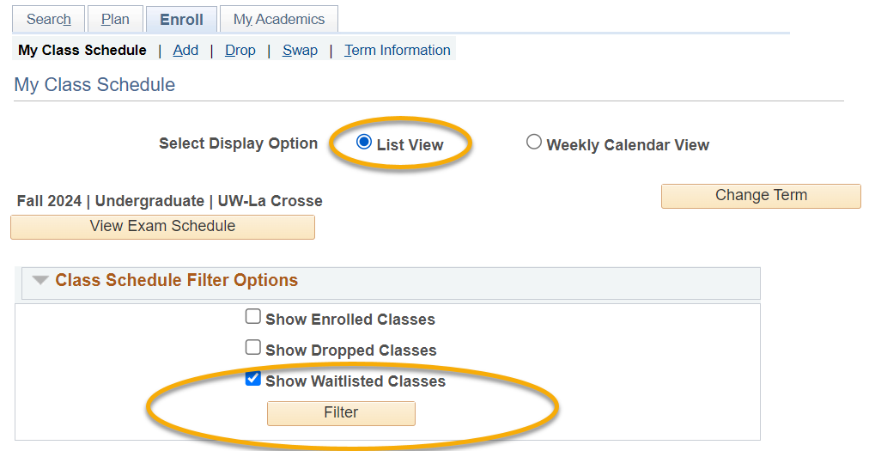

- The Waitlist Position field shows your current position.

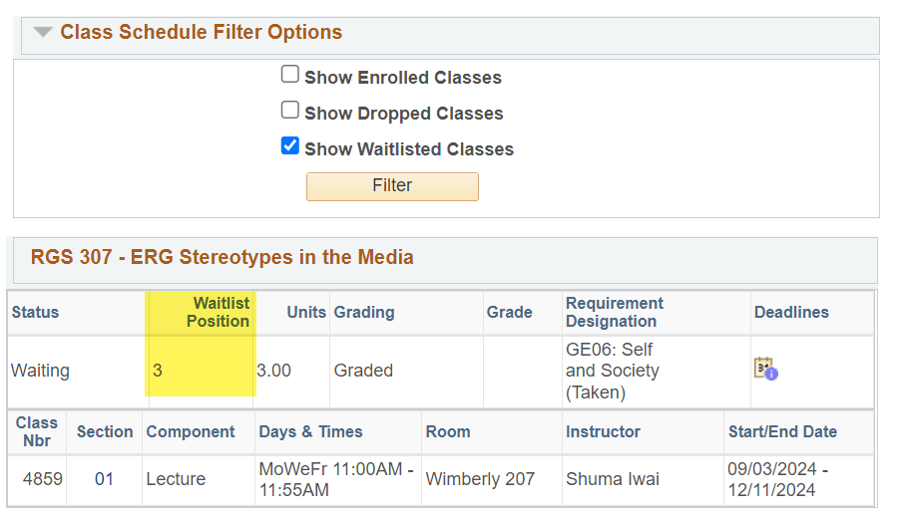

Note: Your wait list position is not listed in Schedule Planner, only in WINGS.

View Your Holds and To Do List

Holds

Holds are notices or restrictions that have been put on your record. These notices sometimes block university services (such as registration and official transcripts) until the hold is resolved. If you have a hold, a Details link will appear.

- On your WINGS Student Center Homepage, the Holds and the To Do List sections are listed in the right-hand column.
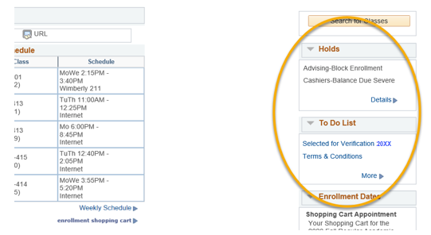

- Click on details find out more about the hold. Restrictions can be for a variety of reasons. The most common ones are advising holds and financial obligations. These restrictions may prevent you from registering or from obtaining an official transcript until you have cleared them up.

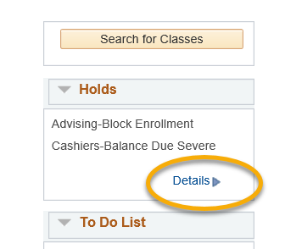

The details page displays basic information about the hold, including the day it was put on and the department or office that put on the hold.

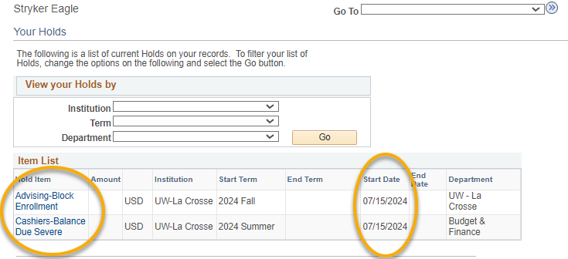

- Click on the name of the hold for instructions on how to get it removed.

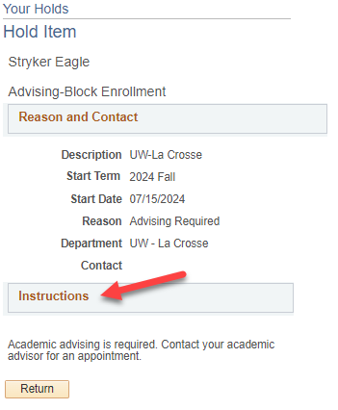

- Return to your homepage by clicking the "Home" button at the top right of the screen.
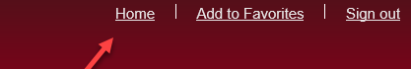

To Do List (also called Checklist)

Your To Do List tracks actions you need to take to complete as part of your admission to UWL, financial obligations, and actions needed to qualify for financial aid. Failure to complete certain tasks can result in a hold being placed on your account until that task is completed.

- Click on more to see the details.
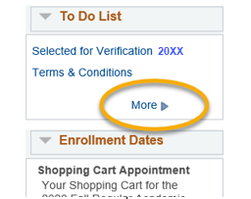

- Note the due date for when the task must be completed.

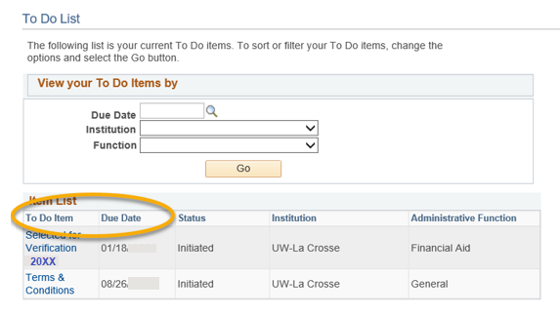

- Click on the name of the To Do Item to find out what you must do to complete the task. There will be a contact person or office to whom you should submit your paperwork or proof that you have completed the task.

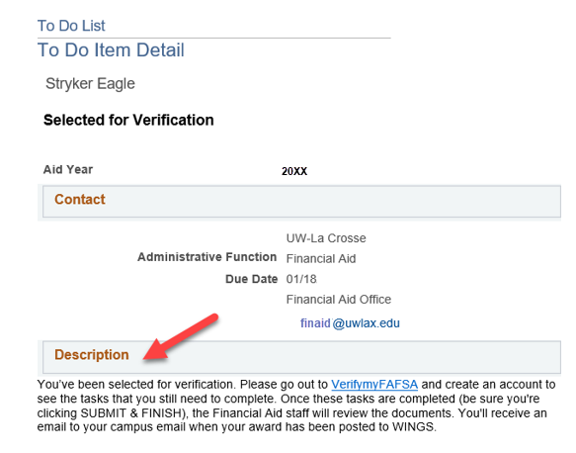

- If you have already completed the task, contact that person or office and let them know it is completed.

Obtain an Enrollment Verification

- Go to the Enrollment Resources section of your Student Center. You can find this section on the right-hand side, toward the bottom.
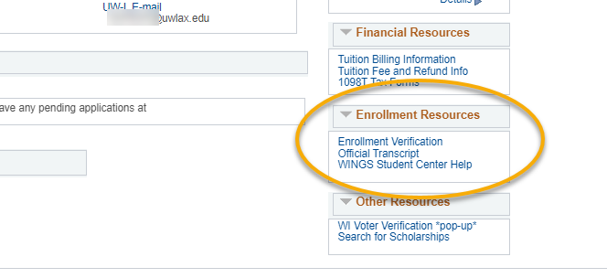

- Click on Enrollment Verification.

- On the next screen, under Obtain an enrollment certificate, select either current enrollment, all enrollment, or advanced enrollment.
  - Current enrollment will print your enrollment status for the current term only. This can only be obtained after the term has started.
  - All enrollment will print the status of all your terms of enrollment since you first started at UWL. If all enrollment is requested before the first day of class, it will not include that term.
  - Advanced registration confirmation is not available at UWL through this site. If you need confirmation that you are pre-registered for a term, contact the Records and Registration Office.
Tip: If you need a good student discount certificate, you may click on Obtain a Good Student Discount Certificate under the next bullet point instead.

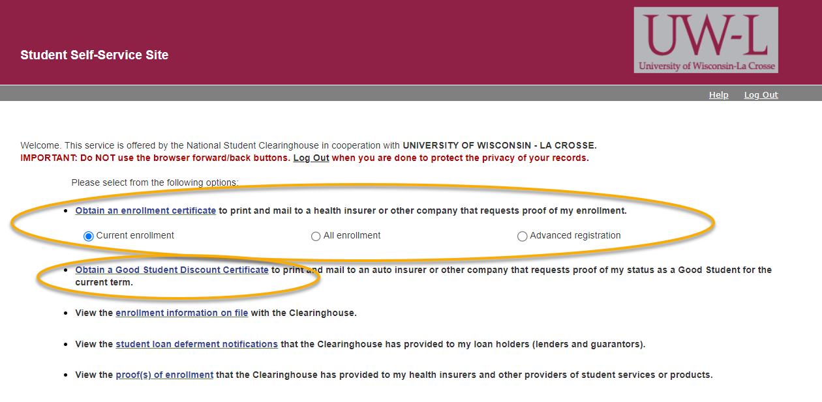

- Click on the Obtain an enrollment certificate link.
- A new window or tab should pop up with a certificate you can print. The certificate will contain the school seal. It will list whether you were full-time or part-time for the term.
Tip: If you don't see the certificate, you may have a pop-up blocker on your internet browser. Go to settings and turn it off and then try again.

- If you receive the following message and you need an enrollment or registration certificate, please contact the Records and Registration office.

View Textbooks for Classes

Undergraduate students may start checking out textbooks two weeks before the first day of class for Fall/Spring semester or the first day of final exams for the semester before the Winter/Summer term.
- You do not need to bring the textbook list with you to Textbook Rental. They will provide the list to you. You will need to bring your Student ID card.
- Additional materials may be required to be purchased for the class. These materials can be purchased through the University Bookstore.
- Graduate students must purchase their books and can do so through the University Bookstore.
- Return policy: if a class is dropped within the first week of class, students must return the textbooks for that class within 24 hours. Textbooks not returned by the close of business the following business day will be fined a processing fee. If a class is dropped after the first 5 class days, students must return the books to Textbook Rental by the last day of finals, or they will incur a processing fee.

View books on individual classes:
- Go to Schedule Planner and select the term.
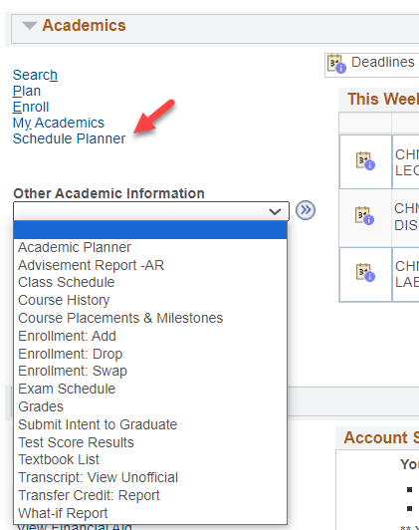

  - If you are registered in the course, go to Current Schedule below or on the Current Schedule tab. Click the blue 'i' information icon for section details.
  - If you are not registered in the course, add a course to the Courses section, click on Sections, and then click the blue 'i' information icon for section details. The information icon in Courses only gives selected details unless you are on the Sections page.

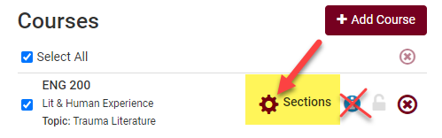

- In the Class Details that open, click on View Books to Buy next to Textbook.

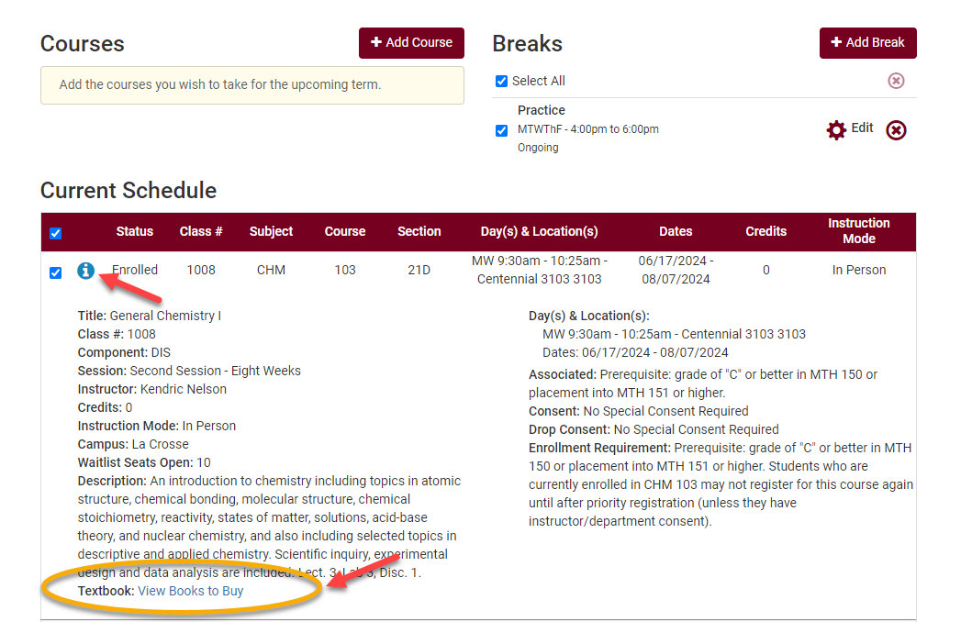

- A new tab/window will open.
  - If the textbooks and materials have been finalized, you will see a list.
  - If textbooks have been finalized but no books or other materials are required, you will see this message:

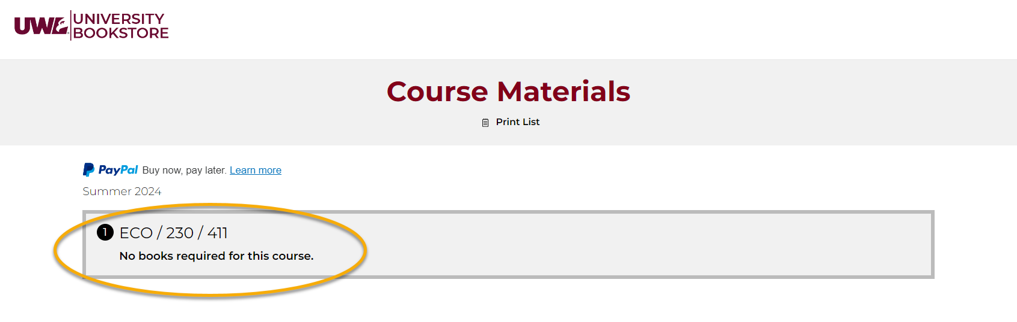

  - If they have not been finalized yet, you will see this message:
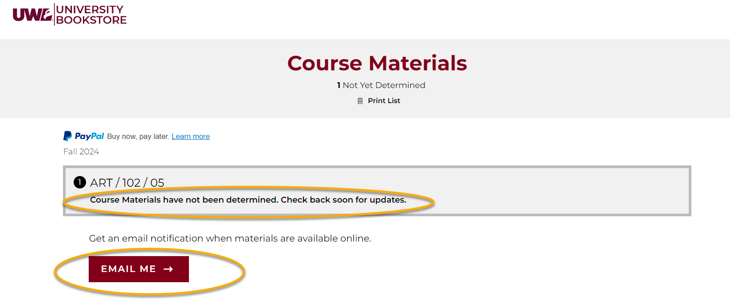
- Click the Email Me button and enter an email address if you want to be notified when the book list is posted.
- If course materials need to be purchased, you may have the option of purchasing them online.

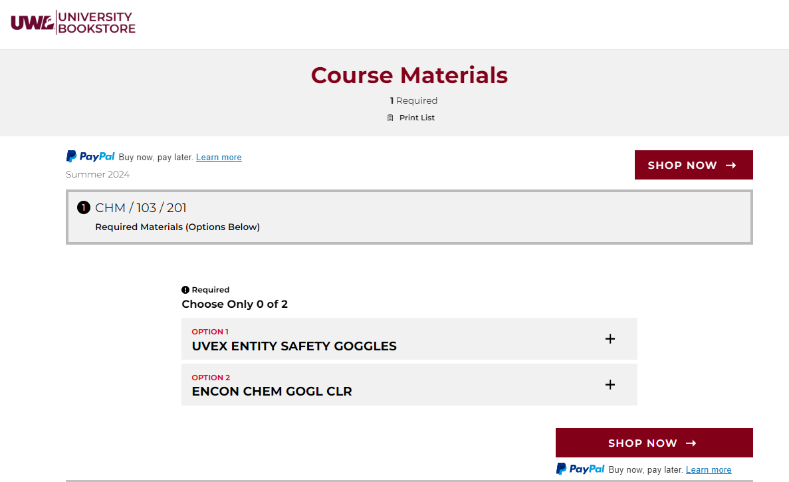

WI Voter ID Verification
UWL students intending to vote in Wisconsin elections will need to provide proof of residency to register as a voter. One document that meets residency requirements is the student Voter ID Enrollment Verification.

- Login to your WINGS Student Center.
- Scroll down to the Personal Information section and select Addresses from the Other Profile Information drop down menu. Click Go. Review your addresses. You must have a Campus or Local address in La Crosse to vote.
  - Campus addresses will print on the ID automatically. If you have a campus address, you don't need to update anything.
  - If you don't have a campus address, update your Local address to reflect where you are physically living during the school year. Your Local address can be the address of your residence hall if it is not already listed as your Campus address.
  - You do not need to update your Home address.

- After saving any changes made to your Local address, return to the Home page in your WINGS Student Center.
- Go to the Other Resources section on the right-hand, bottom side of your Student Center.
- Click on WI Voter Verification.
- A new window or tab should pop up with a PDF of the verification. If no form appears, you may have a popup blocker on your internet browser. Go to the settings in your browser and take off the pop-up blocker. Then try again.
- Print the form out and take it with you to vote.

More information for UWL students voting in Wisconsin elections can be found in UWL's Voting Resources.

