Advisement Reports
The academic Advisement Report (AR) in WINGS provides you with access to your degree requirements, including general education, major, and college requirements. This report shows what requirements you have satisfied and what still need to be completed to earn your degree.

How to Access
- In the Academics area of your Student Center, select the My Academics link. Alternatively, you can also select Advisement Report-AR from the Other Academic Information drop down.

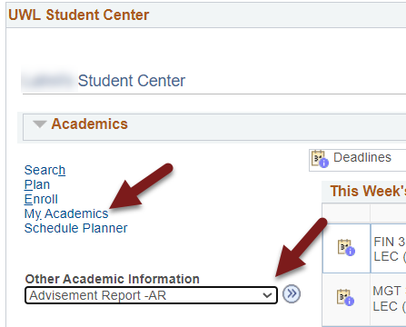

- The My Academics tab will be selected. Next to Academic Requirements, click View my advisement report.

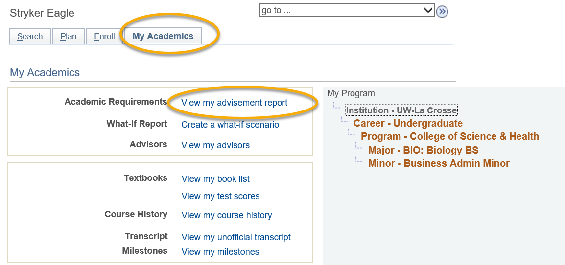

Navigating your Advisement Report (AR)

Collapsing/Expanding
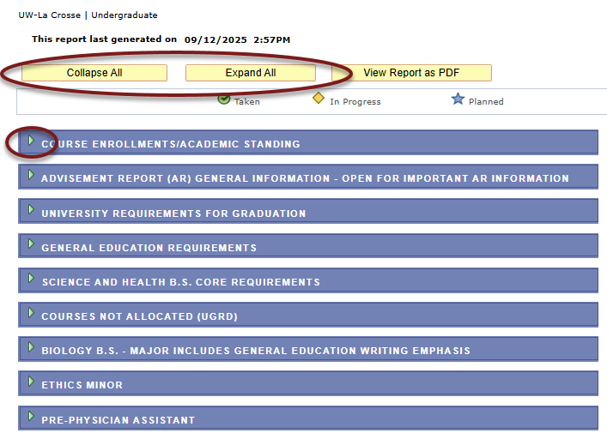
The AR is organized into collapsible sections. Sections contain collapsible sub-headings that categorize requirements. Requirements specify what a student needs to complete to satisfy degree requirements.

To individually expand or collapse a section, click the Expand Section arrow on the left of the section name. All arrows toggle between collapsing and expanding the section. If they point to the right, selecting them expands the section. If they are pointing down, selecting them collapses the section. You can also use the Collapse All and Expand All buttons at the top of the report.

The sections are organized by current course enrollment, university requirements, general education requirements, college/school core, courses not allocated, major, minors, certificates, honors, and pre-professional tracks.

Satisfied vs Not Satisfied
By default, expanded sections contain components with unsatisfied requirements while collapsed sections contain requirements that have been completed.

If a requirement starts with "Not Satisfied," you have not finished that requirement yet. If it starts with "Satisfied," you have completed that requirement.

However, it is possible for a section to be Not Satisfied but also collapsed, if you have closed it manually by clicking on the Collapse section arrow. Sometimes that is useful so you can focus on just one requirement at a time. To reset everything to the default, you will need to go out of the page and re-run the report.

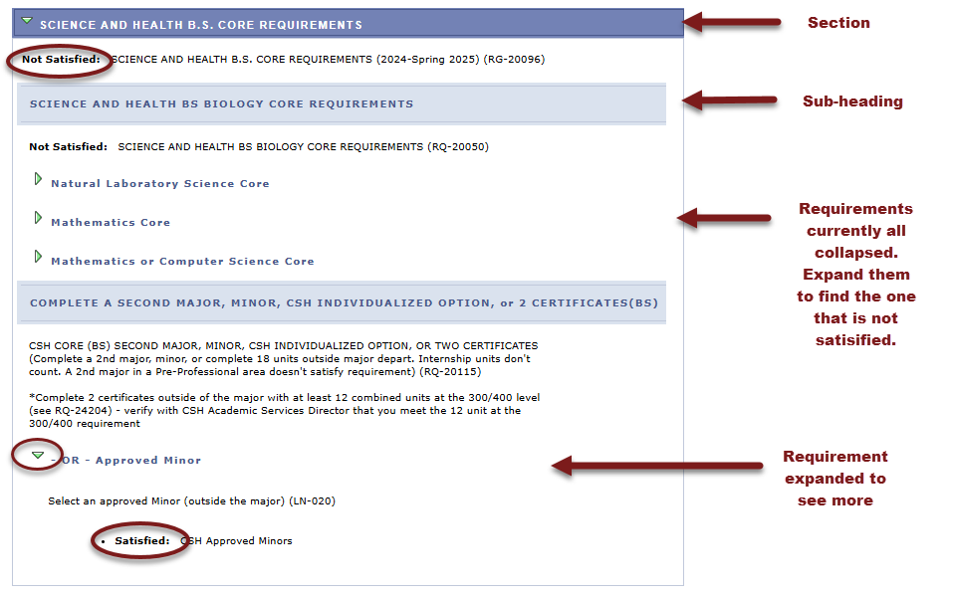

Sections

Course Enrollments/Academic Standing
This section contains currently enrolled courses, pre-registered courses for the next term, and your academic standing.

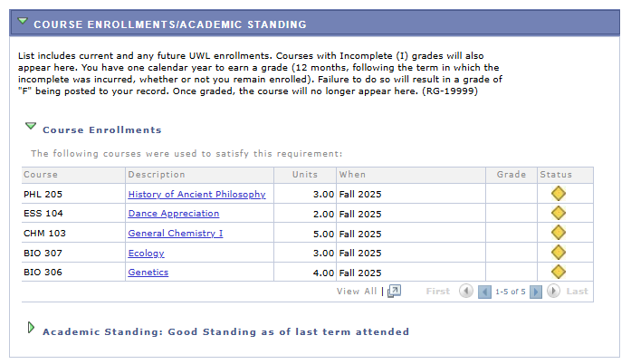

Advisement Report (AR) General Information
This section contains an explanation of the What- If AR, a note to second degree & non-degree students, and an explanation of the Courses Not Allocated section found farther down the AR. There may occasionally be other news pertaining to the AR listed in this section.

If you find errors on the AR, please report them to the your Dean's office.

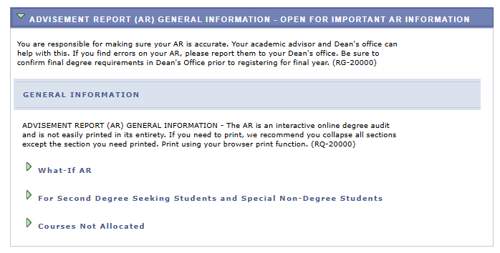

University Requirements for Graduation
The components in this section are required by the university for graduation. The green checkmark symbol denotes a completed or graded course (a.k.a. Taken). The yellow diamond symbol denotes an in-progress course.

Important: The blue star symbol denotes a planned course that has not been taken or enrolled in yet. This symbol only appears in the My Planner Advisement Report. The regular AR always shows the most up to date status of your requirements, so it is best to refer to that report each semester to ensure you are making progress as expected. The start of these directions shows how to get to the regular Advisement Report. Directions on the My Planner report are separate.

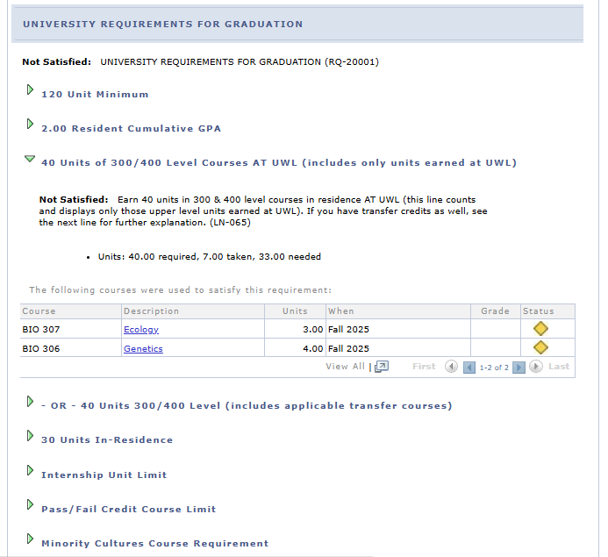

General Education Requirements
This section has several subsections that list the courses needed to satisfy each General Education category.

Use the navigation options at the bottom, right corner of class lists/course grid to view more of the available courses that are not displayed (by default the first 10 courses appear in a list). To view all on one page, click the View All link. To view more course details, click the course description/title link.

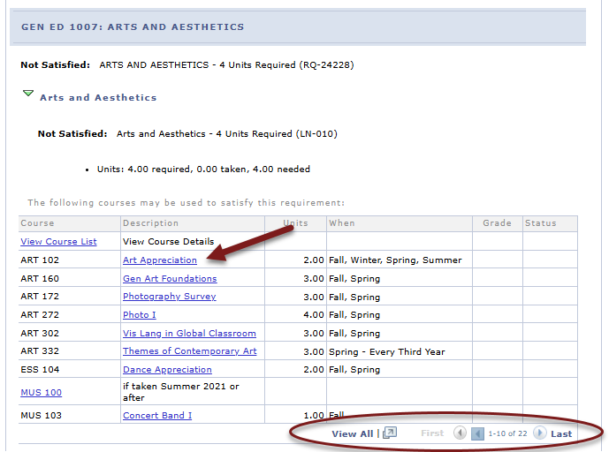

The course details include full course description, when the course is typically offered, course attributes, and any prerequisites.

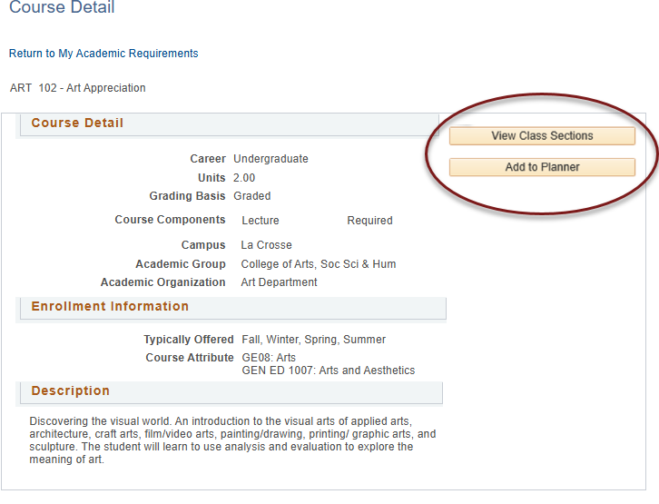
The course details also let you view the schedule to see if that course is being offered in the current or near future. Click View Class Sections to see if the course is scheduled. You can then decide whether to add the course to My Planner. The planner allows you to select courses based on your major/minor/degree requirements so you can plan your future academic schedule. You can plan one term, a year or your entire academic career using the planner. You can register using courses in My Planner later. See the My Planner directions for more planner details.

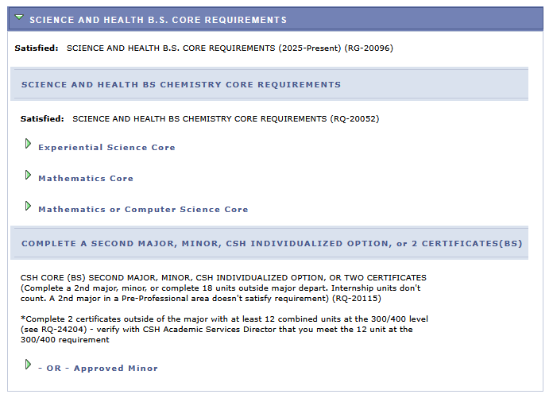
College or School Core Requirements

This section is related to your college or school's core requirements for graduation. Your college/school oversees your first major. In the example below, the student is a computer science major which is housed in the College of Science and Health.

Courses Not Allocated

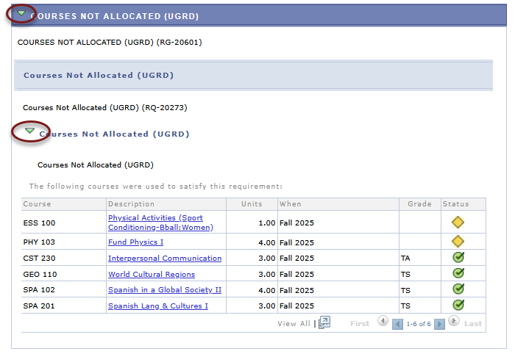
This section lists courses not used elsewhere in the Academic Requirement Report. For example, the grade may not have satisfied the minimum requirement, the student may have withdrawn or failed the course, or the course may have exceeded the number of hours needed for electives.

This section starts out collapsed. Click on the arrows to expand and see what courses are in this section.

Major and Minor Requirements
These sections include any major and/or minors you have declared. The following is a partial example of a computer science major. The major requirements are shown collapsed but are not satisfied. Click the arrows to expand the section details.

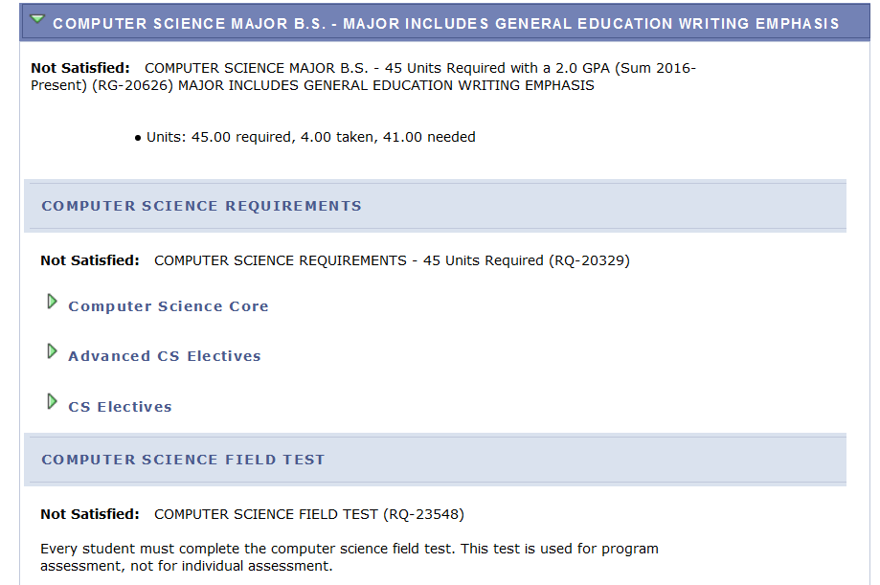

Pre-Professional Tracks/Other
Additional sections/requirements might appear, based on your college and situation, including pre-professional advising sections and individualized options taking the place of minors. As another example, students in CSH that have not yet declared a major will see a CSH 60 Units message.

